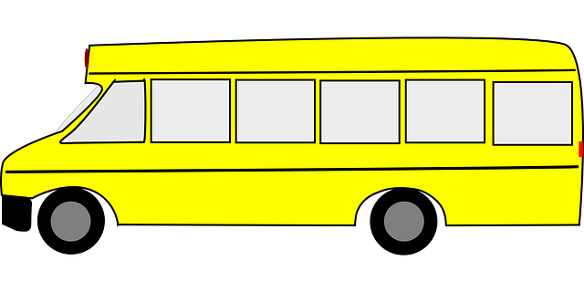
Bus Request Form
Multi-Faith Student Organizations
Please complete the fields below and submit to Chris Darcy (McElroy 233) at least two weeks before your departure date.

Name:
Email:
Student Organization:
Chart-string:
Destination:
Number of students attending:
Number of buses needed:
Departure location, date, and pick-up time:
Return location, date, and pick-up time:
Contact person (with cellphone number):
Advisor:
Approved: ____________________________________________________ Date:________________
(requires Chris Darcy’s signature)

