PeopleSoft HR

ECR Automation Process

Job Reclassification

October 2010

Processing a Job Reclassification

ECR Search Page

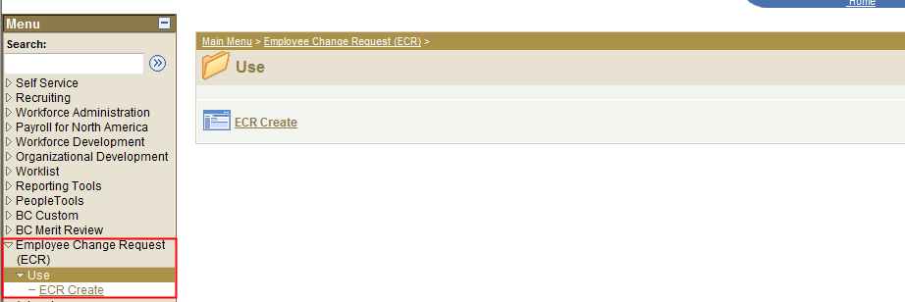

To process a Job Reclassification using the automated ECR process, follow the menu navigation below:

Home > Employee Change Request (ECR) > Use > ECR Create

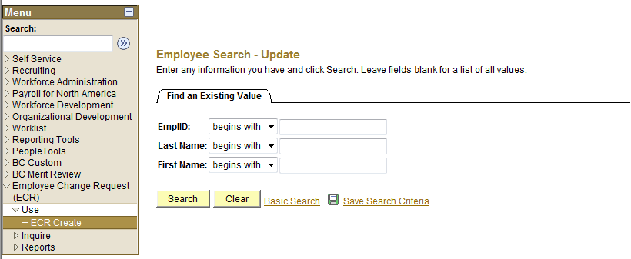

- If you know the Name or Eagle ID of the employee, type it into the appropriate field. A search can still be performed if you only have a partial name or Eagle ID.

NOTE: The Name fields are not case sensitive.

ECR Search Page

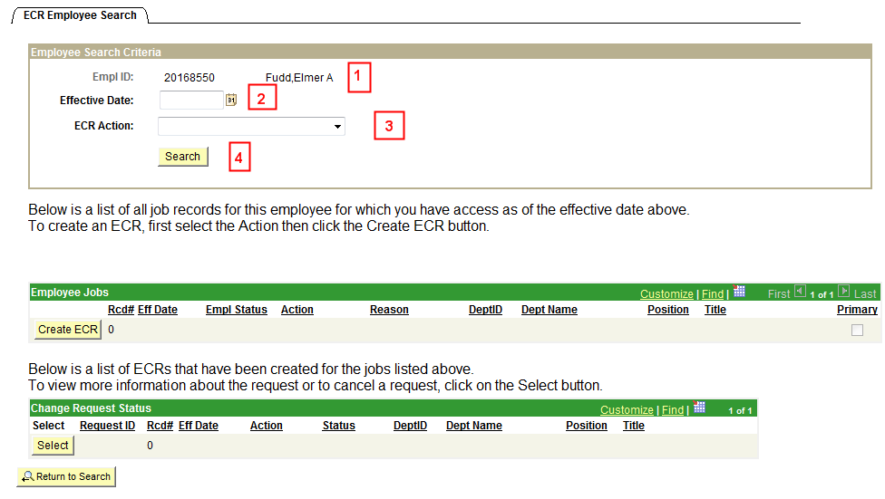

1. Verify the Eagle Id and Name of the employee for whom the transaction is being done.

2. Enter the Effective Date of the Job Reclassification. This is the Effective Date that will be reflected in PeopleSoft HR.

3. Select “Reclassification” from the ECR Action drop down field.

4. Click the Search button to display the Employee Jobs for the employee. This will display all the job records within the security access of the originator. This allows the user to determine which job record to select and run the Create ECR process.

ECR Search Page

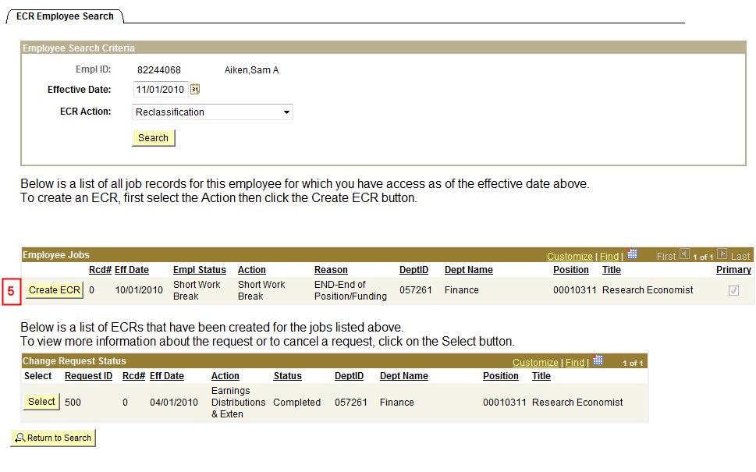

5. Click the Create ECR button next to the job record of the job reclassification.

NOTE: Any ECR transactions that have been processed for the employee will also display under the Change Request Status section of the page.

ECR Job Reclassification Request Page

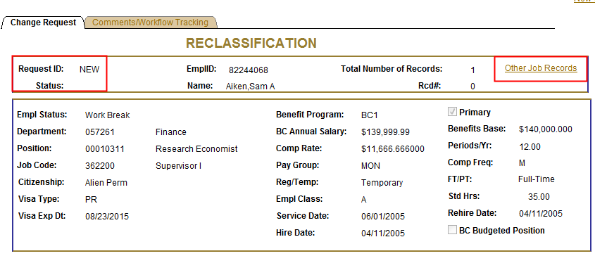

Information specific to the employee and important for processing a Job Reclassification has been identified and captured in the top section of the screen. This information is reflective of the data specific to the job being updated. This data displays current information as of the effective date. It will not display future dated information for the employee.

NOTES:
- Request ID and Status will default to ‘NEW’ until the transaction has been submitted. The various statuses will update as the transaction goes through the process.

Status | Definition
New Request | The status defaults to ‘New Request’ when the request is first opened.  The Request ID defaults to ‘New.’
Pending (area) Approval | The status is ‘Pending (area) Approval’ while waiting for approver action: Approve or Deny.  Approval areas are: Office of the Provost, Restricted Funds, Compensation, Position Management, Foreign Tax, and HRSC.
Denied | The status is set to ‘Denied’ when the request is denied by an approver.  Upon denial, the request is routed back to the originator.  At this point, the originator may cancel or resubmit the request.  On resubmit, Request ID remains the same as original.
Cancelled | The status is ‘Cancelled’ when the request is cancelled by the originator.  No further activity allowed on this request.
Manual Update | The status is ‘Manual Update’ when the HRSC rep presses the ‘Manual Update’ button. The request must be entered into Job Data manually. This is done in the event of a system error or if the rep determines that a manual update is required. The request is complete.  No further activity allowed on this request however, the HRSC has the ability to add a comment. The Originator will receive notification of the manual update.
Completed | The status is ‘Completed’ when the data is entered successfully into PeopleSoft.  No further activity allowed on this request however, the HRSC has the ability to add a comment.

- The Other Job Records link opens a screen that displays other job records the employee has (if applicable) that the user has security access to view.

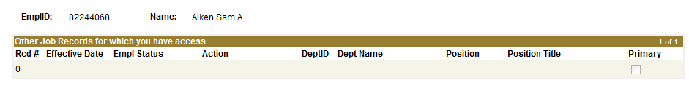

ECR Job Reclassification Request Page (Lower Section)

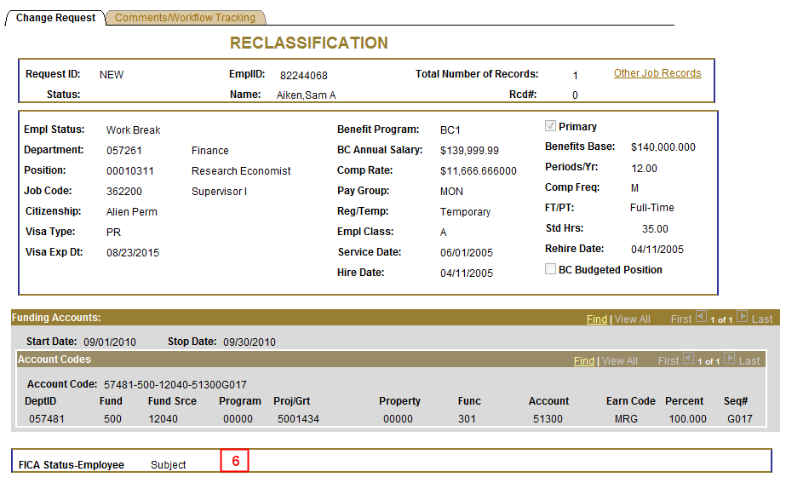
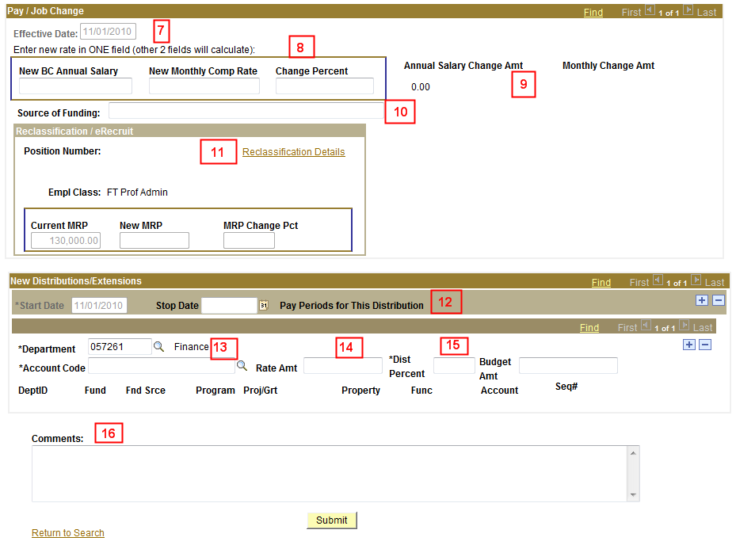

6. Verify the FICA Status of the employee. This is very important when processing a job reclassification. In particular, if the employee is a foreign employee.

7. Confirm the Effective Date is correct because this is the effective date of the job reclassification in payroll. This field will be grayed out. If the date is incorrect, the user must select the Return to Search link at the bottom of the page and begin again.

8. Enter the new pay rate into one of the fields within the selected box. Only one field needs to be entered and the other two will be automatically calculated by the system. The calculations are based on the current Annual Salary and Comp Rate as shown in the information area at the top of the page.

NOTE: The Comp Rate will display whether the field is monthly, weekly or hourly based on the Pay Frequency. Example: New Monthly Comp Rate.

9. Verify the Annual Salary Change Amount and the Change Amount fields calculate correctly. They will be reflective of what is entered into the rate fields in step 8.

10. Enter the Source of Funding for the job reclassification pay change. The Source of Funding is an open text/comment field and is not required. A warning is displayed when Source of Funding is left blank.
- This warning message is ‘Source of Funding is blank. Please enter the Source of Funding for this transaction.”
- This warning is applicable to Originators and all Approvers in the process until there is a field entry.

NOTE: The field can be changed throughout the Approval process – it does not grey out once there is data entered into the field like all the other open entry fields.

11. Click the link to the Reclassification page to enter further data before submission. (See print screen below for instructions)

12. Confirm the Start Date matches the Effective Date of the Job Earning Distribution. This field will be grayed out. If the date is incorrect, the user must select the Return to Search link at the bottom of the page and begin again.
  - If this is a temporary funded position, enter the Stop Date of the distribution. The Pay Periods for this distribution will calculate based on the Stop Date.
  - If this is a BC Budgeted position, a stop date is not needed. A warning will pop up if the last distribution transaction has a stop date for a BC Budgeted position.

13. Enter or look up the Account code for the new Earning Distribution. The Account Code lookup is limited to the department that is defaulted above the account code row. This department number can be changed if needed to access another account code outside of the departmental access.

14. Enter the new rate into one of the fields within the selected box. Only one field needs to be entered and the other two will be automatically calculated by the system.

15. If the percentage is entered, the rate amount will calculate automatically.

NOTE:
- When doing multiple split distributions, the distribution percent must total 100 percent.
- The budget amount will only calculate if there is a Stop Date entered because it calculates against the number of pay periods within the given dates.
- If more than one distribution account needs to be entered for the specific dates, use the plus sign () to insert a second row and repeat steps 10-12 to enter the account information.

16. Originators and Approvers can enter Comments as they go through the process. These will appear on the Workflow Tab and can be viewed by anyone involved in the approval path from the Originator to the HRSC. They can also be referenced at any time after the transaction has been completed.

16a. Enter the Submit Button when all the required information has been entered. This will
begin the workflow and assign a Request ID to the transaction.
ECR Reclassification Details Page

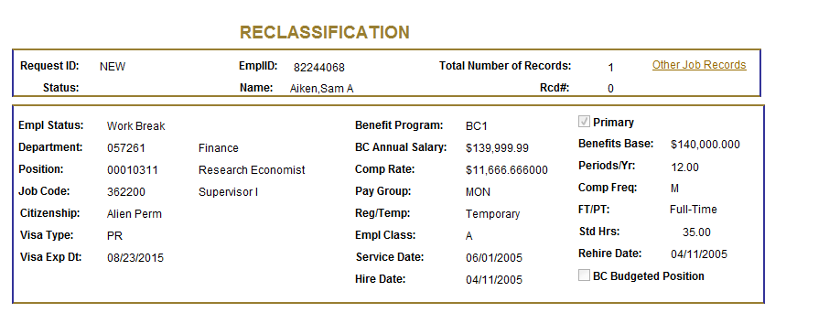
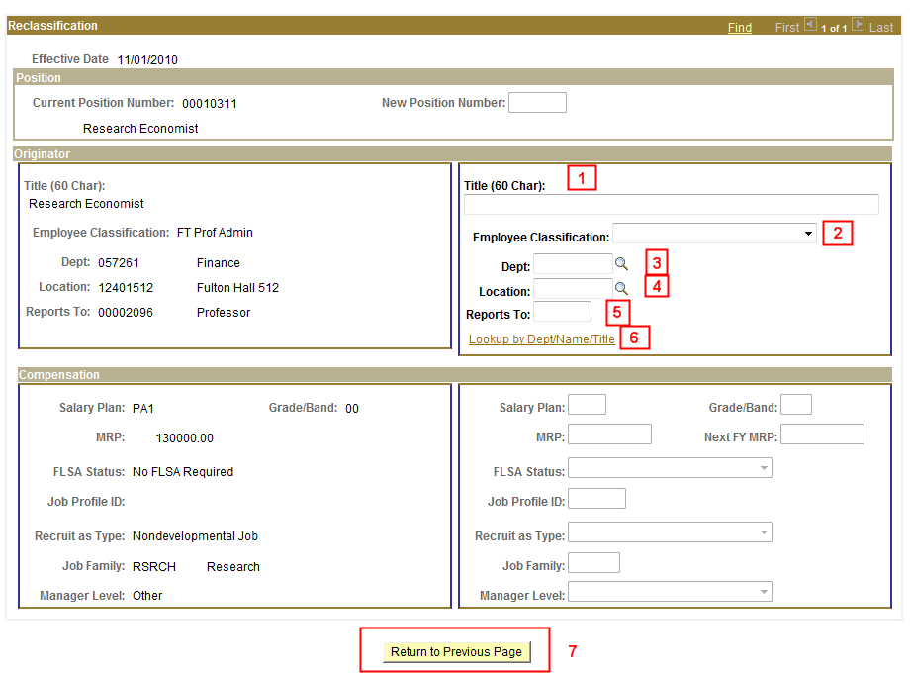

The originator box on the right side of the Reclassification Details Page is for originators to enter changes to the existing data on a .00position reclassification. The left originator box displays the current information for the position number. This is view only.

NOTE: If there are no changes needed, the fields can remain blank. The current information will stay the same on Job Data.

1. Enter a new Title description as needed.

2. Select an Employee Class from the drop down menu if a change is required.

3. Click on the magnifying glass to select a new Department number if the employee is being moved to a new department due to the reclassification. The number can also be entered directly into the field.

4. Click on the magnifying glass to select a new Location code if the employee is changing their location.

5. Enter the position number of the ‘Reports to’ employee if it is changing. If the position number is unknown, click the ‘lookup link’ below the field to search. (see below)

6. Click the link to search for the new ‘Reports to’ employee. The page will automatically search against the department number entered above. If blank, it will search against the current department number. The search page allows the originator to change the search information as needed.

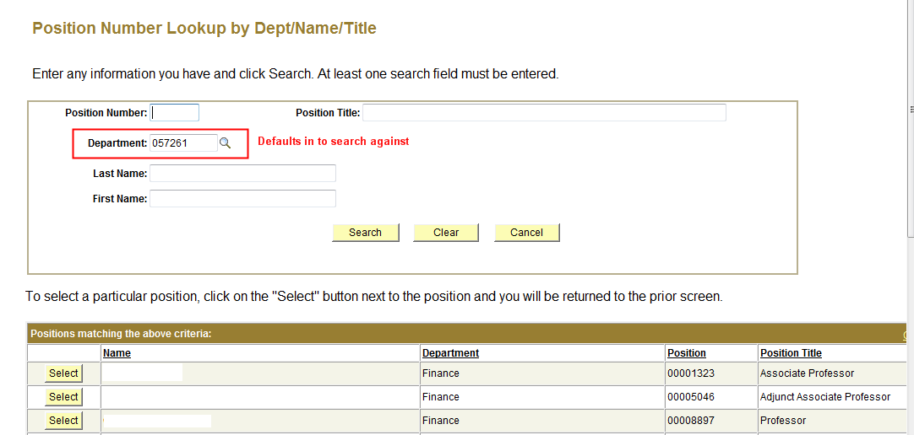
NOTE: The listing is sorted by name, but can be sorted by other fields by clicking the header in that column.

7. Once the information has been completed on the Reclassification Details page, click the Return to previous page button to go back to the ECR page to complete the process.
ECR Reclassification Comments/Workflow Tracking Page

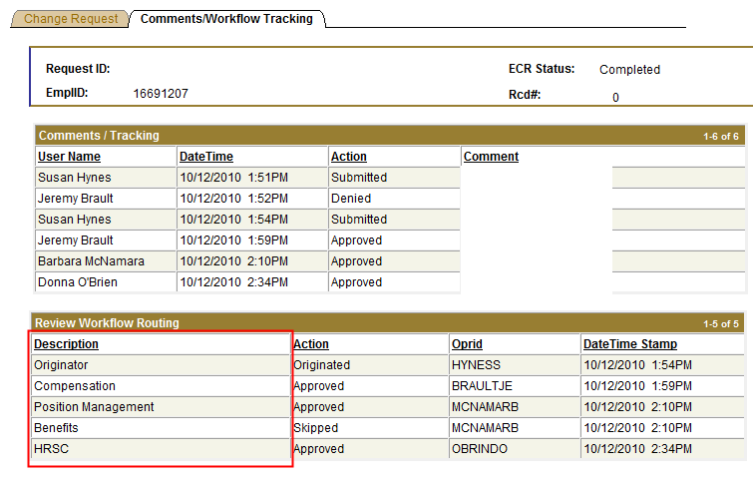

- After the job reclassification is submitted, the workflow approval path is displayed on the second tab called ‘Comments/Workflow Tracking’. This will show each department that must approve the transaction before it is processed in the HRSC.

- The request can be viewed by the originator and the approvers at any point during the workflow process for a status update.

ECR Transaction Inquiry

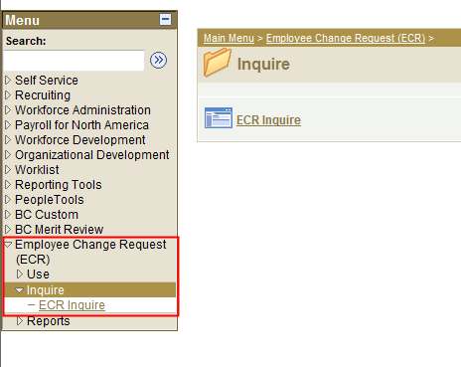

To view a transaction that is in process or already completed, follow the menu navigation below:

Home > Employee Change Request (ECR) > Inquire > ECR Inquire

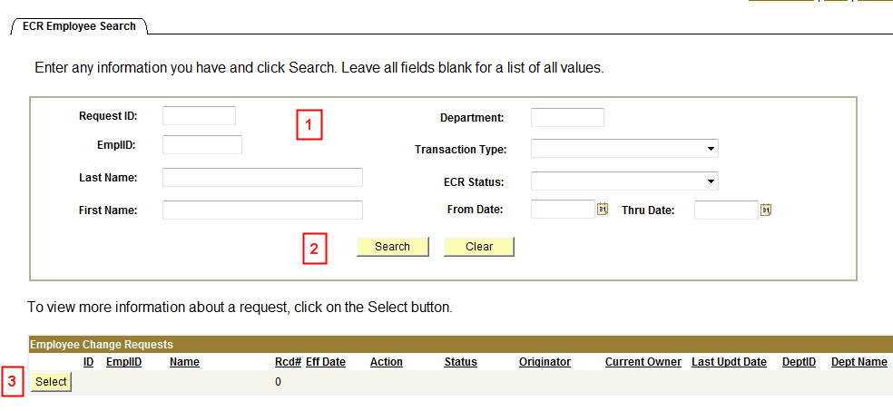

1. In this top section, the user can enter any field and/or multiple fields to search for an ECR. It is also useful to review ECR data already in the system.

2. Hit the Search button to display any ECR Requests that meet the search criteria entered.
If a broader search is done against certain fields, the data can be downloaded to excel by selecting the spreadsheet button to the far right of the header. ()

3. Click the Select button next to the request to pull up a specific ECR Inquiry Page. All the fields will be grayed out except for the current approver of the transaction.

Canceling an ECR Transaction Request

Home > Employee Change Request (ECR) > Inquire > ECR Inquire
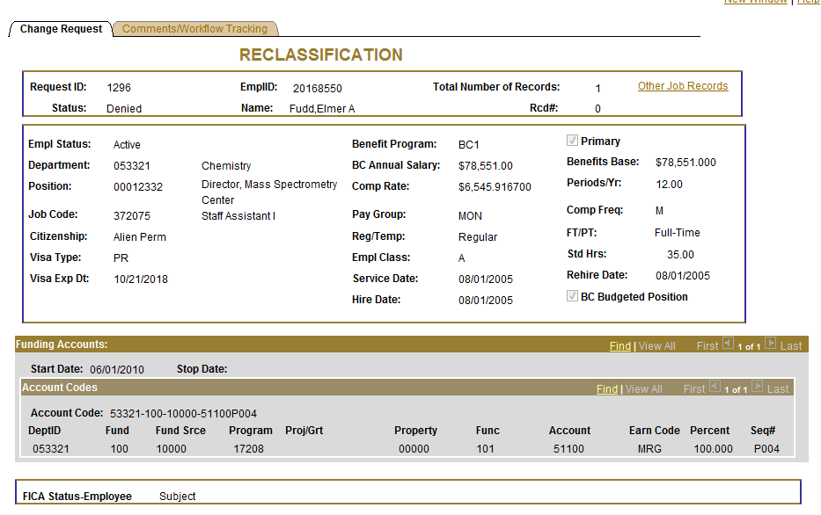
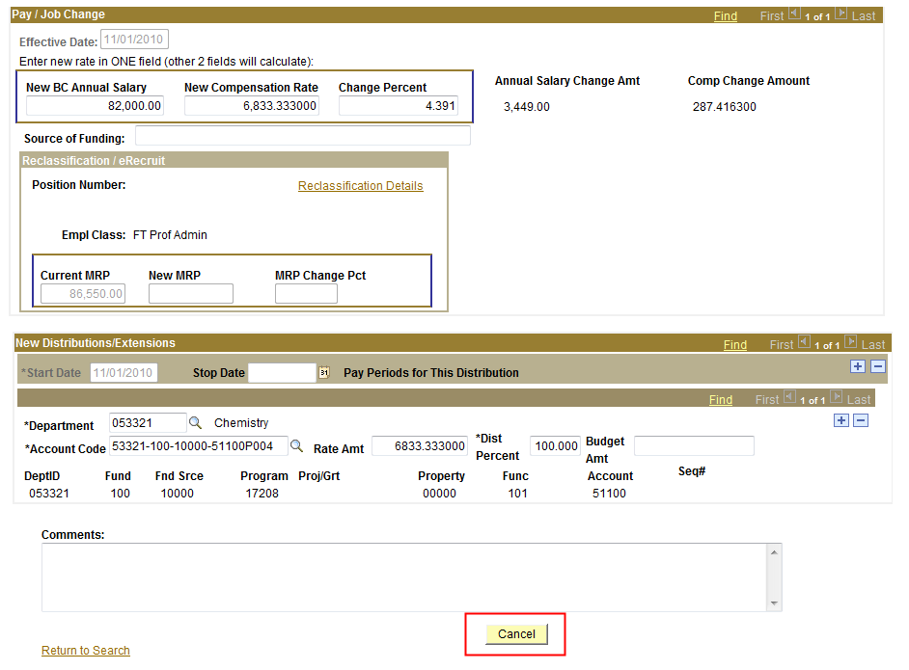

- The Originator is the only one who can cancel an ECR Transaction Request.

- A request can be cancelled at any point during the approval process before the status is updated to ‘Completed’.

- Select ‘Cancel’ at the bottom of the Inquiry Page.

- Confirm the status has been updated to ‘Cancelled’.

- Upon cancellation, an email notification is sent to the pending approver and prior approvers indicating the transaction has been cancelled.

Approve/Deny an ECR Transaction Request

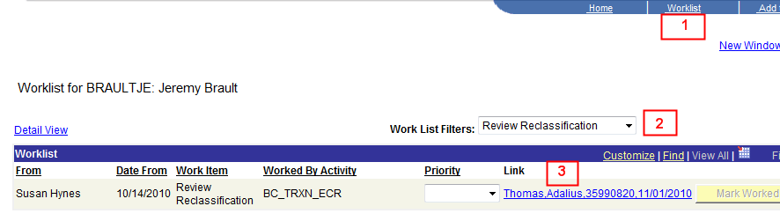

1. An approver has the option to go through his worklist to view any transactions or through ECR > Inquiry to get to the transaction.

2. The worklist allows the user to filter on the different transactions that come through the worklist. The Job Reclassification filter name is ‘Review Reclassification’. This will display only those items under the selected filter.

3. Each worklist item is defined within a link that displays the employee’s name, eagle ID and effective date of the transaction. Click on this link to go directly to the transaction page and review the information.

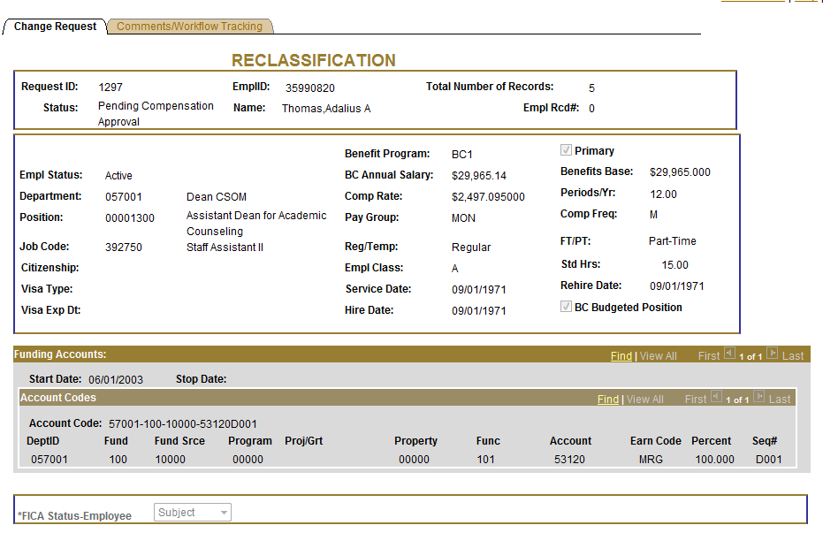
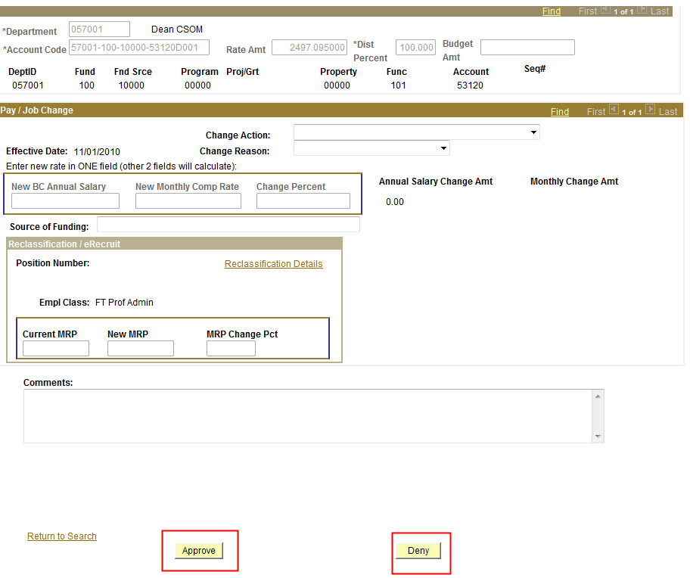
4

4. If the information provided is accurate, the approver will click ‘Approve’ to advance the workflow to the next approver on the list. The workflow tab indicates the route and where it is in the process. It will reflect updated information after each step.

If the information is not correct for any reason, the approver has the option to deny the request. This will send a notification email and the request directly back to the originator with a required comment as to why it has been denied. The originator has the option to re-submit the request or to cancel the request.

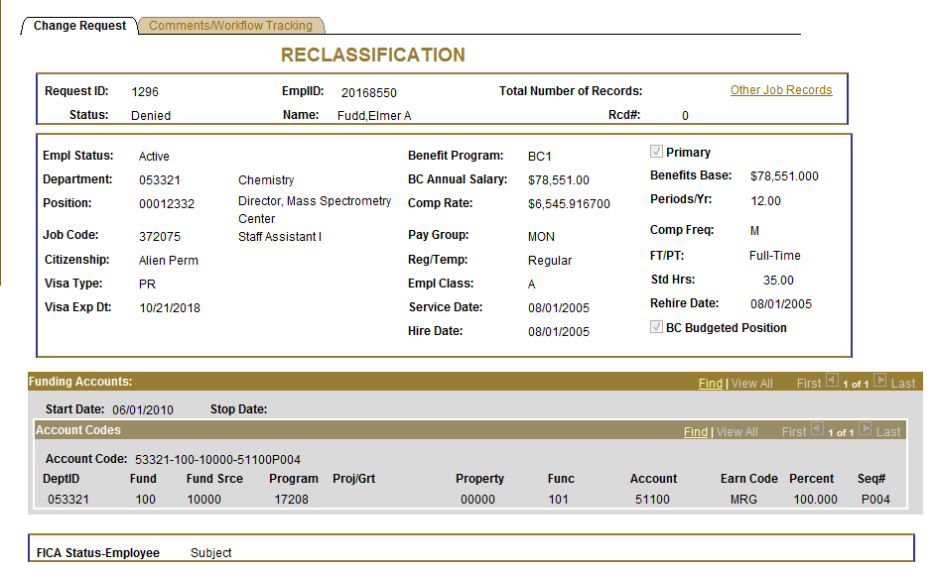
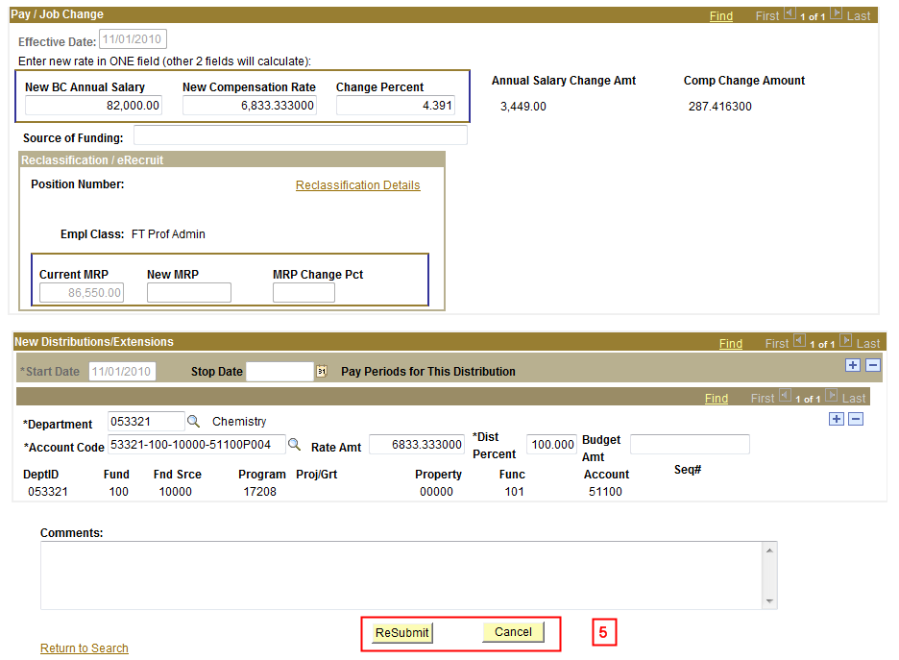

5. If a request is denied, the originator can make changes to the request and Resubmit it or Cancel the request.

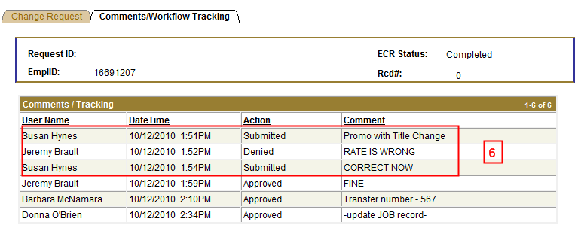

6. When a request is resubmitted, the workflow will readjust according to the changes made and begin the routing cycle again. It will display all activity pertaining to the request, including the resubmission through to completion.

