PeopleSoft HR

ECR Automation Process

Terminations

March 2010

Processing a Termination ECR

ECR Search Page

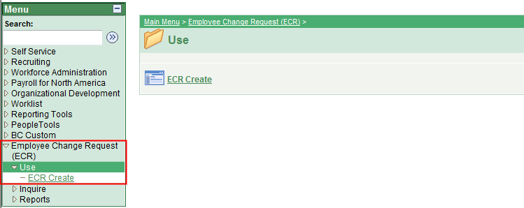

To process a termination using the automated ECR process, follow the menu navigation below:

Home > Employee Change Request (ECR) > Use > ECR Create

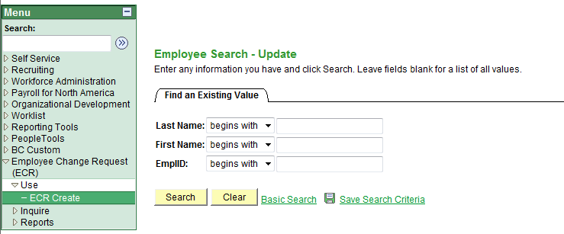

- If you know the Name or Eagle ID of the employee, type it into the appropriate field. A search can still be performed if you only have a partial name or Eagle ID.

NOTE: The Name fields are not case sensitive.
ECR Search Page

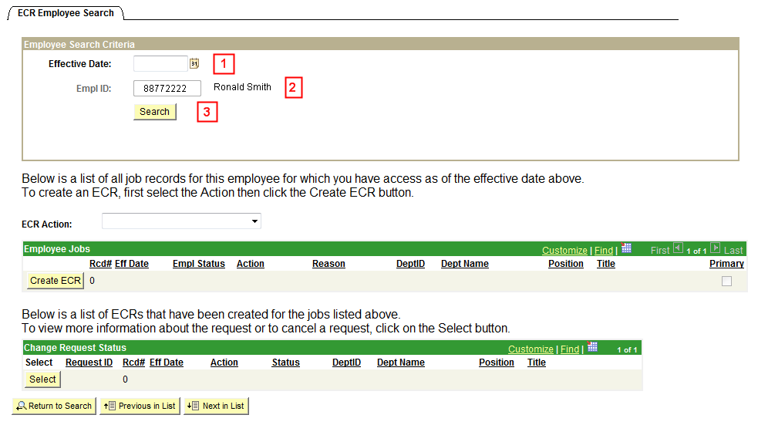

1. Enter the Effective Date of the Termination. This is the Effective Date that will be reflected in PeopleSoft HR.

2. Verify the Eagle Id and Name of the person being terminated.

3. Click the Search button to display the Employee Jobs for the employee. This will display all the job records within the security access of the originator. This allows the user to determine which job record to terminate and run the Create ECR process.

ECR Search Page

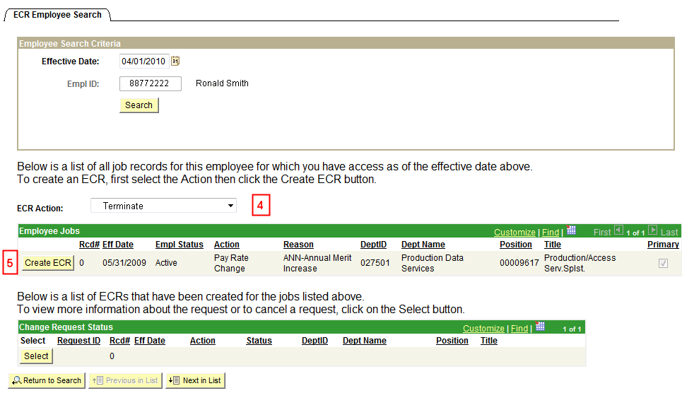

4. Select the action of Terminate from the ECR Action drop down menu.

5. Click the Create ECR button next to the job record being terminated.

NOTE: Any ECR transactions that have been processed for the employee will also display under the Change Request Status section of the page.

ECR Termination Request Page

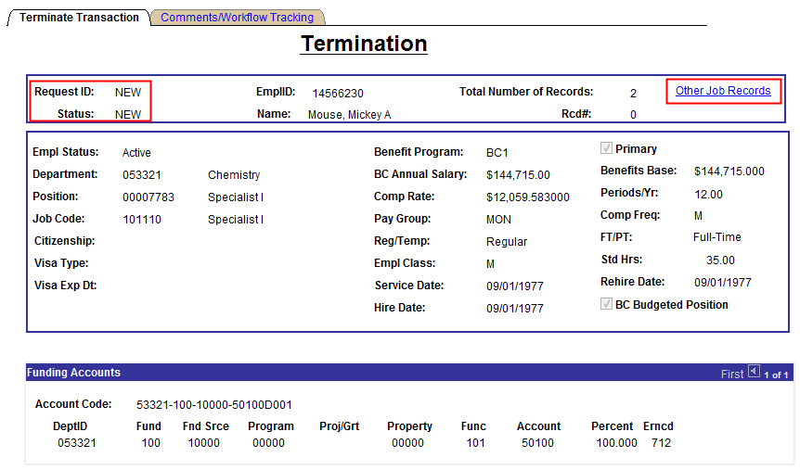

Information specific to the employee and important for processing the Termination ECR has been identified and captured in the top section of the screen. This information is reflective of the data specific to the job being terminated. This data displays current information as of the effective date. It will not display future dated information for the employee.

NOTES:
- Request ID and Status will default to ‘NEW’ until the transaction has been submitted. The various statuses will update as the transaction goes through the process.

Status | Definition
New Request | The status defaults to ‘New Request’ when the request is first opened.  The Request ID defaults to ‘New.’
Pending (area) Approval | The status is ‘Pending (area) Approval’ while waiting for approver action: Approve or Deny.  Approval areas are: Employment, Benefits, Foreign Tax, and HRSC.
Denied | The status is set to ‘Denied’ when the request is denied by an approver.  Upon denial, the request is routed back to the originator.  At this point, the originator may cancel or resubmit the request.  On resubmit, Request ID remains the same as original.
Cancelled | The status is ‘Cancelled’ when the request is cancelled by the originator.  No further activity allowed on this request.
Manual Update | The status is ‘Manual Update’ when the HRSC rep presses the ‘Manual Update’ button. The request must be entered into Job Data manually. This is done in the event of a system error or if the rep determines that a manual update is required. The request is complete.  No further activity allowed on this request however, the HRSC has the ability to add a comment. The Originator will receive notification of the manual update.
Completed | The status is ‘Completed’ when the data is entered successfully into PeopleSoft.  No further activity allowed on this request however, the HRSC has the ability to add a comment.

- The Other Job Records link opens a screen that displays other job records the employee has (if applicable) that the user has security access to view.

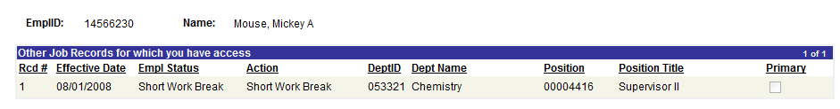

ECR Termination Request Page (Lower Section)

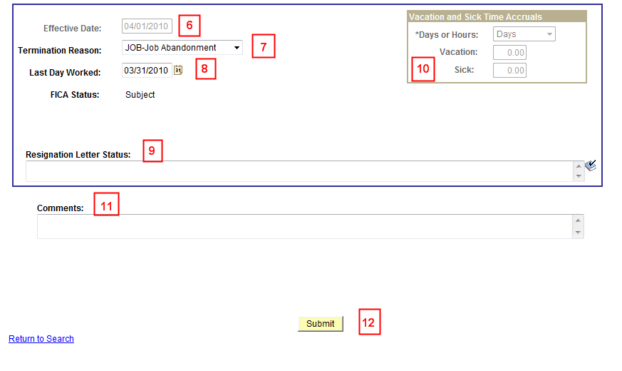

6. Verify that the Effective Date is the same as the one entered when initiating the termination transaction on the ECR Employee Search page. The date is grayed out on this page. If incorrect, click the Return to Search to begin the transaction again.

7. Enter the Termination Reason for the employee. The list displayed will also be available on the HR website. Please see below for the Termination Reasons:

CON – Misconduct  CVN – Covid Vaccine NonCompliant | MUT – Mutual Consent
DEA – Death | NJA – No Job Activity
EEF – End of External Funding | OTP – Resignation-Other Position
ELI – Elimination of Position | PER – Personal Reasons
ELS – End of Lump Sum Payment | PRB – Dismissed during Probation
EOJ – End of Job | RES – Resignation
ERT – Early Retirement | RTR – Regular/Normal Retirement
ESV – End of Severance | TMP – End Temporary Employment
JOB – Job Abandonment | TYP – Dissatisfied with Type of Work
LVE – Failure to Return from Leave | UNS – Unsatisfactory Performance
MIS – Misstatement on Application

8. Enter the last day worked for the employee. This date should be one day prior to the effective date of the termination. If the date is earlier than one day, a ‘Last Day Worked’ warning will appear displaying the rules and if the user would like to go back or proceed with the date entered.



NOTE: If the user decides to keep a different date in the last day worked field, a new comment field will appear and a comment must be entered before submitting the termination. This will inform the approvers and the HRSC of the reason behind the earlier date.

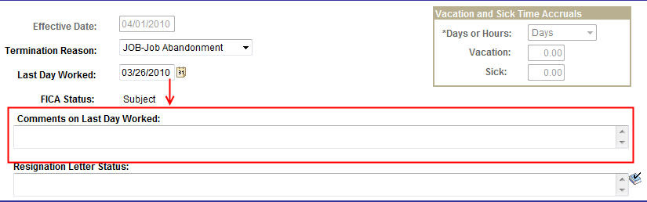

9. When an employee terminates, certain termination reasons require a resignation letter for Employment. When a reason is selected, a ‘Resignation Letter Status’ box appears and requires a comment from the originator. This will provide Employment with the necessary information on which to follow up if necessary.
Termination Reasons that generate a Resignation Letter:
  - ERT – Early Retirement
  - JOB – Job Abandonment
  - LVE – Failure to Return from LOA
  - MUT – Mutual Consent
  - OTP – Resignation – other position
  - PER – Personal Reasons
  - RES – Resignation
  - RTR – Retirement
- For all Employee Classes except Faculty, Grads, Students, Temp Pool and Retirees.

10. If the employee is eligible, the vacation and sick fields will be open and the originator can enter the appropriate days or hours upon termination.
- Grant funded vacation payouts must be approved through Benefits.

11. The user can enter general comments for all approvers to view. It is not a required field. Each approver can also add comments as the transaction request goes through the process.

12. Enter Submit to initiate the transaction and send it through the approval workflow.

ECR Termination Workflow Tracking Page

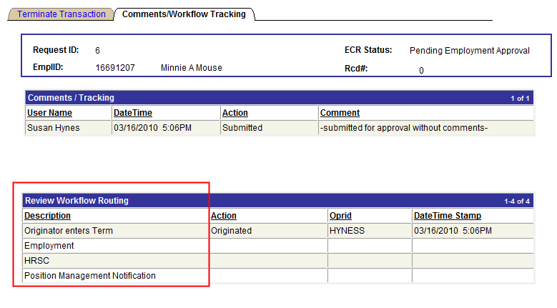

- After the termination is submitted, the workflow approval path is displayed on the second tab called ‘Comments/Workflow Tracking’. This will show each department that must approve the termination before it is processed in the HRSC.

- It also shows the departments that will receive an email notification on the termination.

- The request can be viewed by the originator and the approvers at any point during the workflow process for a status update.

ECR Transaction Inquiry

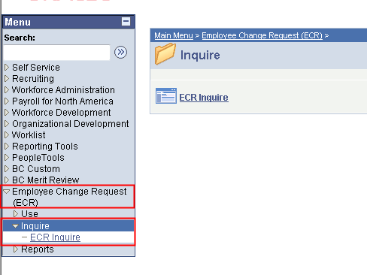

To view a termination that is in process or already completed, follow the menu navigation below:

Home > Employee Change Request (ECR) > Inquire > ECR Inquire

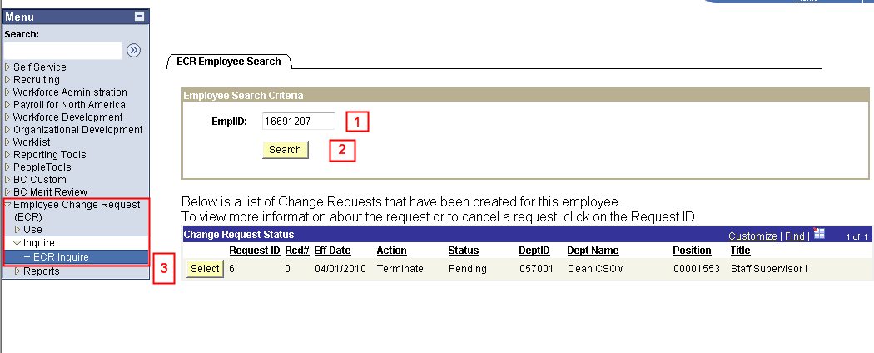

1. Enter the Employee ID. This is a required field.

2. Hit the Search button to display any ECR Requests that are pending or completed for the employee.

3. Click the Select button next to the request to pull up the ECR Inquiry Page. All the fields will be grayed out except for the current approver of the transaction.

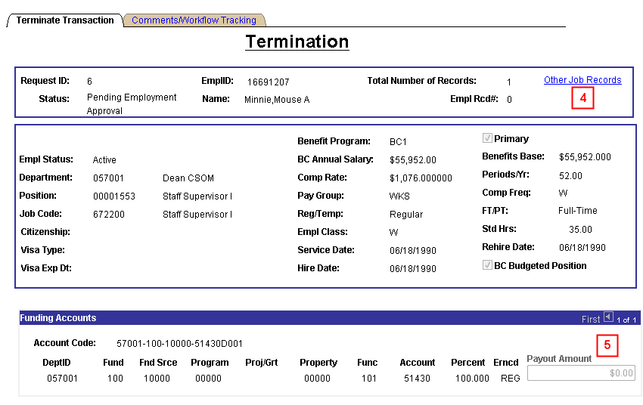
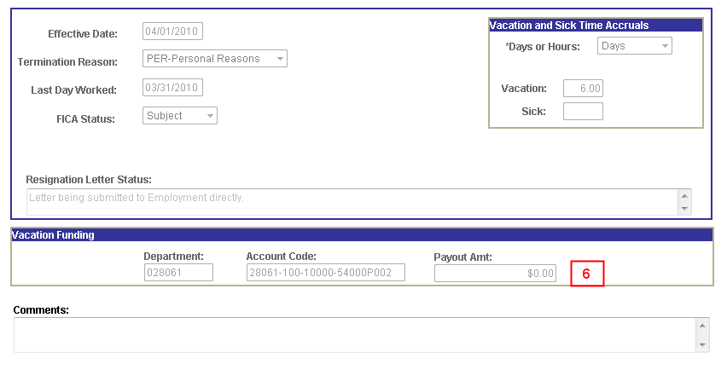

4. The ‘Other Job Records’ link is active for viewing if needed. It will only show records that are within the security access of the user.

5. A Funding ‘Payout Amount’ field will be viewable to reflect any amount entered by the Benefits Department or the HRSC.

6. A ‘Vacation Funding’ section is viewable to display information pertaining to vacation payout amounts entered by the Benefits Department or the HRSC.

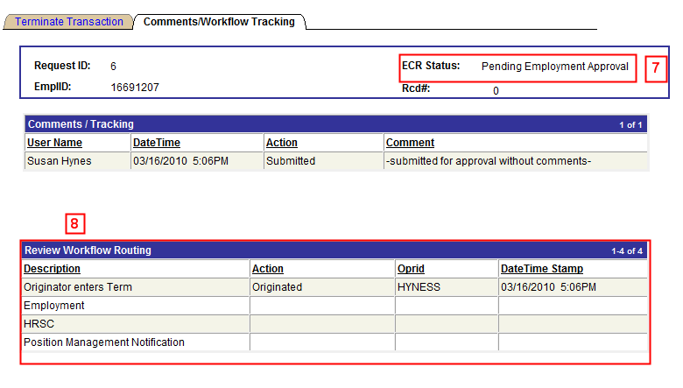

7. At any point during the workflow, the originator or approver can use the Inquiry page to determine where the termination request is in the process. The ECR Status field is one indicator to determine where the request currently resides.

8. The Workflow Routing path is also an indicator with additional detail. It will display the location of the request, the Action and Oprid for each approval step already processed and the Date/Time Stamp of approval.
Canceling an ECR Termination Transaction Request

Home > Employee Change Request (ECR) > Inquire > ECR Inquire

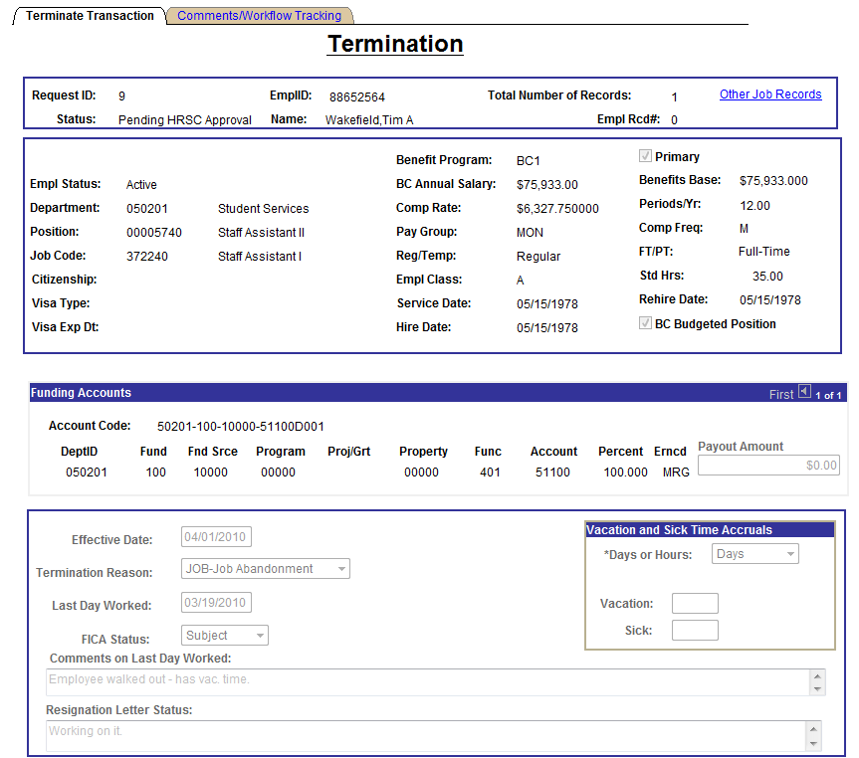
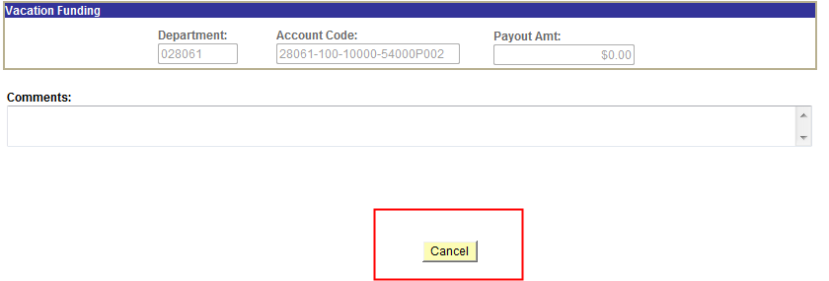

- The Originator is the only one who can cancel an ECR Termination Request.

- A termination request can be cancelled at any point during the approval process before the status is updated to ‘Completed’.

- Select ‘Cancel’ at the bottom of the Inquiry Page.

- Confirm the status has been updated to ‘Cancelled’.

- Upon cancellation, an email notification is sent to the pending approver and prior approvers indicating the transaction has been cancelled.

Approve/Deny an ECR Termination Transaction Request

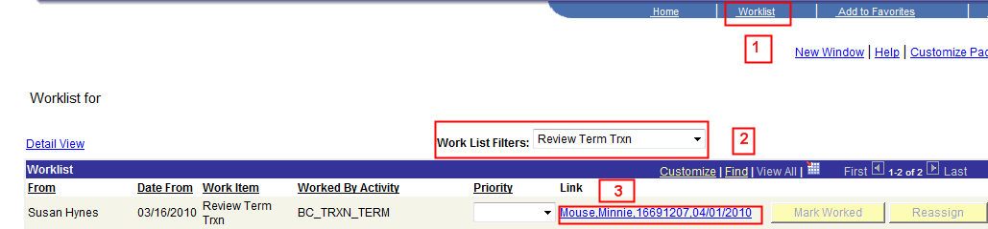

1. An approver has the option to go through his worklist to view any termination transactions or through ECR > Inquiry to get to the transaction.

2. The worklist allows the user to filter on the different transactions that come through the worklist. The Termination Transaction filter name is ‘Review Term Trxn’. This will display only those items under the selected filter.

3. Each worklist item is defined within a link that displays the employee’s name, eagle ID and effective date of the termination. Click on this link to go directly to the transaction page and review the information.

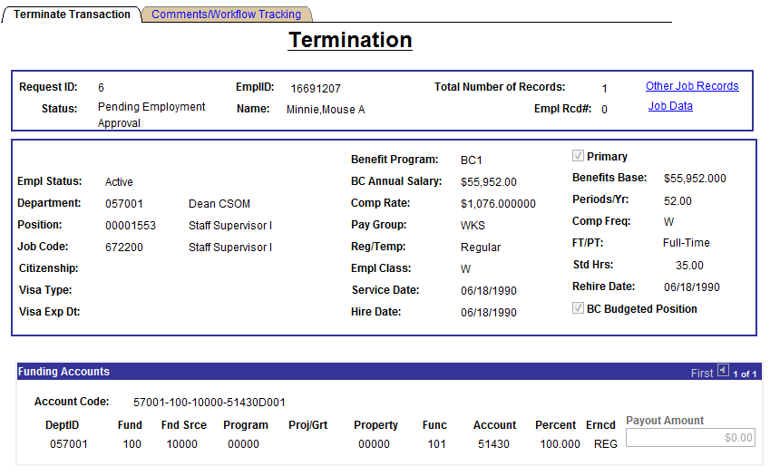
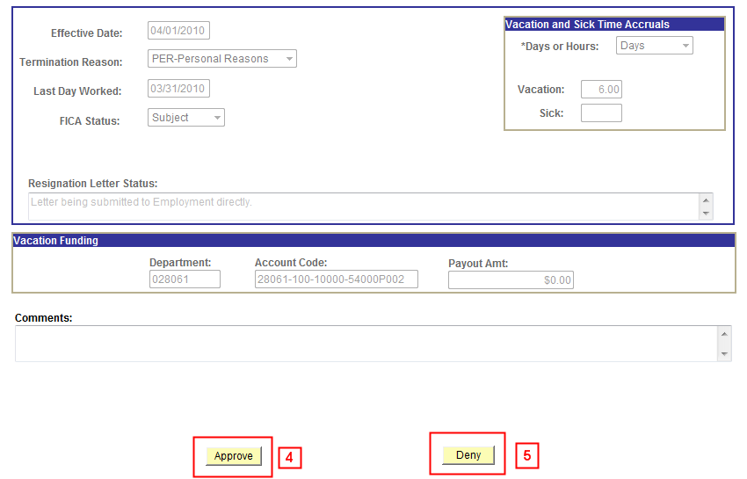

4. If the termination information provided is accurate, the approver will click ‘Approve’ to advance the workflow to the next approver on the list. The workflow tab indicates the route and where it is in the process. It will reflect updated information after each step.

5. If the termination information is not correct for any reason, the approver has the option to deny the request. This will send a notification email and the request directly back to the originator with a required comment as to why it has been denied. The originator has the option to re-submit the request or to cancel the request.

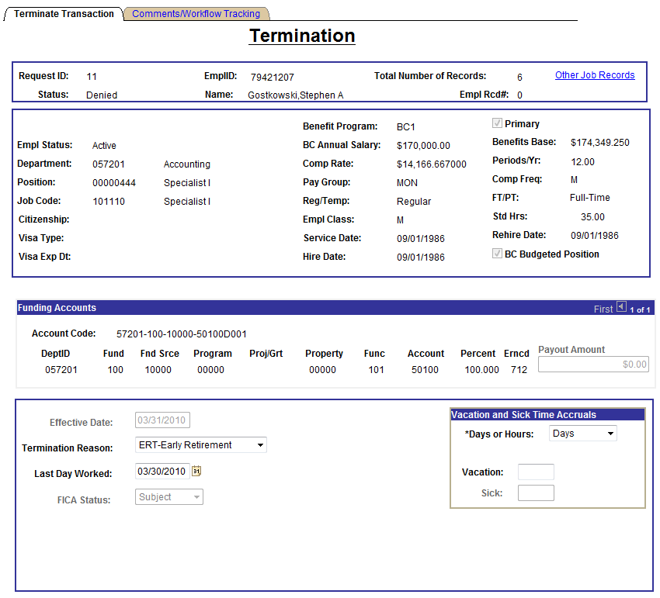
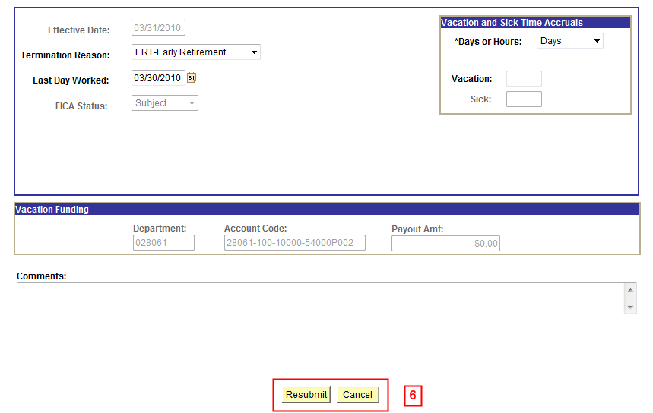

6. If a request is denied, the originator can make changes to the request and Resubmit it or Cancel the request.

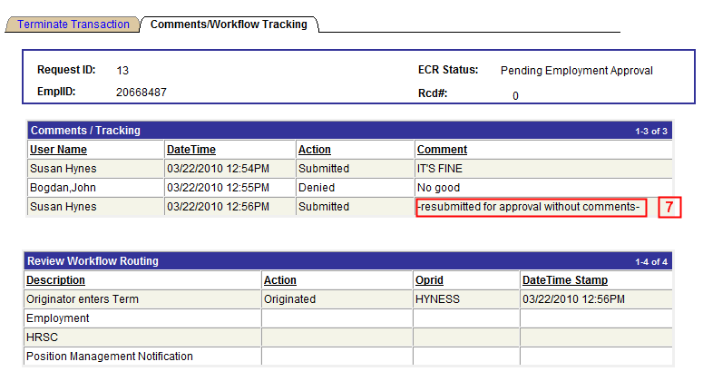

7. When a request is resubmitted, the workflow will readjust according to the changes made and begin the routing cycle again. It will display all activity pertaining to the request, including the resubmission through to completion.

