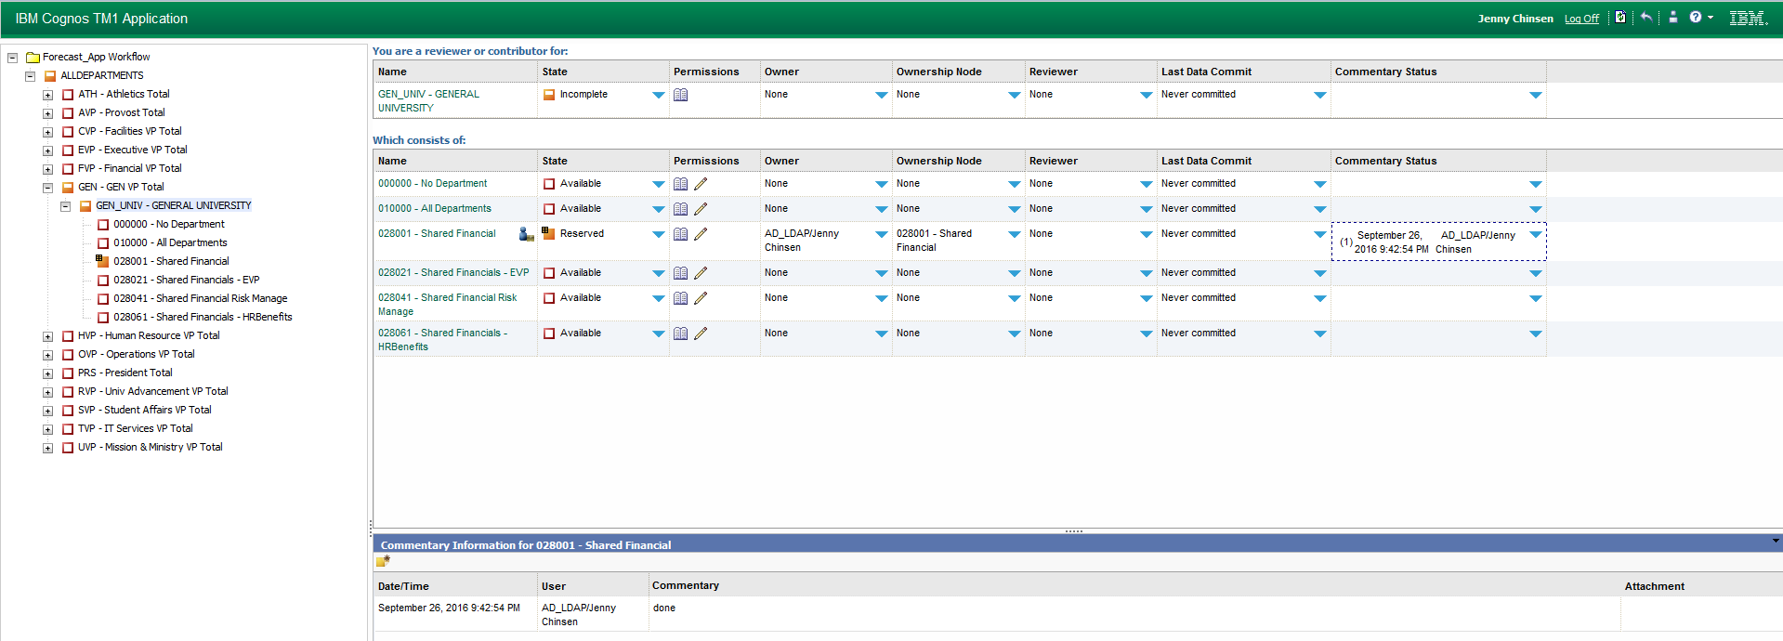
5
3
2
4
5
1
- Navigate up and down the department tree to find department id.
- Summary consolidation - view reports at this consolidation
- Release Ownership – allow others to commit their inputs
- Identify who currently working on a department
- Comments available to users
  - Select Blue Triangle
  - Click Yellow note pad
  - Type comment into popup window and attach file if desired

