TM1 Forecast Applications – Step by step guide

Purpose:
Highlights: Users input the current year actuals forecast.

STEPS:
- Login to TM1 Application
  - Open Browser (preferred Mozilla)
  - Type in url: http://badger.bc.edu:9510/pmpsvc/applications.jsp
  - Enter your LDAP login user id and password
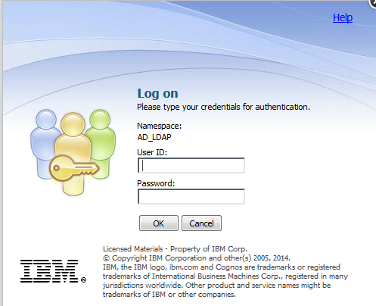

  - Click “Continue” to bypass security warning.
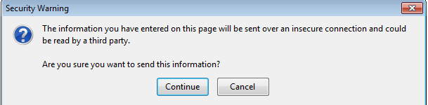

- Select your Forecast APP to work on 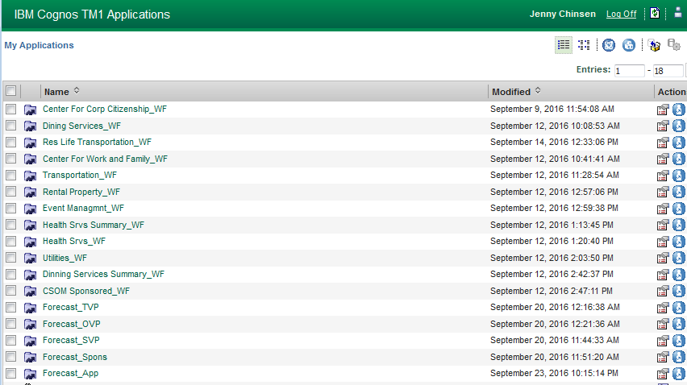

- Expand Department Tree on left to navigate to select department to input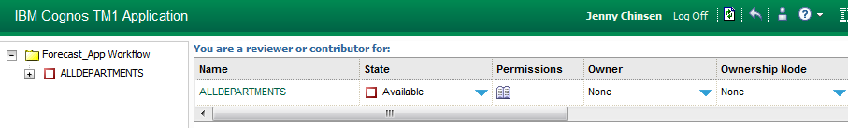

- Click on desired department on the right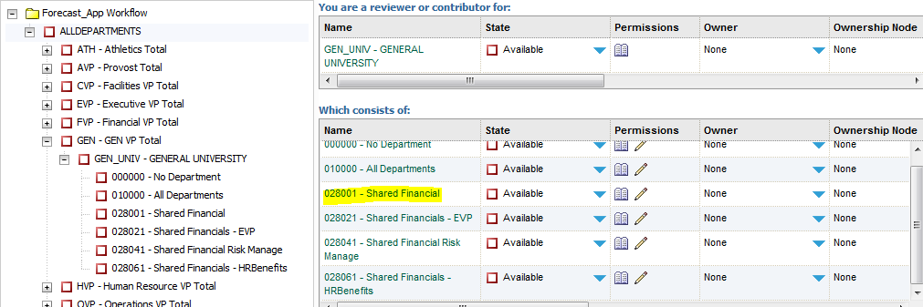

- New window will open with input schedule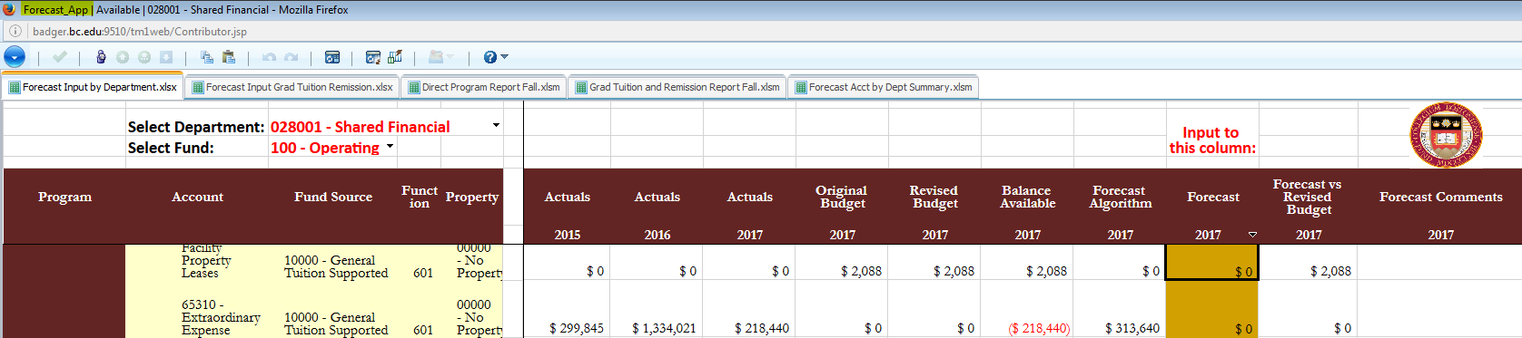
- Take control of the ownership of the App by clicking on 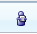 from the TM1 menu bar

- Columns available for input are the Forecast and Forecast Comments
  - Inputs will be in blue until they have been committed
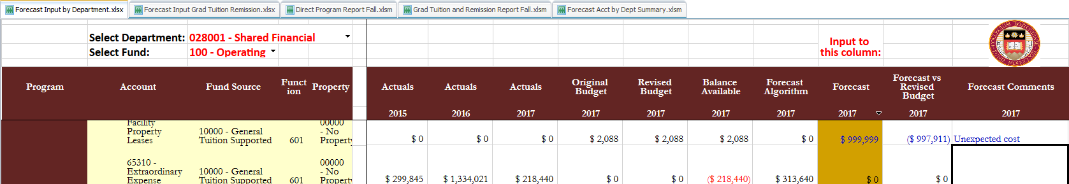
- Uncommitted inputs will flow to summary reports

- Commit entered numbers by clicking on from the TM1 menu bar

- Print Reports (can be done under ownership or not)
  - Click on the TM1 menu item 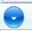
  - Navigate to Export\Snapshot to Excel
  - In the popup window, click ok
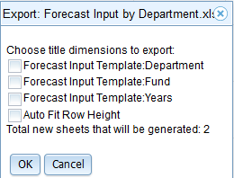
  - Select your option to open or save the file in the next popup window. 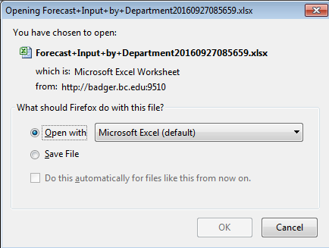
  - File can be saved and used like any other excel file. (No connection to TM1 exists. Any modification done to the file will be independent from the TM1 system)

- Once input has been complete, release Ownership from the My Application page.
  - Click on icon
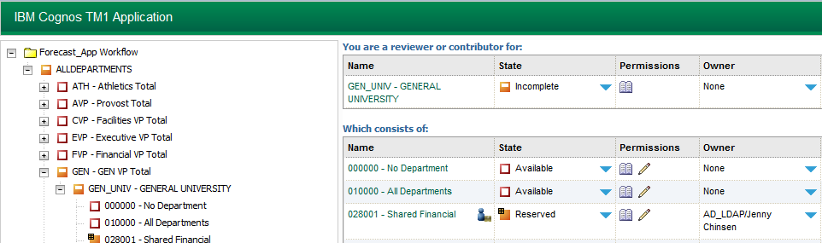
  - Confirm that you want to release ownership in the popup window. 