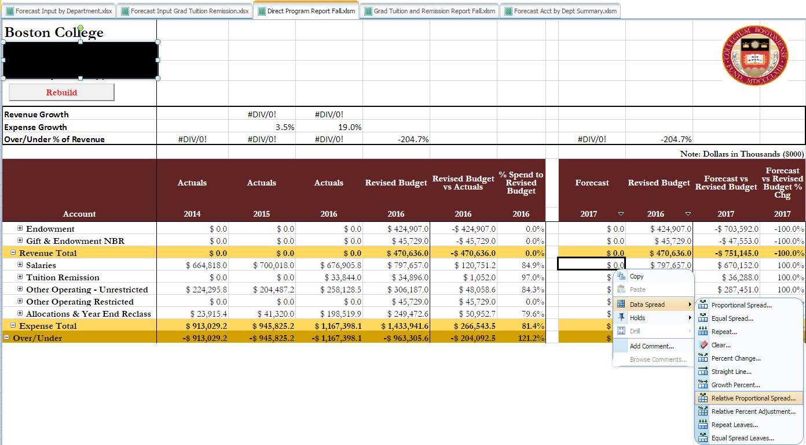
- Right click on cell intersection
- Navigate to desired spread calculation
  - Example: Relative Proportion Spread
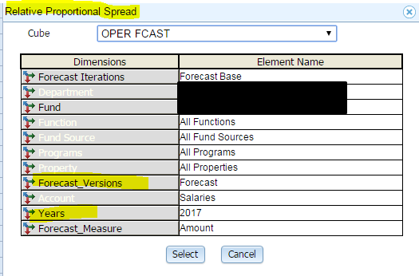

  - Click on desired Dimension: Forecast Versions and/or year
  - Select element to base spread
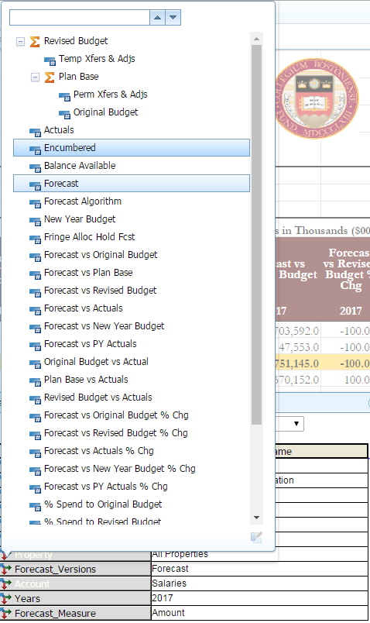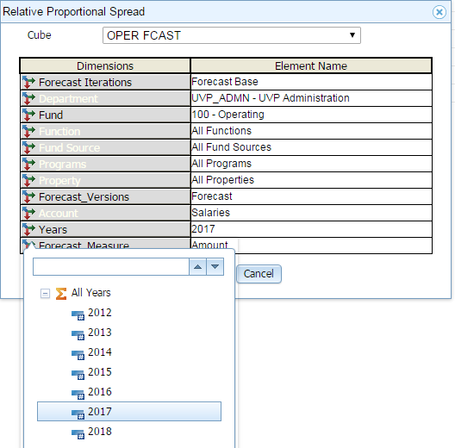
  - Click Select button
  - Confirm value in next popup window and apply
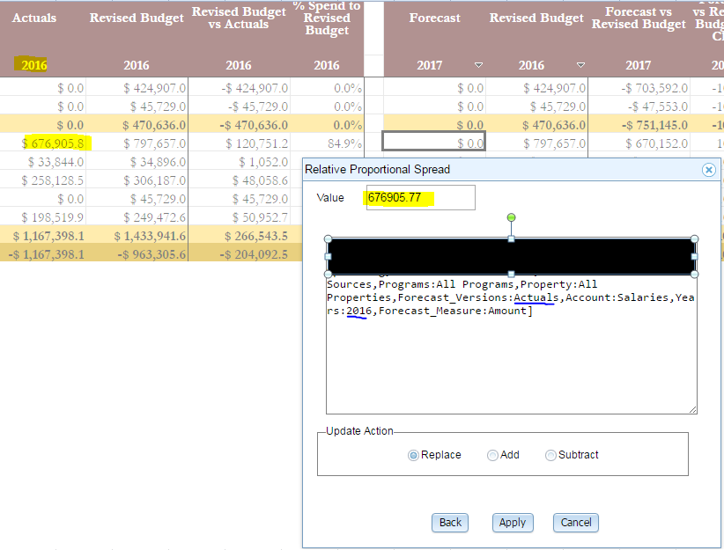
  - Confirm Results 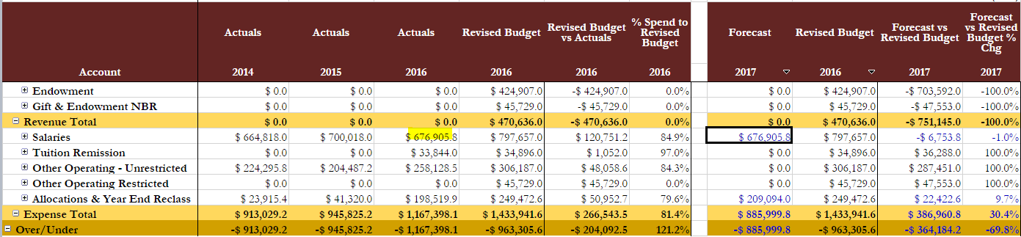
  - Example: Relative Percent Adjustment
  - Follow steps b-d
  - Confirm value in next popup window
  - Input desired % increase (e.g. 2.5% over 2016 Actuals) and click apply
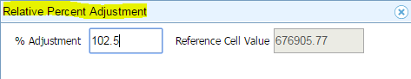
  - Confirm Results
