**Faculty Annual Report Guide: Grants**

Contents

Grants Overview 2

Grants Section A: Input Form (Required) 3

Grants Section B: Dates and Funding Periods (Required) 5

Grants Section C: Funded Amounts (Required) 6

Grants Section D: Activity Classifications (Required) 7

Grants Section E: Attachments (Optional) 8

Tagging a Grant Activity with a Semester and Year 9

Managing Grant Activity Status 10

# Grants Overview

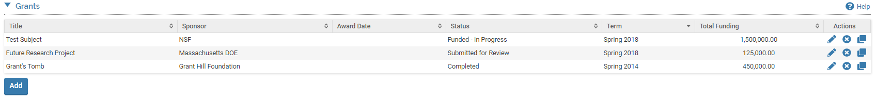

The Grants Form enables you to record research, teaching, service, or other types of grants that have been drafted, submitted, or funded. To report a grant, click on the button.

Any previously created Grants will also be listed and you can edit, delete, or duplicate any of the previously created Grants.

# Grants Section A: Input Form (Required)

***Appearance***

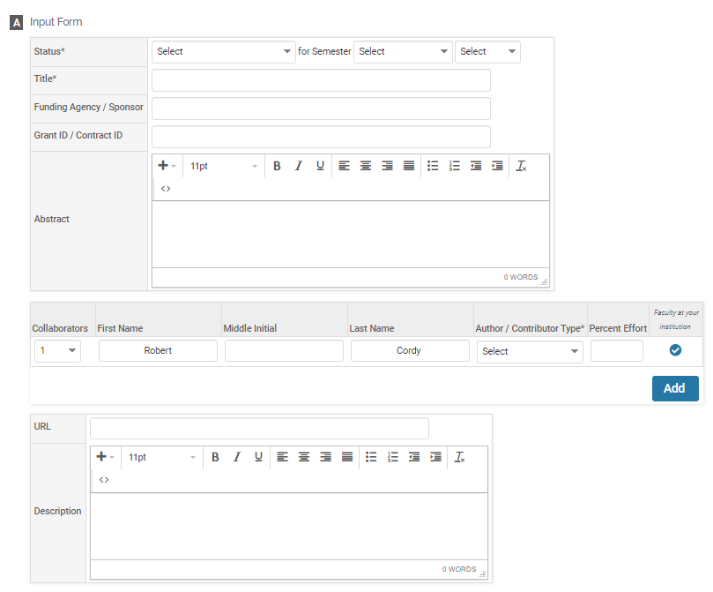

***Editing***

All asterisked (*) fields are required. If any are incomplete, then you will not be able to save your changes.

Required: Specify the Status and Title of the grant. See page 9 for more information on tagging a grant activity with a semester and year.

For all collaborators, including yourself, you must indicate the collaborator’s role:

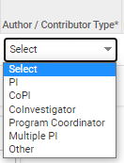

Optional: Funding Agency / Sponsor, an ID number for the grant, an Abstract, URL, Description, or your collaborators on the grant.

# Grants Section B: Dates and Funding Periods (Required)

***Appearance***

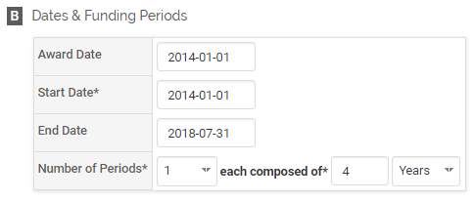

***Editing***

Required: Specify the Start Date and the duration of the grant in Number of Periods and the type of periods (years or months). Most often, faculty enter 1 period and specify the number of years the grant was funded.

Optional: You may also enter the award date and the end date for the grant.

Rather than manually entering the dates for Award Date, Start Date, or End Date, you can use the pop-up calendar that appears when you click in each field:

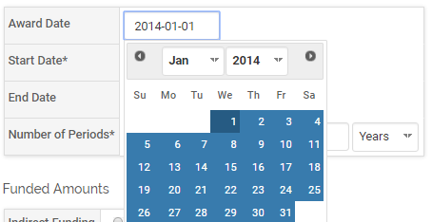

# Grants Section C: Funded Amounts (Required)

***Appearance***

***Editing***

Required: Specify the Total Funding amount. If you have more than one funding period, you will need to enter the total funding for each row. Additional rows are created when you enter more than one funding period in Section B. The Total row is automatically calculated.

Optional: Indirect Funding, Currency (USD is default), Start Data, End Date.

# Grants Section D: Activity Classifications (Required)

***Appearance***

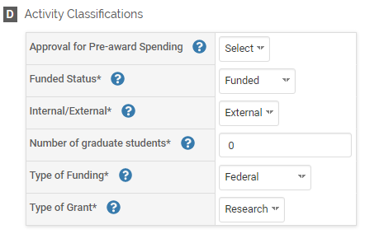

***Editing***

Required: Specify the Funded Status, Internal/External, Number of Graduate Students, Type of Funding, Type of Grant.

Optional: Approval for Pre-Award Spending (Yes/No).

# Grants Section E: Attachments (Optional)

***Appearance***

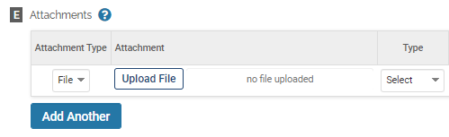

**OR**

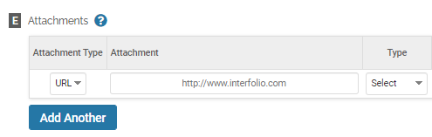

***Editing***

Optional: You can upload file attachments or provide a URL relevant to the grant, such as the grant proposal.

# Tagging a Grant Activity with a Semester and Year

For each grant activity, you must (1) select a status and (2) tag it by semester and year. This is how it is pulled into your Faculty Annual Report (e.g., a grant tagged Fall 2018 will show up in your 2018 FAR).

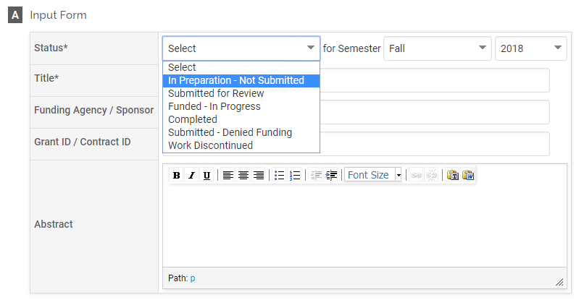

Tagging by semester and year is different from the year the activity started and ended. For example, Section B for **Grants** allows you to specify a start and end date.

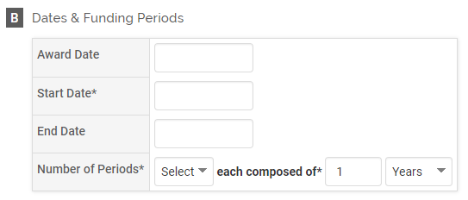

# Managing Grant Activity Status

Rather than duplicate a grant activity each time its status changes, simply change the status of the previously created grant activity using the  button then the  button. The  button only appears for grant activities previously entered.

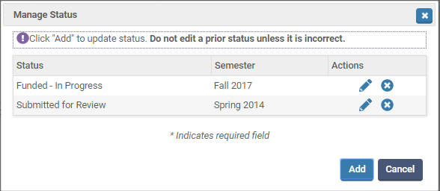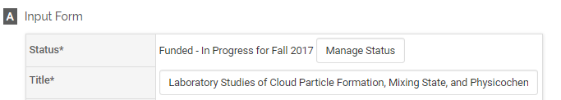

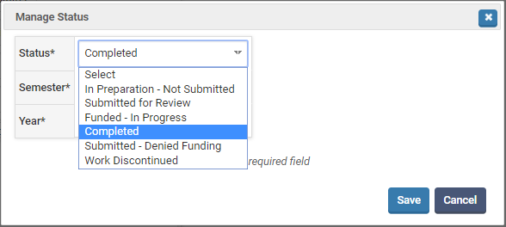

For example, this grant shows two statuses, first Submitted for Review during Spring 2014, then Funded – In Progress in Fall 2017.

