**Faculty Annual Report Guide: Teaching**

Contents

Teaching Overview 2

Teaching Section A: Course Information (Optional) 3

Teaching Section B: Activity Classifications (Optional) 4

# Teaching Overview



The Teaching Form enables you to add description to the courses you teach. Courses are imported into the system from Student Services data, so you cannot manually add or remove courses listed. If you believe there is an error (e.g., missing courses) please email [bcfarhelp@bc.edu](mailto:bcfarhelp@bc.edu)

For each course listed, use the edit button  to add information about the course.

# Teaching Section A: Course Information (Optional)

***Appearance***



***Editing***

Because course information is imported for you from Student Services, no action is required on the Course Information section unless you need to mark a course not taught because it is incorrectly listed.

# Teaching Section B: Activity Classifications (Optional)

***Appearance***

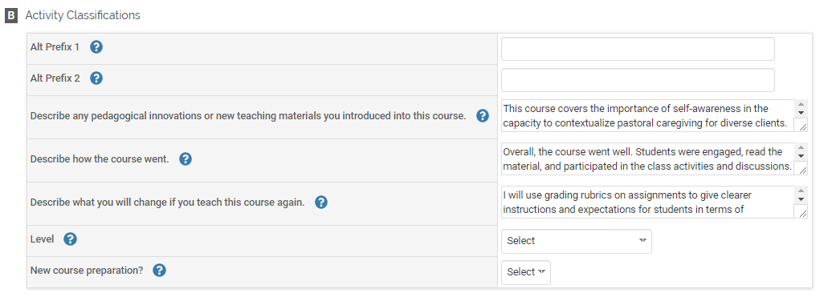

This semester I introduced new interactive modules for students to complete through Canvas. Instead of requiring

The course went well. The students were engaged and thanked me after the last class for the challenging assignments..

If I were to teach this course again, I would switch out the following readings:

***Editing***

Optional: You may describe how the course went, any new changes to the course, and what you would change if taught the course again. You can classify the course as new (Yes/No) or identify the level of the course:

