**Faculty Annual Report Guide: Profile**

Contents

Profile Overview 2

Current Position (Optional) 3

Personal Information (Optional) 4

Interests (Optional) 5

Degrees (Optional) 6

Professional Licensures & Certifications (Optional) 7

Work Experience (Optional) 8

Membership (Optional) 9

Attachments 10

# Profile Overview

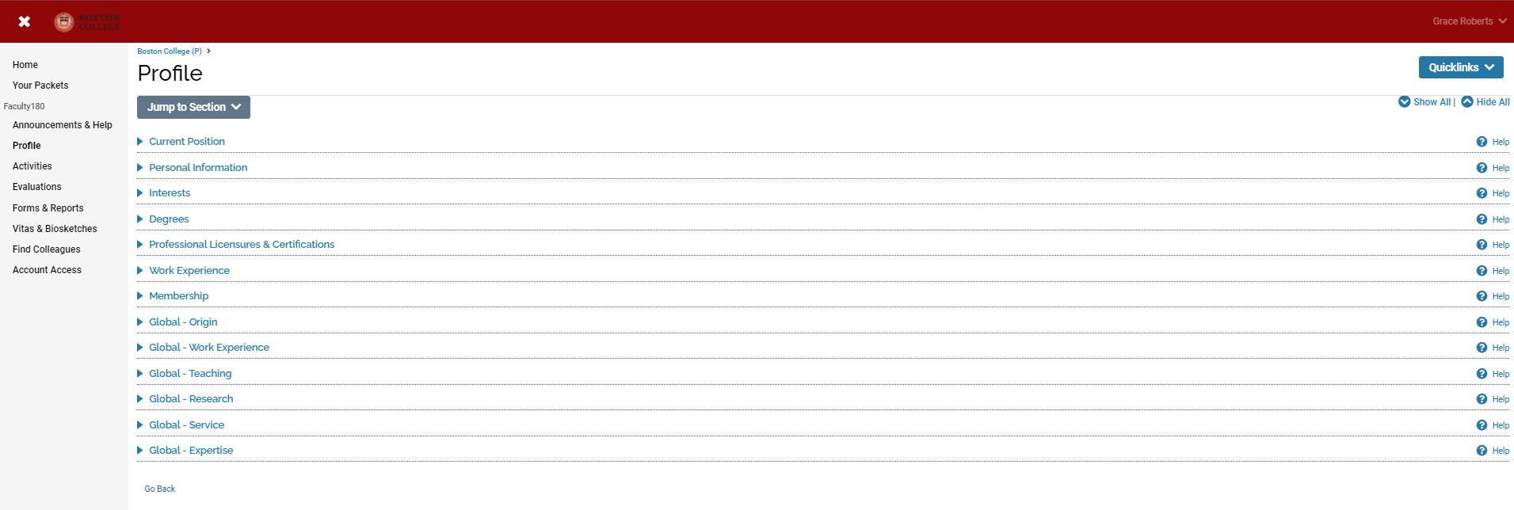

The Profile Form is used to input personal data that tends to remain static over time, such as contact information, degrees, credentials, and work experience. Faculty members can update their profile at any time, except for locked fields that come from institutional databases (e.g., first name).

Faculty members can attach transcripts to their degrees in the Degrees section on the Profile Form. The transcripts can then be viewed and deleted as necessary. Administrators can also attach official transcripts to faculty degrees; however, the transcripts are only viewable in limited circumstances as determined by your institution, such as during the use of accreditation reports.

For detailed information on updating Global Profile sections, please see the [“Profile – Global” Faculty Annual Report Guide](https://www.bc.edu/content/dam/files/offices/avp/pdf/FAR%20guide%2002A%20-%20Profile%20-%20Global%20Engagement%20FINAL-1.pdf).

# Current Position (Optional)

***Appearance***



***Editing***

This information comes from Human Resources and cannot be changed through the system. You might have multiple positions listed. If the information listed is incorrect, please email [bcfarhelp@bc.edu](mailto:bcfarhelp@bc.edu).

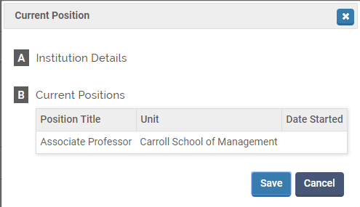

# Personal Information (Optional)

***Appearance***

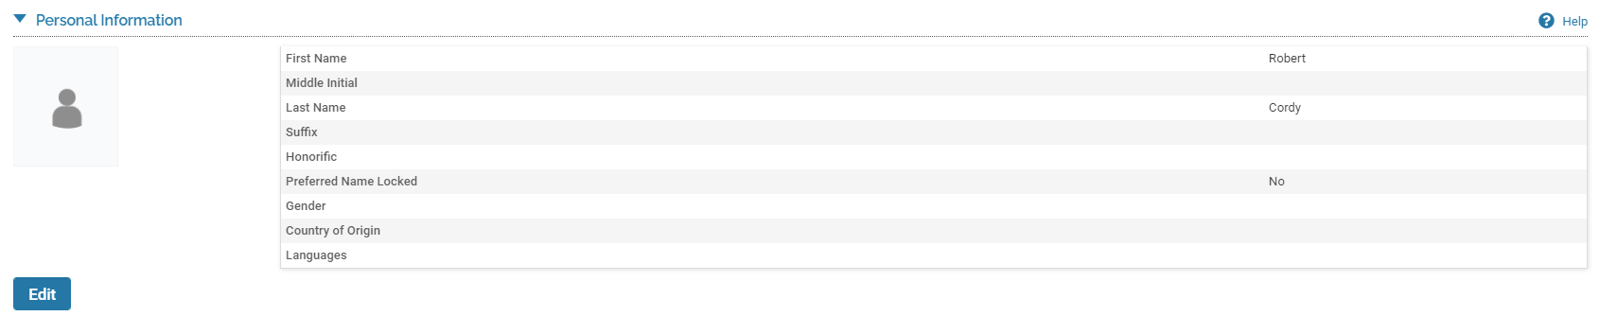

***Editing***

In this section you can update your Gender, Country of Origin, Languages, or your picture by using the blue circle with a plus sign. Your Name comes from Human Resources records and cannot be changed directly through the system.

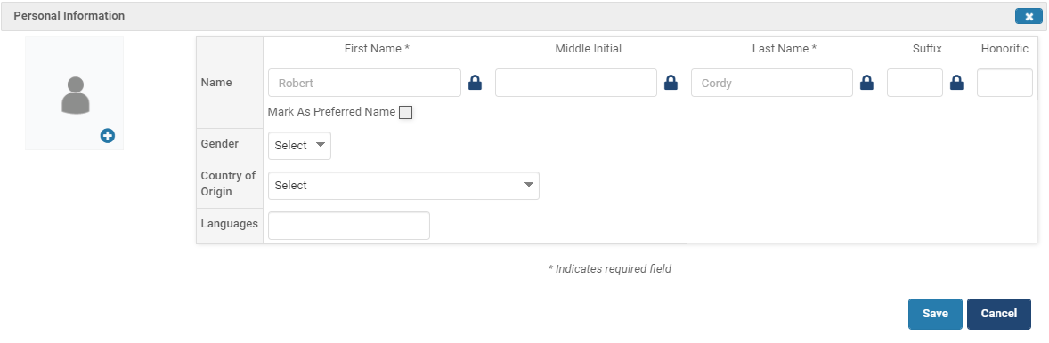

# Interests (Optional)

***Appearance***



***Editing***

Optional: Teaching Interests and Research Interests, which are searchable by faculty who use the Find Colleagues tool in Interfolio.

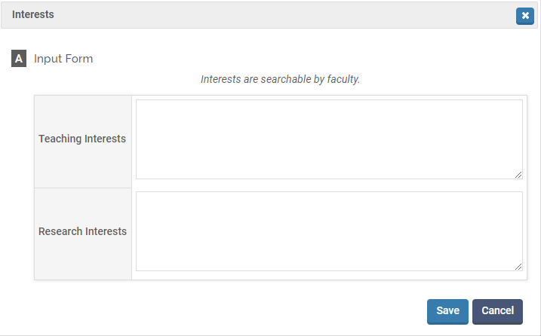

# Degrees (Optional)

***Appearance***



***Editing***

Optional: Academic degrees.

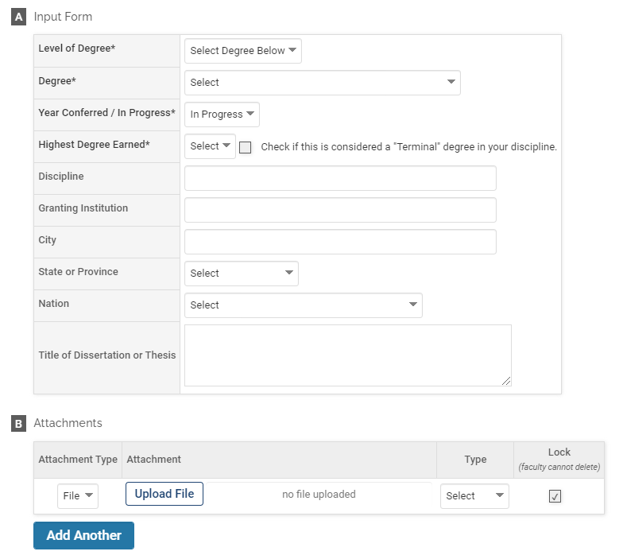

# Professional Licensures & Certifications (Optional)

***Appearance***

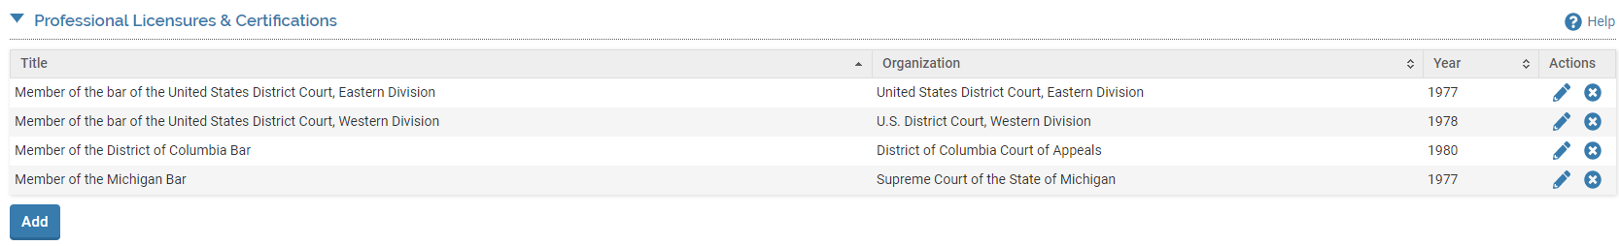

***Editing***

Optional: Professional licensures and certifications.

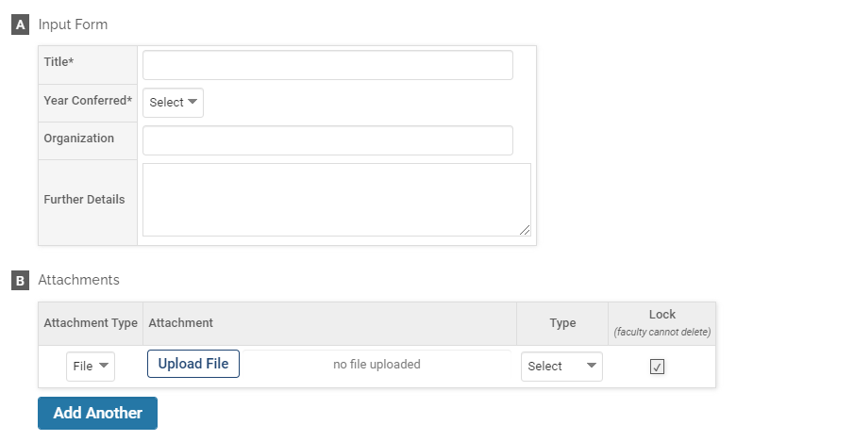

# Work Experience (Optional)

***Appearance***

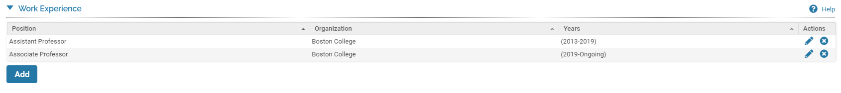

***Editing***

Optional: Previous employment.

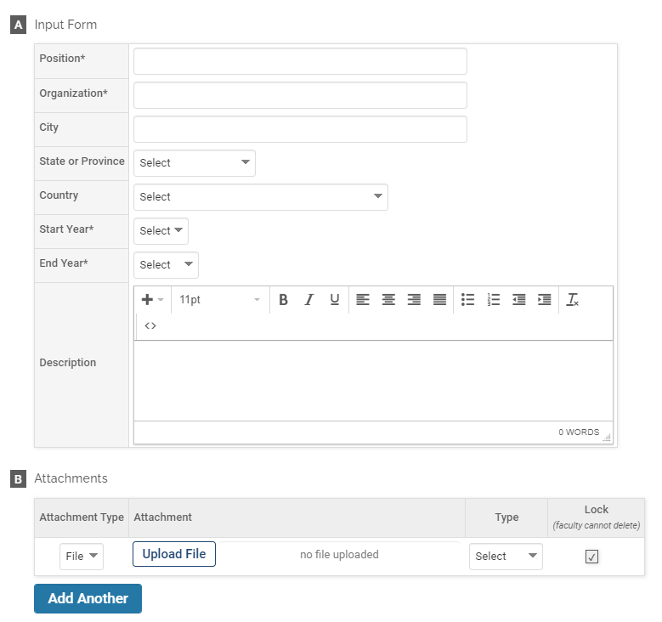

# Membership (Optional)

***Appearance***

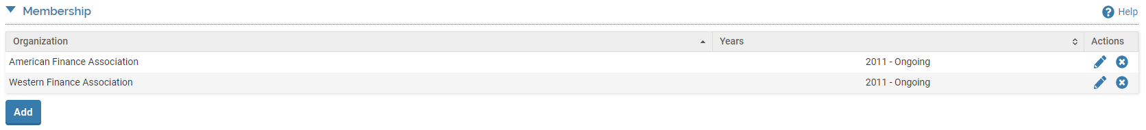

***Editing***

Optional: Organizational memberships, whether they are ongoing or have ended.

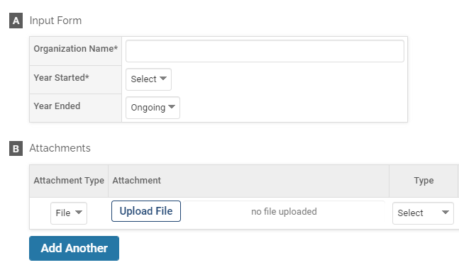

# Attachments

When given the opportunity to include an attachment in the Profile section, you have the option to attach an electronic file or provide a URL.

***Appearance***

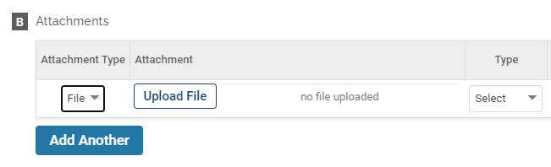

***OR***

