**Faculty Annual Report Guide**

Table of Contents

NAVIGATION 6

Accessing Interfolio through Agora Portal 7

Home Page 8

Accessing Activities 9

Navigation Buttons 12

Fields 15

PROFILE 16

Profile Overview 17

Current Position (Optional) 18

Personal Information (Optional) 19

Interests (Optional) 20

Degrees (Optional) 21

Professional Licensures & Certifications (Optional) 22

Work Experience (Optional) 23

Membership (Optional) 24

Attachments 25

PROFILE - GLOBAL 26

Global Overview 27

Global – Navigation 28

Global – Adding and Editing Entries 30

TEACHING 36

Teaching Overview 37

Teaching Section A: Course Information (Optional) 38

Teaching Section B: Activity Classifications (Optional) 39

Teaching Section C: Attachments (Optional) 40

ADVISING 41

Advising Overview 42

Advising Section A: General (Required) 43

Advising Section B: Undergraduate Students (Optional) 44

Advising Section C: Masters Students (Optional) 45

Advising Section D: Doctoral Students (Optional) 46

Advising Section E: Attachments (Optional) 47

Tagging Advising Activity with a Semester and Year 48

STUDENT SUPERVISION 49

Student Supervision Overview 50

Student Supervision Section A: Input Form (Required) 51

Student Supervision Section B: Attachments (Optional) 52

Tagging Student Supervision Activity with a Semester and Year 53

SCHOLARLY CONTRIBUTIONS AND CREATIVE PRODUCTIONS 54

Scholarly Contributions and Creative Productions Overview 55

Scholarly Contributions and Creative Productions: Manual Input and Import 56

Manual Input 56

Import 57

Scholarly Contributions and Creative Productions Section A: Input Form (Required) 58

Scholarly Contributions and Creative Productions Section B: Activity Classifications (Required) 60

Scholarly Contributions and Creative Productions Section C: Attachments (Optional) 61

Tagging Scholarly Contributions and Creative Productions with a Semester and Year 62

Managing the Status of a Scholarly Contributions and Creative Productions 63

GRANTS 64

Grants Overview 65

Grants Section A: Input Form (Required) 66

Grants Section B: Dates and Funding Periods (Required) 68

Grants Section C: Funded Amounts (Required) 69

Grants Section D: Activity Classifications (Required) 70

Grants Section E: Attachments (Optional) 71

Tagging a Grant Activity with a Semester and Year 72

Managing Grant Activity Status 73

SERVICE 74

Service Overview 75

Institutional Committee Service Section A: Input Form (Required) 77

Institutional Committee Service Section B: Activity Classifications (Required) 79

Institutional Committee Service Section C: Attachments (Optional) 80

Other Institutional Service Section A: Input Form (Required) 81

Other Institutional Service Section B: Activity Classifications (Required) 83

Other Institutional Service Section C: Attachments (Optional) 84

Professional Service Section A: Input Form (Required) 85

Professional Service Section B: Activity Classifications (Required) 87

Professional Service Section C: Attachments (Optional) 89

Community Service Section A: Input Form (Required) 90

Community Service Section B: Activity Classifications (Required) 92

Community Service Section C: Attachments (Optional) 94

Tagging a Service Activity with a Semester and Year 95

FACULTY DEVELOPMENT ACTIVITIES ATTENDED 96

Faculty Development Activities Attended Overview 97

Faculty Development Activities Attended Section A: Input Form (Required) 98

Faculty Development Activities Attended Section B: Dates (Optional) 100

Faculty Development Activities Attended Section C: Attachments (Optional) 101

Tagging Faculty Development Activity Attended with a Semester and Year 102

CONSULTING 103

Consulting Overview 104

Consulting Section A: Input Form (Required) 105

Consulting Section B: Attachments (Optional) 106

Tagging a Consulting Activity with a Semester and Year 107

NARRATIVE 108

Narrative Overview 109

Narrative Section A: Input Form (Required) 110

Narrative Section B: Attachments (Optional) 112

Tagging a Narrative with a Semester and Year 113

HONORS 114

Honors Overview 115

Honors Section A: Input Form (Required) 116

Honors Section B: Attachments (Optional) 117

Tagging an Honor or Award with a Semester and Year 118

PREVIEWING AND SUBMITTING YOUR REPORT 119

Previewing and Submitting Your Report Overview 120

Previewing Your Report: Option 1 121

Previewing Your Report: Option 2 124

Submitting Your Report 127

Appendix A: Types of Scholarly Contributions and Creative Productions 128

Appendix B: Importing Scholarly Contributions and Creative Productions 130

Import via Generic (RIS / BibTeX) Bibliographic File 130

Import via Medline/Pubmed 132

Import via Web of Science 133

Import via ORCID 134

# NAVIGATION

## Accessing Interfolio through Agora Portal

1. Log into Agora Portal.
2. Click on **Faculty Annual Reports** under *Academics and Courses*.

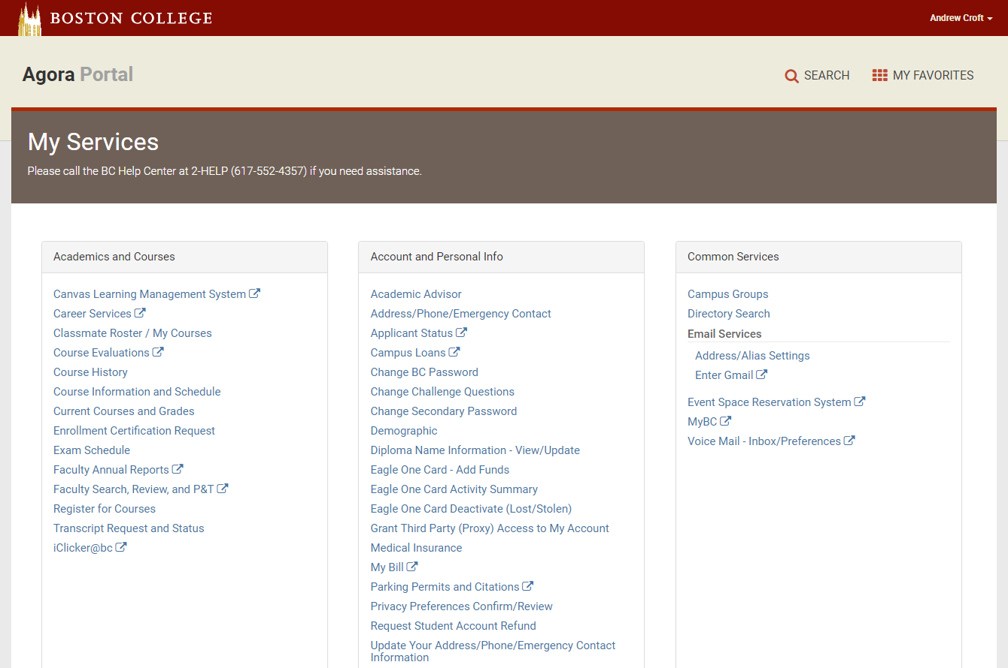

## Home Page

*Note*. The menu on the left shows only the Faculty180 menu for FAR, but you will also see an additional menu for Faculty Search in your account.

 will close the left-side menu and  will open it again.

This is the main navigation menu.

**Home** brings you to the page shown.

**Announcements & Help** includes Interfolio Announcements, Institutional Announcements, and Institution FAQ’s.

**Profile** contains demographic information about yourself and your educational and work experiences.

**Activities** are where you enter your yearly activities and accomplishments (e.g., advising).

**Evaluations** is for department chairs and deans to review submitted FARs and leave requests.

**Forms & Reports** allows you to find current reports to complete and past reports completed, e.g., COI/COC and FAR forms. It also allowsyou to create customized reports of your activities.

**Vitas & Biosketches** allows you to print standardized CVs and FARs, and link to your ORCID account.

**Find Colleagues** allows you to find colleagues at Boston College.

**Account Access** enables you to delegate account access to other users.

**My Tasks** lists tasks in your queue.

## Accessing Activities

There are two ways to input your Activities.

1. Action Item on your Home page: Click **20XX Faculty Annual Report** (note the year will be updated annually).

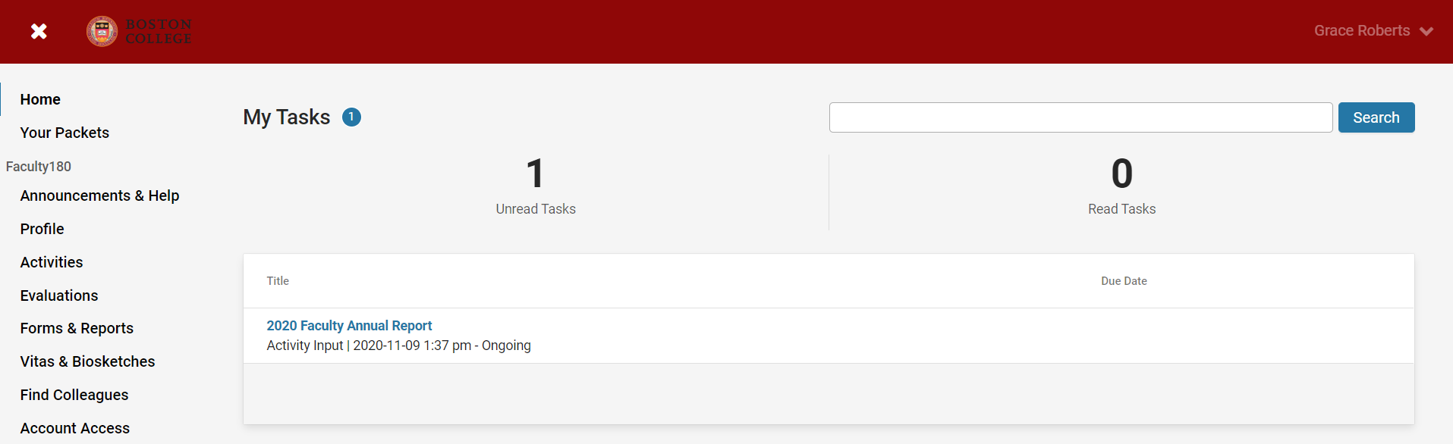

This will take you to the current **20XX Faculty Annual Report** page (also listed under **Forms & Reports** on the left-side menu), which lists all the activities you may wish to add or update for the calendar year report. Note that this view will only list all activities covered by the current year’s **Faculty Annual Report**. To view all your previously input activities, follow option 2 (on p. 11) below.

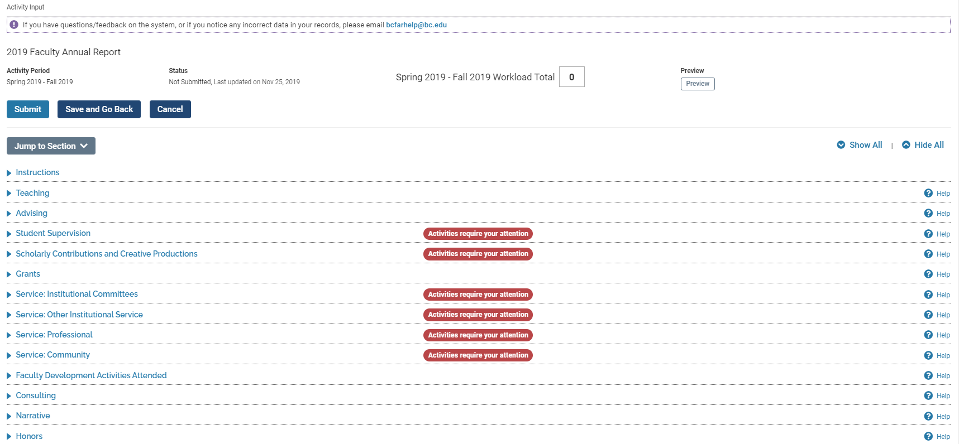

Courses taught for the (calendar) year will be prepopulated under the **Teaching** section. Unless you have been adding activities that have a ***start***and ***end semesters*** covered by the current year, the rest of the sections will be empty. Sections that have a red “**Activities Require Your Attention”** indicate that previously reported activities have an *Ongoing* end semester and need to be updated to reflect an end period or require confirmation that the activity remains ongoing.

1. A second way to input activities is through the **Activities** section on the left-side menu. Using this method to access activities allows you to view all the activities you have previously entered in the system and not just the current year. This access is available throughout the year, and allows you to input activities as they occur or end without waiting for the yearly Faculty Annual Report.

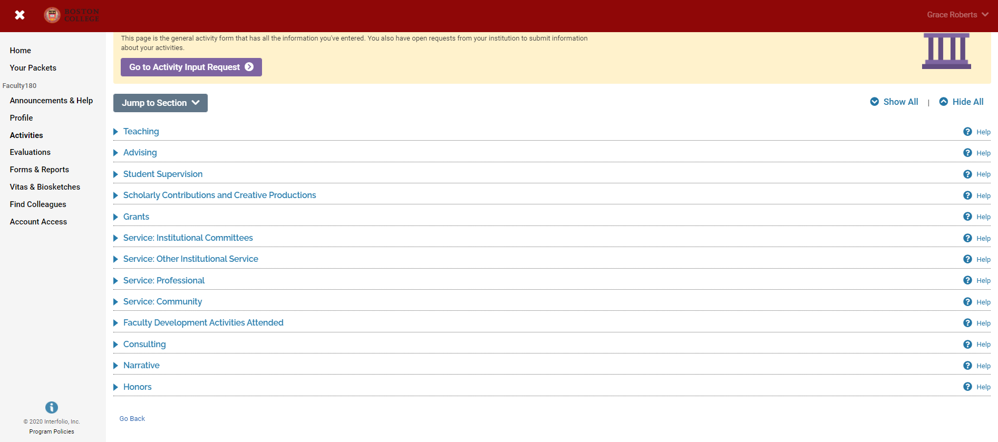

## Navigation Buttons

|  |  |  |
| --- | --- | --- |
| **Name** | **Icon / Button** | **Function** |
| Activity Actions |  | The edit button  allows you to edit an item on a row.  The delete button  removes an item in a row.  The duplicate button copies an item into a new row. |
| Add |  | Click to add a new activity. |
| Add Another Attachment |  | Click to add another attachment to an activity. |
| Collapse/Expand |  | A section is collapsed when the arrow is pointing to the right:  A section is expanded when the arrow is pointed downward: |
| Edit |  | Click to edit fields. |
| Export/Share |  | This allows you to export a report into a Word document or PDF. |
| Jump to Section |  | This menu lets you jump to a section instead of manually scrolling. It is a useful tool if the webpage is long. |
| Preview |  | Use this button to generate a PDF preview of your Faculty Annual Report (see section on Previewing and Submitting Your Report for additional information). |
| Print |  | This opens a new window to show you a print preview of your report. Use your browser’s print menu to print the report. |
| Quicklinks |  | This is a customized set of links in the system for you to jump to a section at anytime. You can also manage your list of Quicklinks. |
| Refresh Vita |  | Use this button to reload a report with updated information based on display options that you have changed. |
| Save and Cancel |  | Saves your information on that page but does not leave the page.  Saves your information on that page and brings you to a new blank page in that same category (e.g., another grant).*  Saves your information on that page and brings you back to the previous page.  Leaves that page without saving any new information. You will receive the following warning:  * This is different from the “Add Another Attachment” button described above. |
| Show All/Hide All |  | **Show All** will expand all sections on the page while **Hide All** will collapse all sections on the page. |
| Submit For Review |  | When you are ready to submit your Faculty Annual Report, you may click this button. The task prompt for your FAR will disappear from your **Home** Dashboard, but you may access activities anytime by using the left-side Activities menu (see p. 6). |
| View |  | Redirects to a new page with a report shown. |
| View All |  | Use this button to view all entries in a specific category. |

## Fields

Fields with an asterisk are required. For example, Start Date is required, but Award Date is not, in this example.

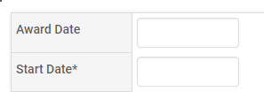

Instead of typing a date manually, you can select a date on the pop-up calendar:

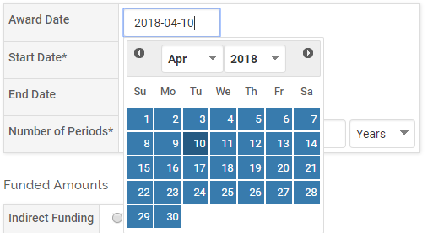

# PROFILE

## Profile Overview

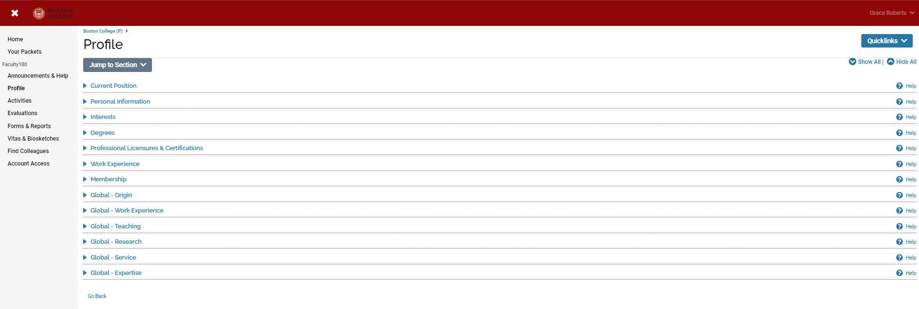

The Profile Form is used to input personal data that tends to remain static over time, such as contact information, degrees, credentials, and work experience. Faculty members can update their profile at any time, except for locked fields that come from institutional databases (e.g., first name).

Faculty members can attach transcripts to their degrees in the Degrees section on the Profile Form. The transcripts can then be viewed and deleted as necessary. Administrators can also attach official transcripts to faculty degrees; however, the transcripts are only viewable in limited circumstances as determined by your institution, such as during the use of accreditation reports.

For detailed information on updating Global Profile sections, please see the “Profile – Global” Faculty Annual Report Guide.

## Current Position (Optional)

***Appearance***



***Editing***

This information comes from Human Resources and cannot be changed through the system. You might have multiple positions listed. If the information listed is incorrect, please email [bcfarhelp@bc.edu](mailto:bcfarhelp@bc.edu)

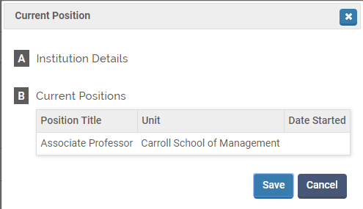

## Personal Information (Optional)

***Appearance***

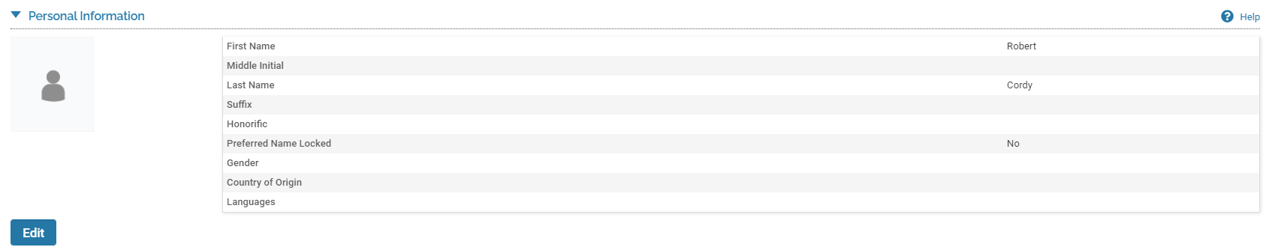

***Editing***In this section you can update your Gender, Country of Origin, Languages, or your picture by using the blue circle with a plus sign. Your Name comes from Human Resources records and cannot be changed directly through the system.

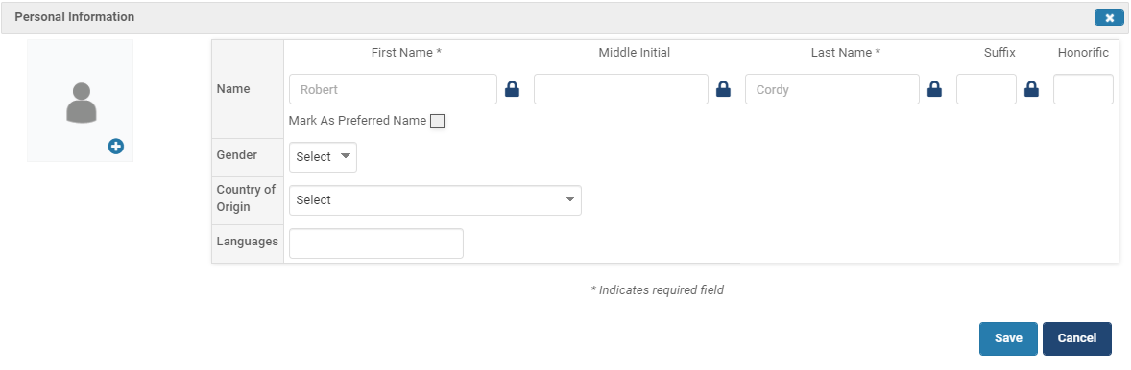

## Interests (Optional)

***Appearance***



***Editing***

Optional: Teaching Interests and Research Interests, which are searchable by faculty who use the Find Colleagues tool in Interfolio.

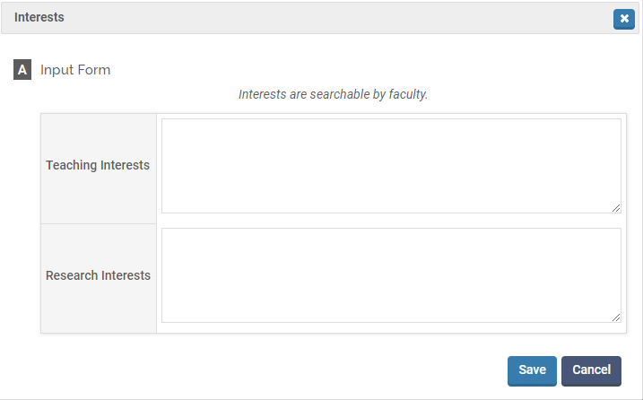

## Degrees (Optional)

***Appearance***



***Editing***

Optional: Academic degrees.

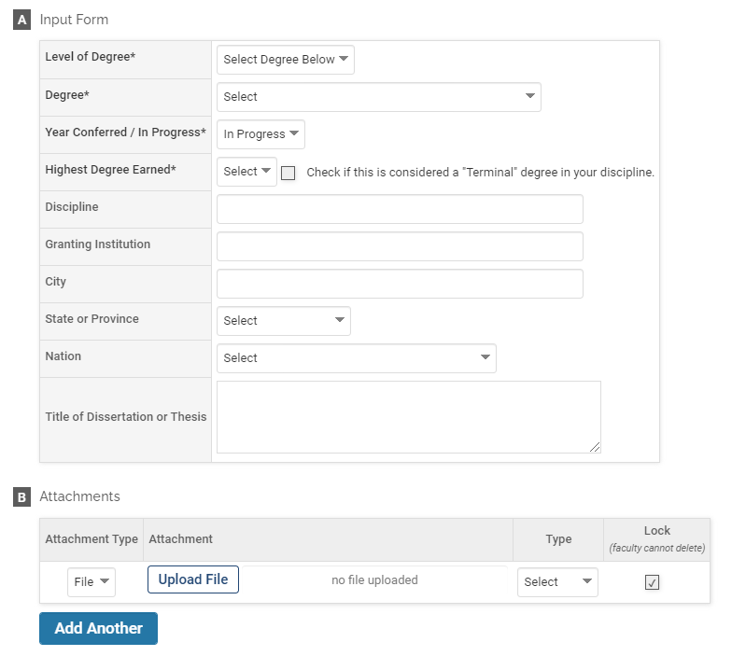

## Professional Licensures & Certifications (Optional)

***Appearance***

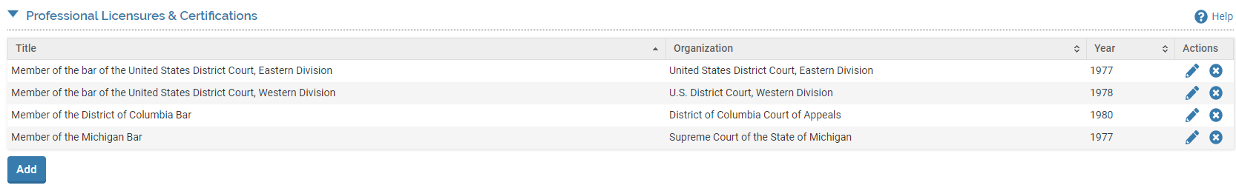

***Editing***

Optional: Professional licensures and certifications.

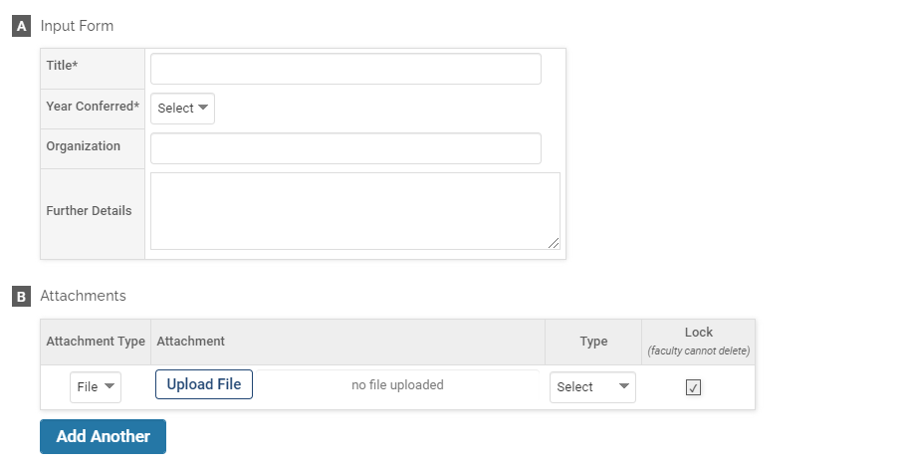

## Work Experience (Optional)

***Appearance***

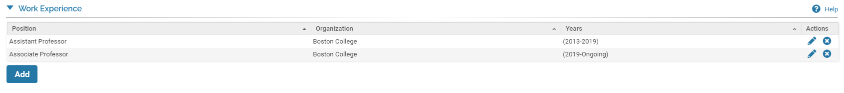

***Editing***

Optional: Previous employment.

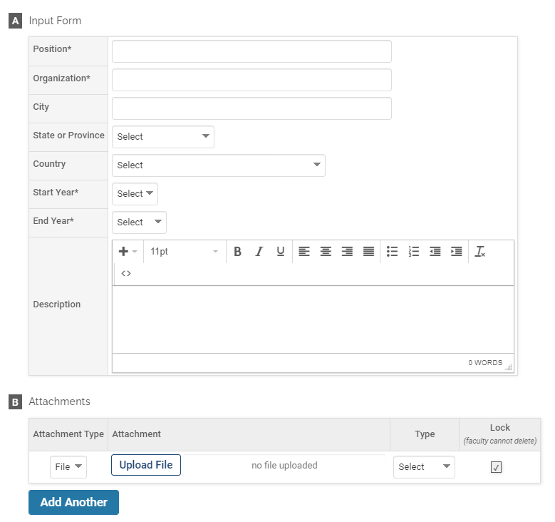

## Membership (Optional)

***Appearance***

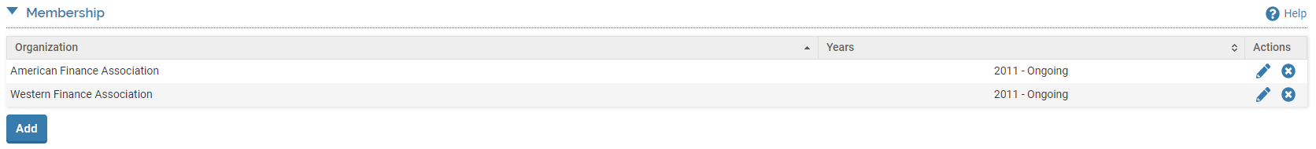

***Editing***

Optional: Organizational memberships, whether they are ongoing or have ended.

## Attachments

When given the opportunity to include an attachment in the Profile section, you have the option to attach an electronic file or provide a URL.

***Appearance***

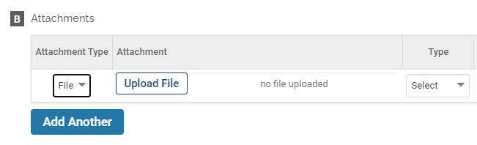

***OR***

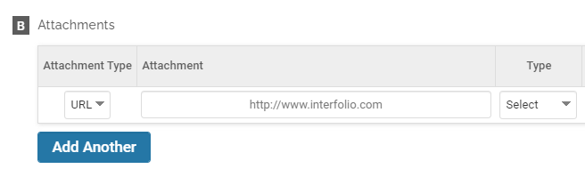

## 

# PROFILE - GLOBAL

## Global Overview

In an effort to promote global engagement, Boston College is setting up a system that will identify the global expertise and endeavors of our faculty on an interactive world map. The map will be posted on [BC’s global website](https://www.bc.edu/bc-web/sites/global-engagement.html) and will be accessible to both internal and external parties. Your participation is requested.

The goals of this interactive map are to help faculty and other parties identify colleagues engaged in the same countries or regions of the world, as well as identify areas of strengths and weaknesses in terms of international collaborations to help make informed decisions.

The only information we ask from you in this section is a list of the non-US *countries* or, if applicable, *regions,* of your background and professional experience. The categories you will be asked to enter country information include: Origin, Work Experience, Teaching, Research, Service, and Expertise. A guide for when to list a country in each category is provided in the table below. Specific details about your involvement in these various categories should be included in the appropriate section of the Faculty Annual Report (under the **Activities** section).

The information collected from the Global section (other than Origin) will feed into an interactive map that will list all faculty who mention the country or region based on one of the categories above. The faculty list will link to your individual faculty web profile. It is recommended, therefore, that you update your BC webpage to include your international activities.

|  |  |
| --- | --- |
| ***Origin*** | The country(ies) where you were born or raised. *Please note: information collected in the origin section will be used solely for internal purposes and will not be used as an input to the publicly viewable global map.* |
| ***Work Experience*** | Country(ies) in which you have worked. |
| ***Teaching*** | Country(ies) or region(s) of expertise in your teaching. Include here countries you have taught in or region-specific subject matter you have taught in class. You may also enter a country where you have been a director of a study abroad program, or engaged as a faculty at a local university or in a professional training program. |
| ***Research*** | Indicate if your research is related to a particular country or region, or if you are involved in a research project whose data or subjects belong to a particular country(ies) or region(s). |
| ***Service*** | Country(ies) for which you have provided service (e.g., editorial or committee work, a conference contribution, work for an international academic or professional organization, university, community, or church. Also include here any overseas immersion trips, service trips, or retreats. Service for these activities is typically unpaid or nominally compensated. |
| ***Expertise*** | Country(ies) or region(s) of expertise. Expertise – the result of years of scholarship on a given country/region – reflects a higher level of knowledge and is, as a rule, well compensated financially. Examples of expertise activities include consulting, media interventions, awards by a foreign entity, memberships in boards or committees, etc. |

## Global – Navigation

The new global questions will be part of the **Profile** section in Faculty 180. While we encourage you to periodically update all of your information in the Profile section, the sections relevant to Global Engagement have a **Global** prefix. To answer these questions, click **Profile** under **Faculty 180** on the left-side menu, and the Profile page will appear.

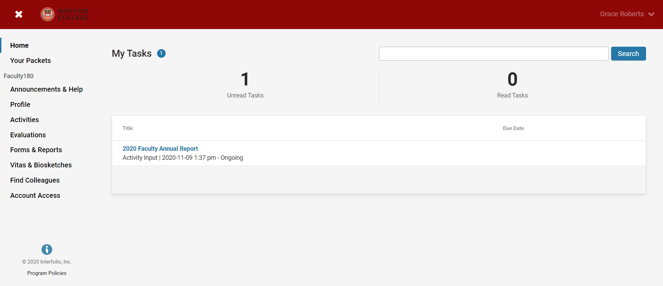

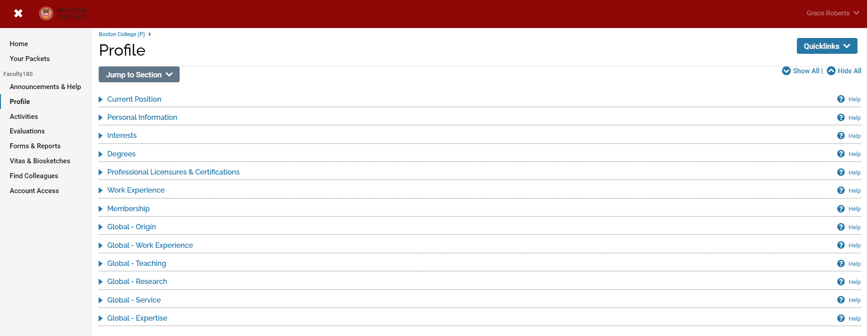

To enter information on the Global Engagement questions, click on the triangle next to any section to expand it.

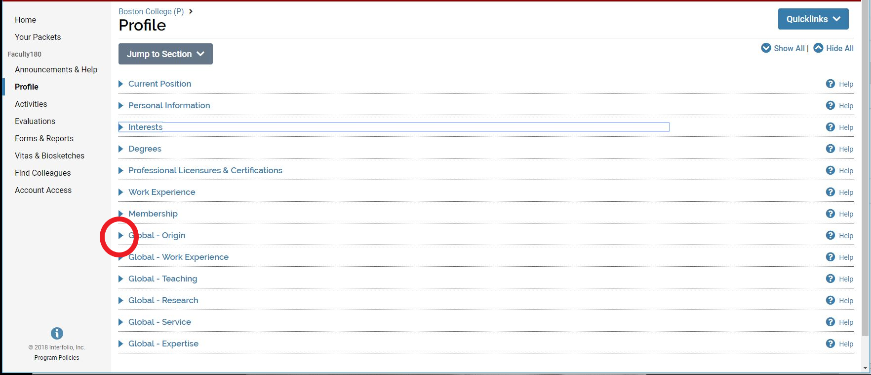

## Global – Adding and Editing Entries

When you click on a section, it will expand and provide you with options to view the countries and/or regions you have previously entered, edit or delete any entries you have already made, or add new entries.

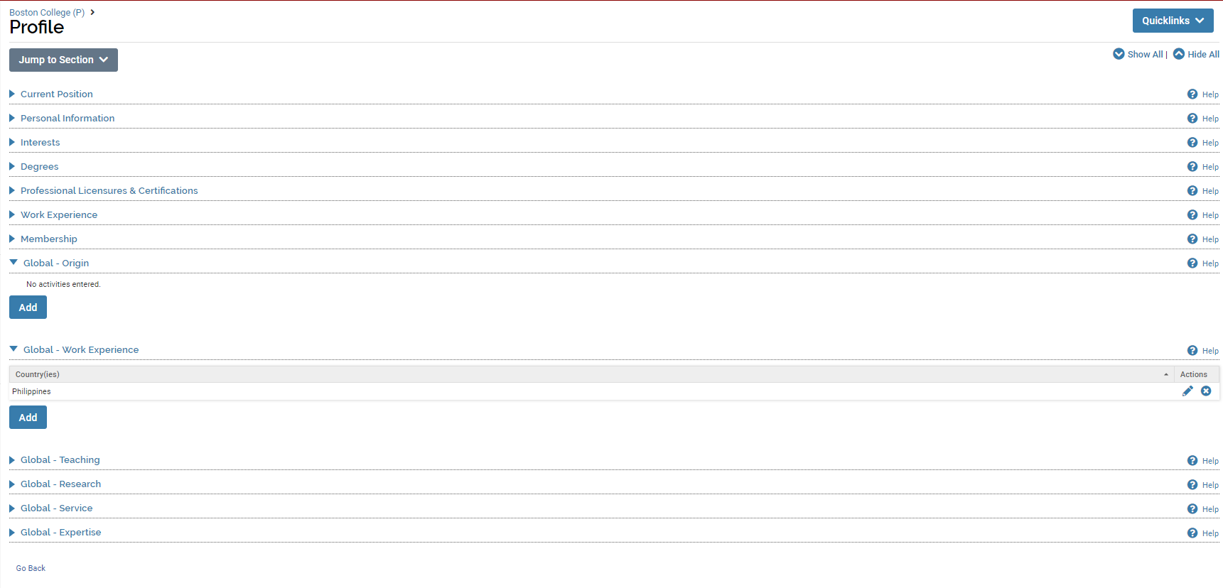

To add a new entry, click on the **Add** button, and you will be taken to the entry screen.

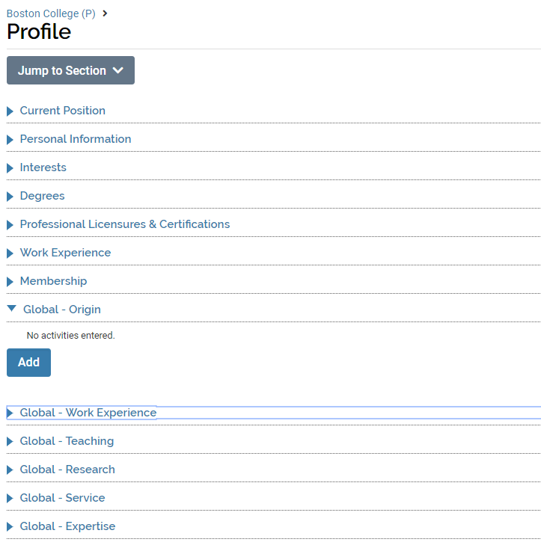

The **Global –** **Origin and Work Experience** screens ask only for country or countries of engagement.

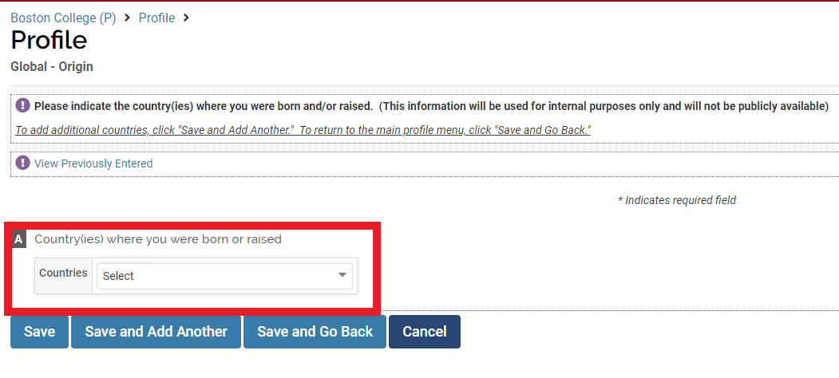

Select a country from the drop-down list. After making a selection, click on **Save and Add Another** if you wish to add more countries to the question or **Save and Go Back** if you only want to enter one country on the list and go back to the Profile page. Clicking **Save** will save your selection but keep you on the same entry screen. Clicking **Cancel** will produce a pop-up window letting you know that you will lose your selection unless you cancel and go back to the same page and save first.

To edit an existing entry – click on the **pencil icon** on the right. To delete an existing entry – click on the **X** on the right.

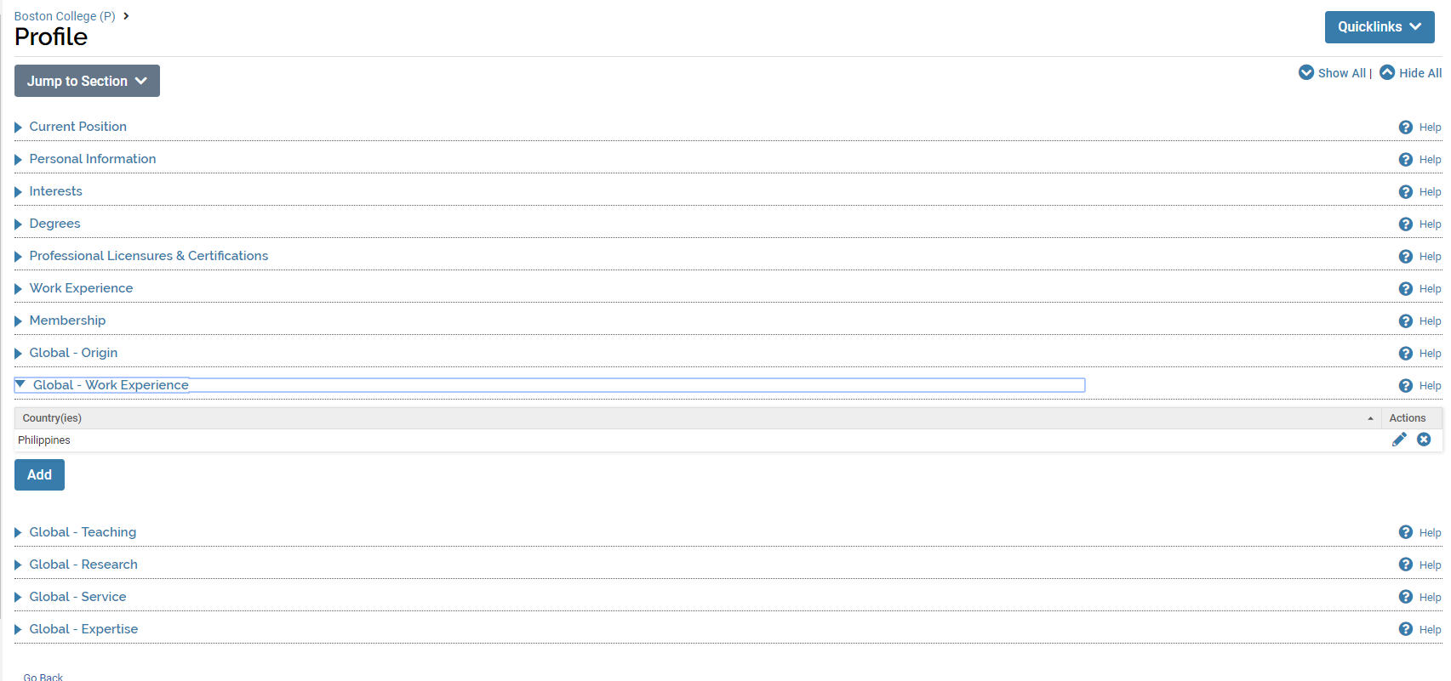

When you click on the pencil icon to edit, it will take you to the entry screen and you can select a different country from your original selection. Make sure to **Save** your selection before leaving the page.

The **Global - Teaching, Research, Service, and Expertise** screens will offer an additional drop down where, instead of selecting multiple countries in the same region, you can enter a single region, multiple regions, or global, to capture the range of your area expertise.

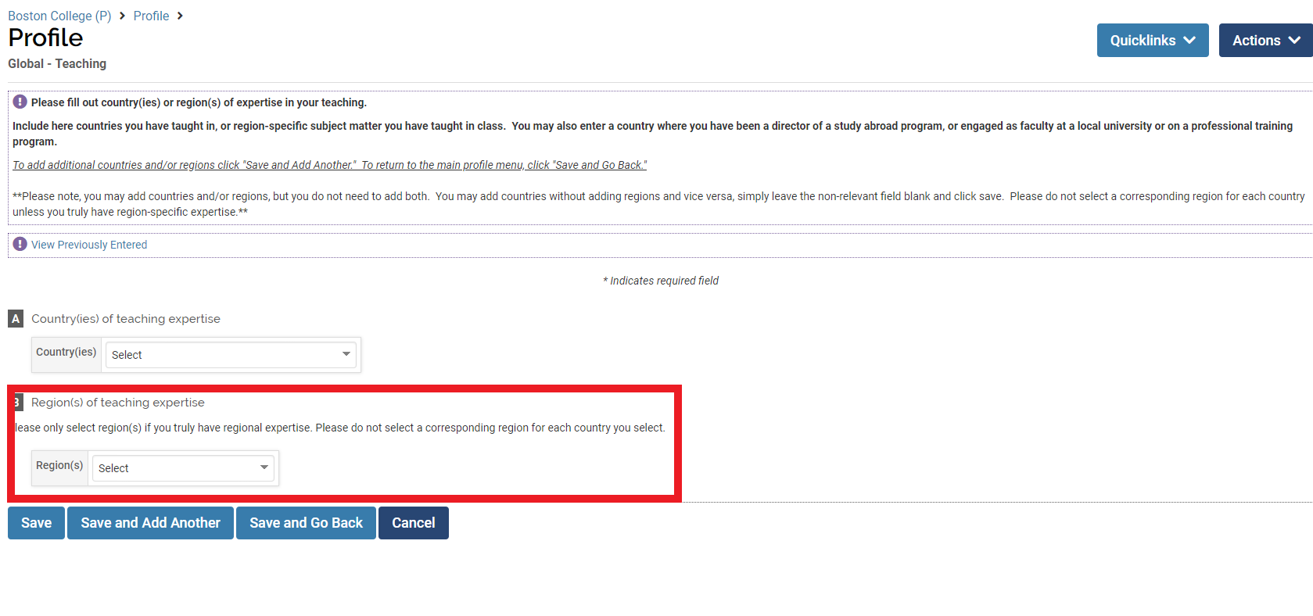

As with the country-only screens, please use the drop down menu to select any region(s) appropriate to the section. If you have only one region to report, make your selection, and click **Save and Go Back.** If you have multiple regions to report, click **Save and Add Another** and you will be taken to a new entry screen. If you click **Cancel** without saving, your selection(s) will not be saved.

**Please do not select a corresponding region for each country you select, rather use the region or global option in cases of true regional or global expertise. You should not select the countries of the regions you have already selected.**

If after selecting multiple countries or regions, you would like to see which countries or regions you have already reported, click on **View Previously Entered** and a list of all prior entries will appear.

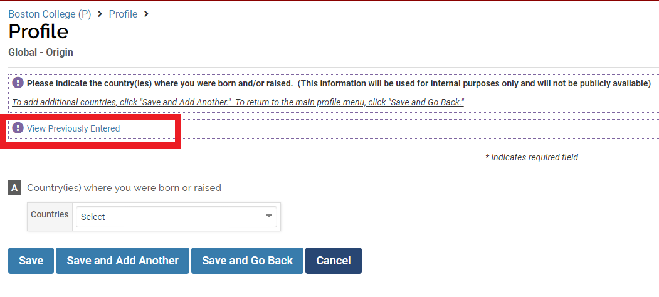

# TEACHING

## Teaching Overview



The Teaching Form enables you to add description to the courses you teach. Courses are imported into the system from Student Services data, so you cannot manually add or remove courses listed. If you believe there is an error (e.g., missing courses) please email [bcfarhelp@bc.edu](mailto:bcfarhelp@bc.edu)

For each course listed, use the edit button  to add information about the course.

## Teaching Section A: Course Information (Optional)

***Appearance***



***Editing***

Because course information is imported for you from Student Services, no action is required on the Course Information section unless you need to mark a course not taught because it is incorrectly listed.

## Teaching Section B: Activity Classifications (Optional)

***Appearance***

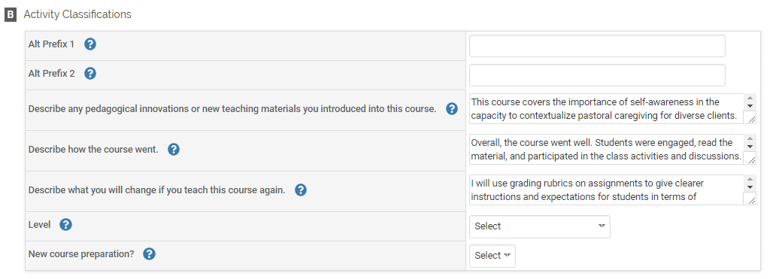

This semester I introduced new interactive modules for students to complete through Canvas. Instead of requiring

The course went well. The students were engaged and thanked me after the last class for the challenging assignments..

If I were to teach this course again, I would switch out the following readings:

***Editing***

Optional: You may describe how the course went, any new changes to the course, and what you would change if taught the course again. You can classify the course as new (Yes/No) or identify the level of the course:

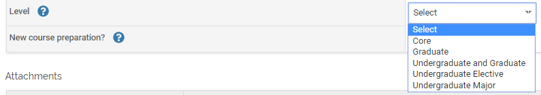

# ADVISING

## Advising Overview

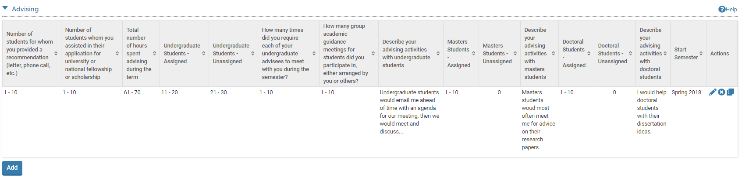

The Advising Form enables you to report the number of students you advise and the nature of your advising. To report advising activities, click on the button.

Any previously created Advising activities will also be listed and you can edit, delete, or duplicate any of these previously reported activities.

*Note:* On the activity summary page (shown above) you might find it helpful to use the duplicate button to copy and revise one semester’s advising to summarize a different semester. For example, you could copy Spring 2018 advising activities, relabel as Fall 2018, and revise as necessary.

## Advising Section A: General (Required)

***Appearance***

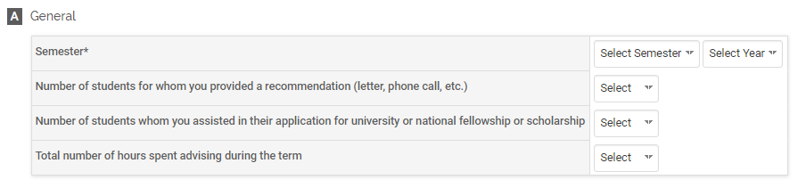

***Editing***

All asterisked (*) fields are required. If any are incomplete, then you will not be able to save your changes.

Required: Specify the semester and year that you advised students. This is referred to as “tagging” the semester (see p. 48)

Optional: Number of students for whom you provided a recommendation, assisted in their application for a university or scholarship, and total number of hours spent advising during the term.

*Note:* While none of the following sections is required to save an advising activity, it is likely that you will complete at least one section (B, C, or D) for advising undergraduate, masters, and/or doctoral students.

## Advising Section B: Undergraduate Students (Optional)

***Appearance***

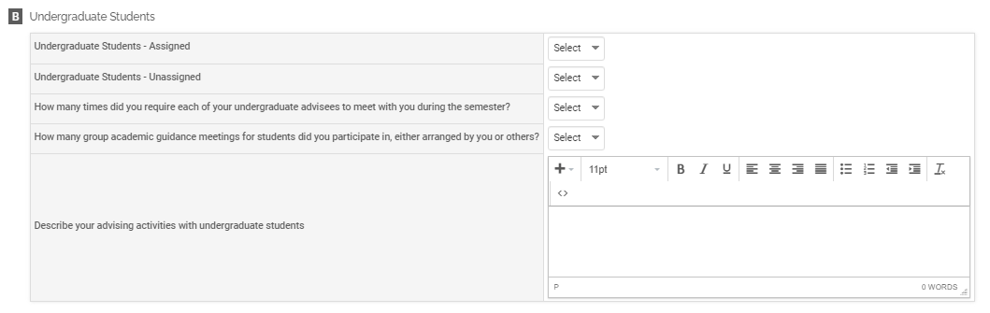

***Editing***

Optional: The number of undergraduate students assigned or unassigned whom you advised, number of times you required undergraduates to meet with you, number of academic guidance meetings for students, and a description of your advising activities.

## Advising Section C: Masters Students (Optional)

***Appearance***

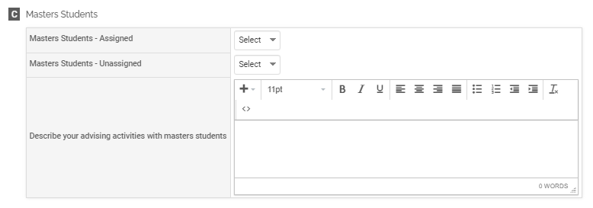

***Editing***

Optional: The number of masters students assigned or unassigned to you whom you advised, and a description of your advising activities.

## Advising Section D: Doctoral Students (Optional)

***Appearance***

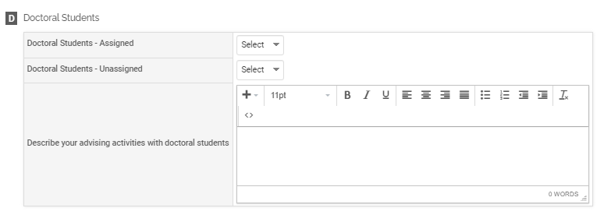

***Editing***

Optional: The number of doctoral students assigned or unassigned to you whom you advised, and a description of your advising activities.

## Advising Section E: Attachments (Optional)

***Appearance***

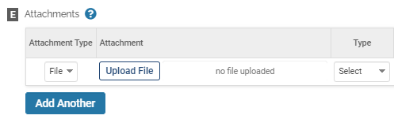

OR

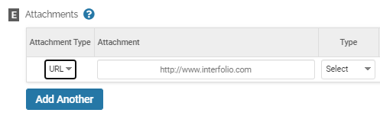

***Editing***

Optional: You can upload file attachments (e.g., recommendation letters written on behalf of students) or provide a URL to a website relevant to your advising.

## Tagging Advising Activity with a Semester and Year

For each advising activity, you must tag it by semester and year. This is how it is pulled into your Faculty Annual Report (e.g., advising activity during Fall 2017 will show up in your 2017 FAR).

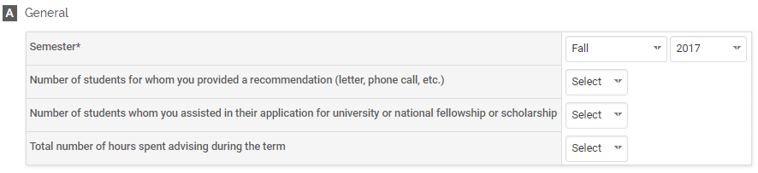

For advising activities, the semester tagged is the same as the semester for the advising activities you are reporting.

# STUDENT SUPERVISION

## Student Supervision Overview



The Student Supervision Form enables you to report the number of students you supervised in a formal role. To report student supervision activities, click on the button.

Any previously created Student Supervision activities will also be listed and you can edit, delete, or duplicate any of these previously reported activities.

## Student Supervision Section A: Input Form (Required)

***Appearance***

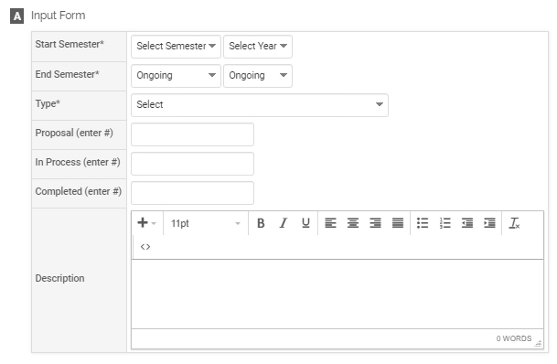

***Editing***

All asterisked (*) fields are required. If any are incomplete, then you will not be able to save your changes.

Required: Specify the start and end semester of student supervision (see p. 53), and type of supervision:

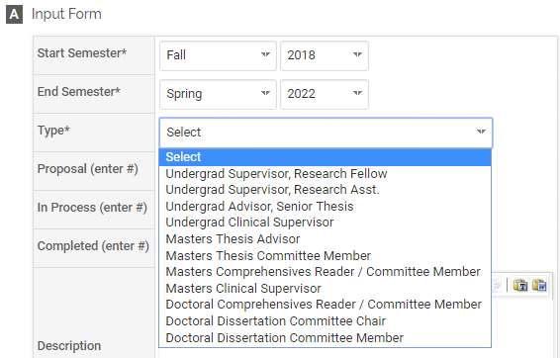

Optional: Number of students for whom you have either proposed for supervision, are in process of supervision, or have completed supervision, and a description of your student supervision activities.

## Student Supervision Section B: Attachments (Optional)

***Appearance***



OR



***Editing***

Optional: You can upload file attachments or provide a URL to a website relevant to your student supervision.

## Tagging Student Supervision Activity with a Semester and Year

For each student supervision activity, you must tag it with a start and end semester and year. This is how it is pulled into your Faculty Annual Report (e.g., a student supervision activity tagged Fall 2018 through Spring 2022 will show up in your 2018, 2019, 2020, 2021, and 2022 FARs).

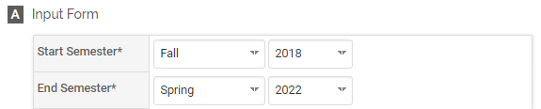

# SCHOLARLY CONTRIBUTIONS AND CREATIVE PRODUCTIONS

## Scholarly Contributions and Creative Productions Overview

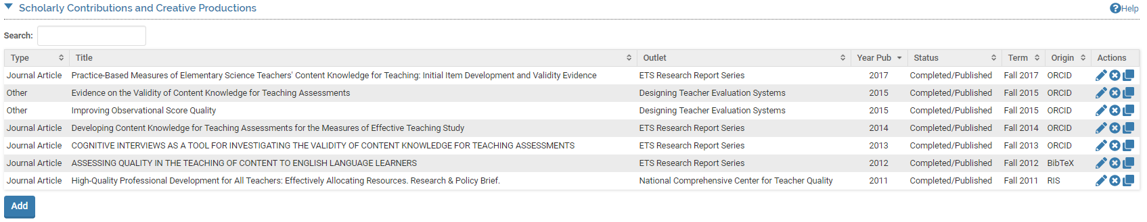

The Scholarly Contributions and Creative Productions Form enables you to report Scholarly Contributions and Creative Productions (e.g., journal articles, books, presentations, exhibitions, etc.) that have been drafted, presented, submitted, or published. To report an activity for Scholarly Contributions and Creative Productions, click on the button. Appendix A shows the different types of Scholarly Contributions and Creative Productions to choose from.

Any previously created Scholarly Contributions and Creative Productions will also be listed and you can edit, delete, or duplicate any of the previously created Scholarly Contributions and Creative Productions.

## Scholarly Contributions and Creative Productions: Manual Input and Import

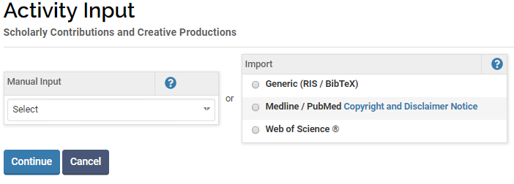

Unlike other activities, instead of going directly to the input form when clicking , you have two choices for adding new scholarly contributions and creative productions.

### Manual Input

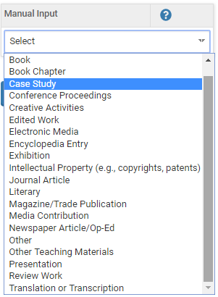You may add an activity manually one-at-a-time by using the drop down menu to select the activity type:

*Note*. Fields that display on the Input form (Section A) will vary by activity type selected. For example, selecting Journal Article will results in fields about Journal, Volume, Issue, whereas selecting Book will result in fields that gather information on the Place of Publication and Edition.

After selecting an activity type and clicking , you will be directed to the input form starting with Section A.

### Import

Instead of typing each part of a publication reference, you may also add an activity or several at a time by using the import tool, which provides 3 sources to obtain your publication record:

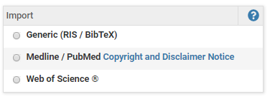

These import options are described in more detail in the Appendix in addition to first steps on linking your account with ORCID.

## Scholarly Contributions and Creative Productions Section A: Input Form (Required)

***Appearance (varies by activity type; Journal Article view presented)***

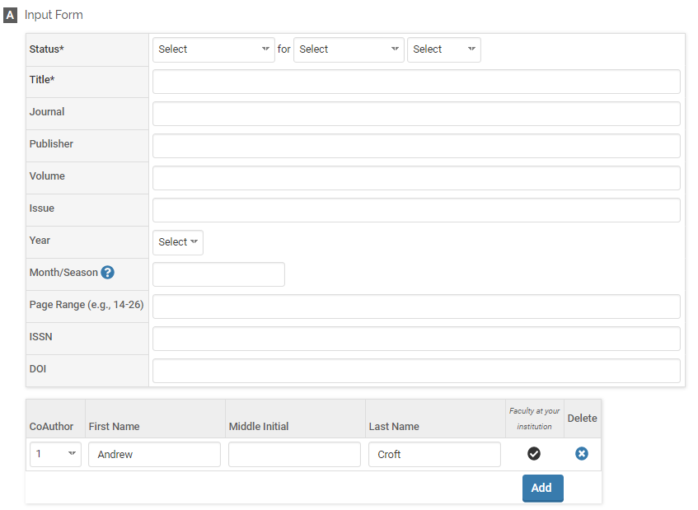

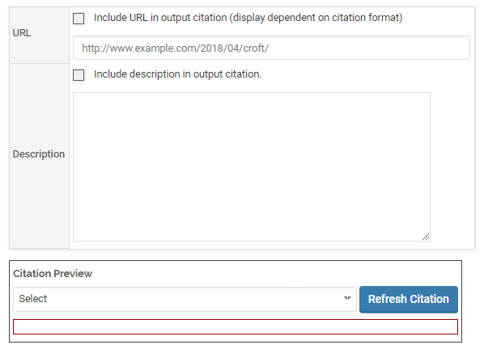

***Editing***

All asterisked (*) fields are required. If any are incomplete, then you will not be able to save your changes.

Required: Specify the status, semester and year of the activity (see p. 62), and title of the work. Options for the status include:

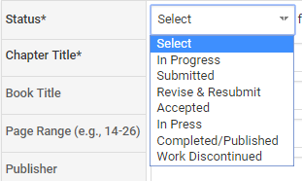

Optional: Additional publication/manuscript information (varies by activity type), listing of coauthors, URL, description.

*Note*. The citation preview tool is an optional tool for viewing your scholarly contribution/creative production as a citation in order to confirm that you have input all the information you intended to include.

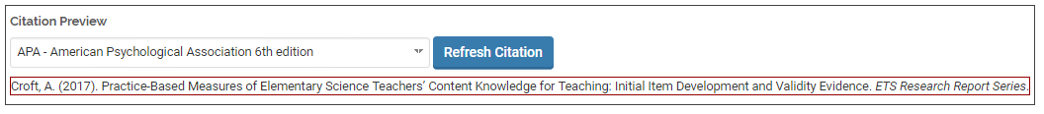

## Scholarly Contributions and Creative Productions Section B: Activity Classifications (Required)

***Appearance (varies by activity type; Journal Article view presented)***

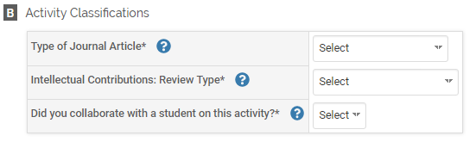

***Editing***

Required: Specify the type of publication/manuscript (if shown), review type (options displayed below), and whether you collaborated with students (yes/no).

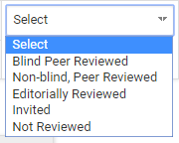

## Scholarly Contributions and Creative Productions Section C: Attachments (Optional)

***Appearance***

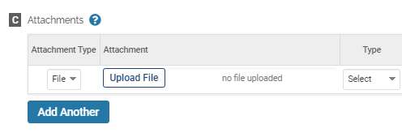

OR

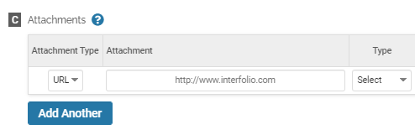

***Editing***

Optional: You can upload file attachments or provide a URL to a website relevant to your scholarly contribution or creative production.

## Tagging Scholarly Contributions and Creative Productions with a Semester and Year

For each scholarly contribution/creative production, you must (1) select a status and (2) tag it by semester and year. This is how it is pulled into your Faculty Annual Report (e.g., a journal article tagged Fall 2018 will show up in your 2018 FAR).

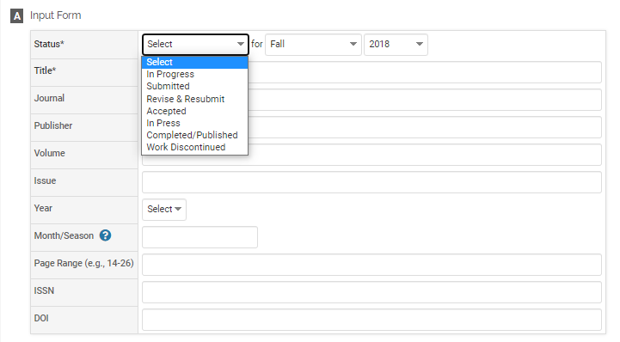

Tagging by semester and year is different from the year the activity started and ended or was published. For example, Section A (input form) allows you to specify the year published, which may be different from when it was first submitted or accepted.

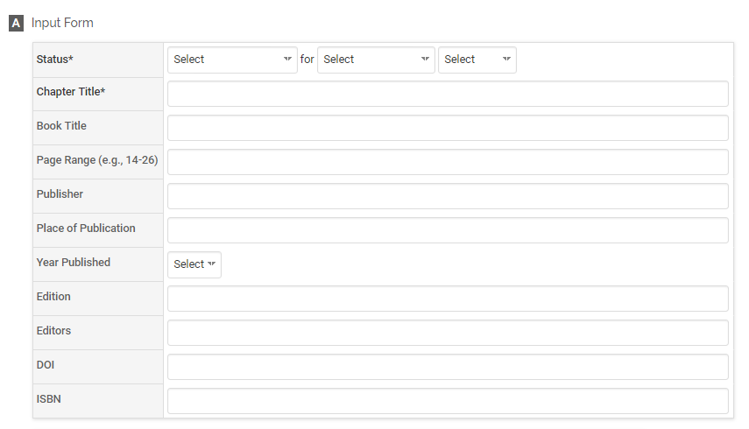

## Managing the Status of a Scholarly Contributions and Creative Productions

Rather than reporting an activity separately each time its status changes (e.g., from submission to revision, acceptance and then publication), simply add the new status of that activity by going back into the activity and clicking on the  button and then the  button. This will allow you to add a new status for the activity without re-entering the other information.

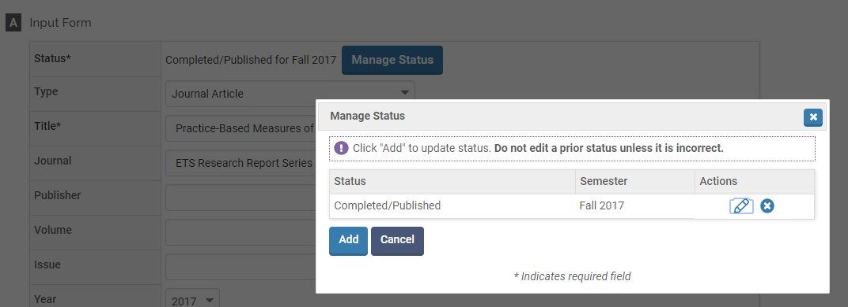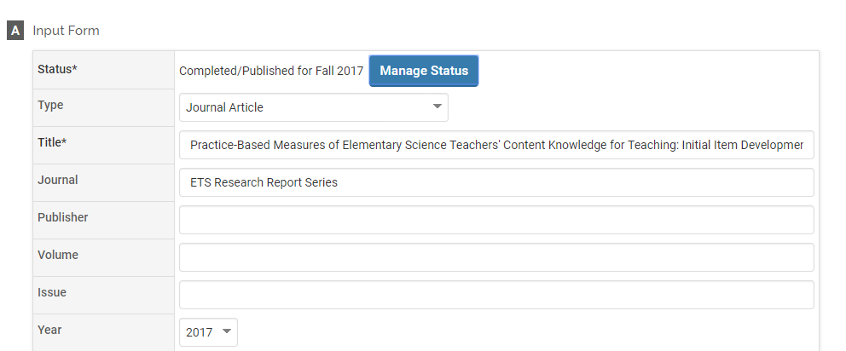

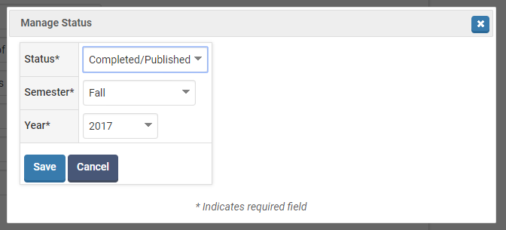

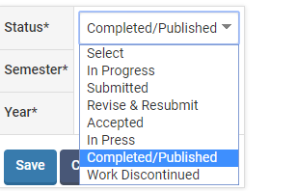

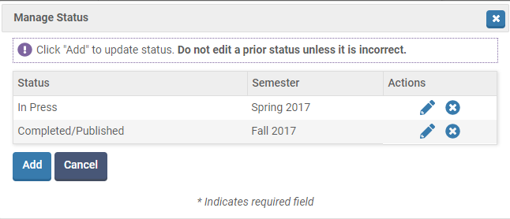For example, this scholarly contribution shows two statuses, first **In Press** during Spring 2017, then **Completed/Published** in Fall 2017.

# 

# GRANTS

## Grants Overview

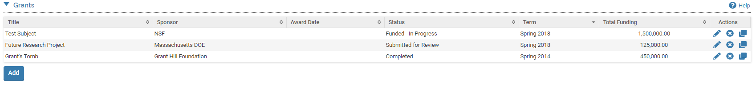

The Grants Form enables you to record research, teaching, service, or other types of grants that have been drafted, submitted, or funded. To report a grant, click on the button.

Any previously created Grants will also be listed and you can edit, delete, or duplicate any of the previously created Grants.

## Grants Section A: Input Form (Required)

***Appearance***

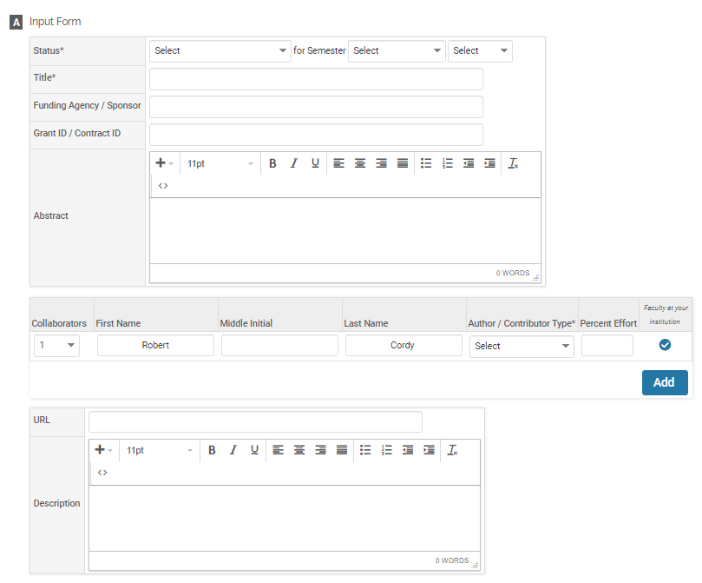

***Editing***

All asterisked (*) fields are required. If any are incomplete, then you will not be able to save your changes.

Required: Specify the Status and Title of the grant. See page 72 for more information on tagging a grant activity with a semester and year.

For all collaborators, including yourself, you must indicate the collaborator’s role:

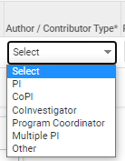

Optional: Funding Agency / Sponsor, an ID number for the grant, an Abstract, URL, Description, or your collaborators on the grant.

## Grants Section B: Dates and Funding Periods (Required)

***Appearance***

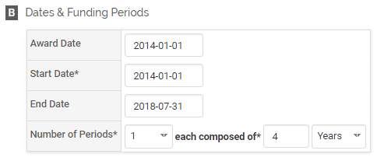

***Editing***

Required: Specify the Start Date and the duration of the grant in Number of Periods and the type of periods (years or months). Most often, faculty enter 1 period and specify the number of years the grant was funded.

Optional: You may also enter the award date and the end date for the grant.

Rather than manually entering the dates for Award Date, Start Date, or End Date, you can use the pop-up calendar that appears when you click in each field:

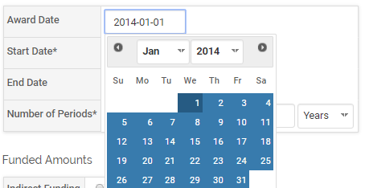

## Grants Section C: Funded Amounts (Required)

***Appearance***

***Editing***

Required: Specify the Total Funding amount. If you have more than one funding period, you will need to enter the total funding for each row. Additional rows are created when you enter more than one funding period in Section B. The Total row is automatically calculated.

Optional: Indirect Funding, Currency (USD is default), Start Data, End Date.

## Grants Section D: Activity Classifications (Required)

***Appearance***

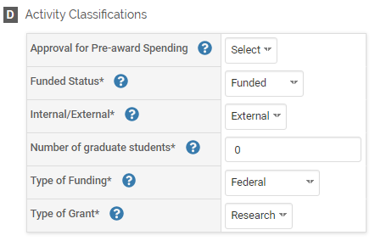

***Editing***

Required: Specify the Funded Status, Internal/External, Number of Graduate Students, Type of Funding, Type of Grant.

Optional: Approval for Pre-Award Spending (Yes/No).

## Grants Section E: Attachments (Optional)

***Appearance***

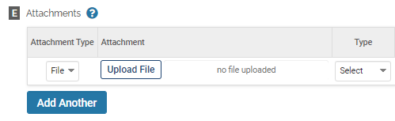

**OR**

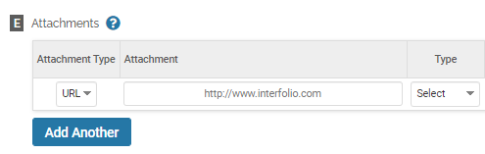

***Editing***

Optional: You can upload file attachments or provide a URL relevant to the grant, such as the grant proposal.

## Tagging a Grant Activity with a Semester and Year

For each grant activity, you must (1) select a status and (2) tag it by semester and year. This is how it is pulled into your Faculty Annual Report (e.g., a grant tagged Fall 2018 will show up in your 2018 FAR).

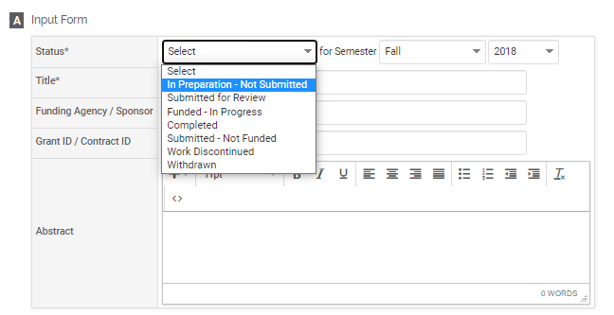

Tagging by semester and year is different from the year the activity started and ended. For example, Section B for **Grants** allows you to specify a start and end date.

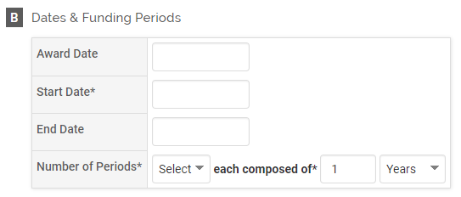

## Managing Grant Activity Status

Rather than duplicate a grant activity each time its status changes, simply change the status of the previously created grant activity using the  button then the  button. The  button only appears for grant activities previously entered.

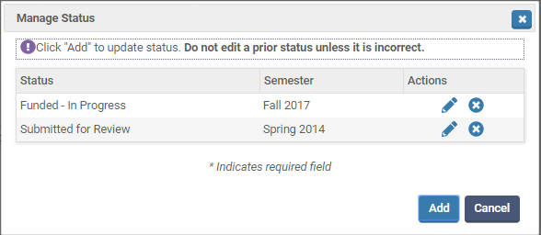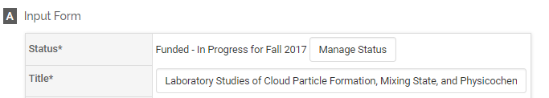

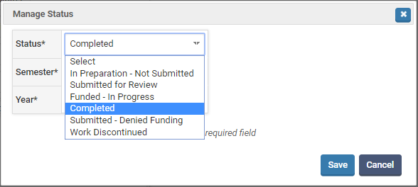

For example, this grant shows two statuses, first Submitted for Review during Spring 2014, then Funded – In Progress in Fall 2017.



# SERVICE

## Service Overview

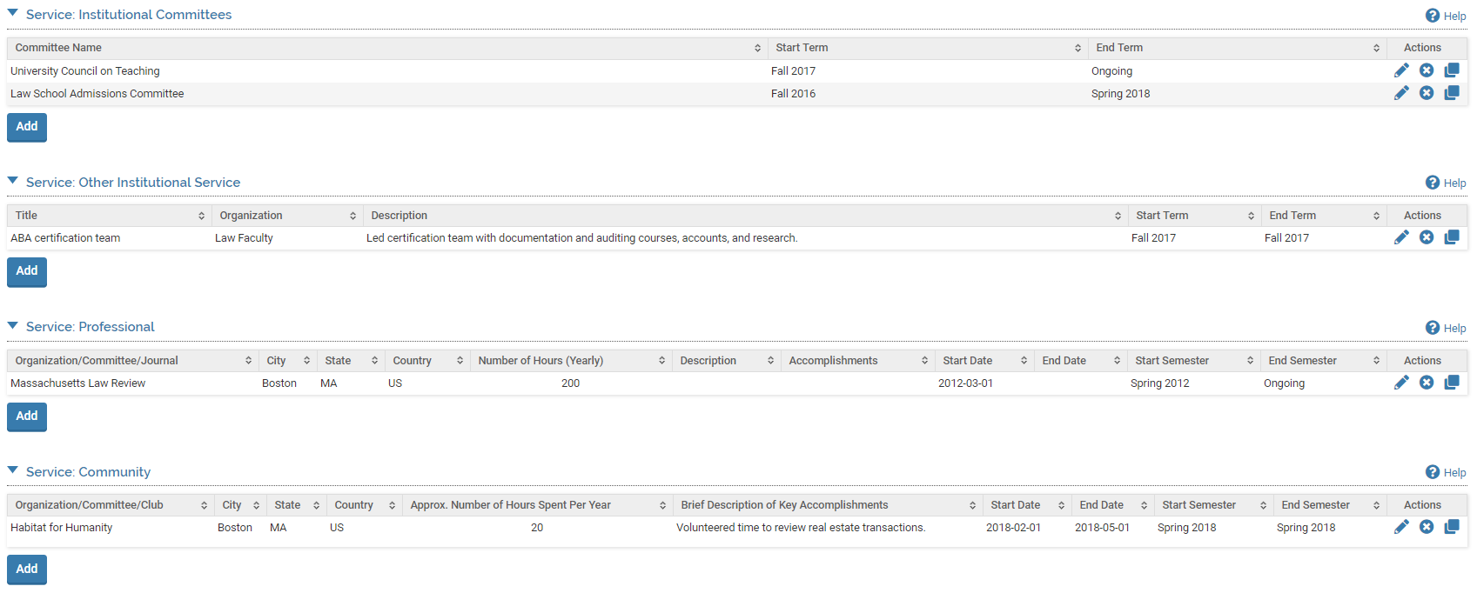

The Service Forms enable you to report your service in one of four categories: (1) Institutional Committees, (2) Other Institutional Service, (3) Professional Service, and (4) Community Service. To report service activities, click on the button for the corresponding category for that activity.

Report service on department, school and university committees under Institutional Committees.

Report non-committee, Boston College-related service under Other Institutional Service. For example, serving as faculty advisor to student clubs or organizations, participating in Half-time or Admitted Eagle Days, guest speaking in classes or other events on campus.

Report professional, academic or non-academic, service under Professional Service. For example, serving on awards, conference, academic or professional organization committees, editorial boards, providing journal or book reviews, etc.

Report local, national or international, non-profession-related service under Community Service. For example, serving on town, congressional or international committees or boards.

Any previously created Service activities will also be listed and you can edit, delete, or duplicate any of these previously reported activities.

## Institutional Committee Service Section A: Input Form (Required)

***Appearance***

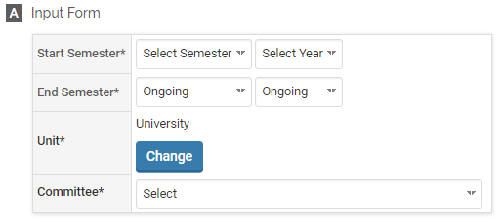

***Editing***

All asterisked (*) fields are required. If any are incomplete, then you will not be able to save your changes.

Required: Specify the start and end semester of Institutional Committee Service (see p. 95), the title, and unit (i.e., university, school, or department), and committee from the drop-down list. To specify the unit, click on  and choose from the list. **The drop-down list for Committee will display different committees depending on the unit selected.** Choose **Other** If your committee is not on the list.

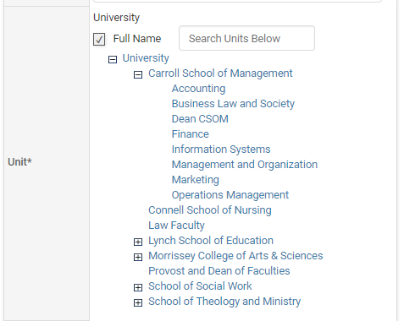

The following **university-wide** committees are available to choose from:

* Academic Technology Advisory Board
* Athletic Advisory Board
* Faculty Compensation Committee
* Faculty Grievance Committee
* Faculty Hearing Committee
* Faculty Review Panel
* Faculty Technology Contracts
* Institutional Review Board
* Intersections
* Provost’s Advisory Council
* University Core Development Committee
* University Council on International Exchange and Research
* University Council on Teaching
* University Fellowships Committee
* University Research Council
* Other

School specific committees vary by school.

## Institutional Committee Service Section B: Activity Classifications (Required)

***Appearance***

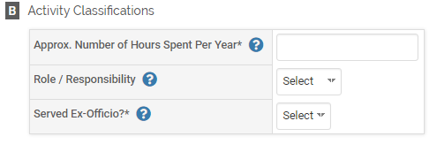

***Editing***

Required: Specify the approximate number of hours you spend on the activity each year, your role or responsibility (Member, Chair, Co-Chair, or Other), and if you served Ex-Officio (Yes/No).

## Institutional Committee Service Section C: Attachments (Optional)

***Appearance***

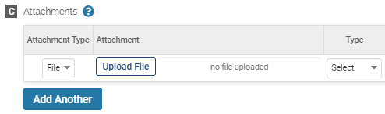

OR

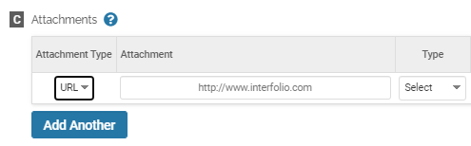

***Editing***

Optional: You can upload file attachments or provide a URL to a website relevant to your Institutional Committee Service activity.

## Other Institutional Service Section A: Input Form (Required)

***Appearance***

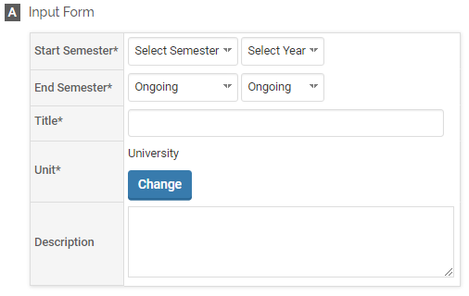

***Editing***

All asterisked (*) fields are required. If any are incomplete, then you will not be able to save your changes.

Required: Specify the start and end semester of the Other Institutional Service activity (see p. 95), the title, and unit (i.e., university, school, or department). To specify the unit, click on  and choose from the list. You can use the  icon to expand a list of department for CSOM, LSOE, MCAS, SSW, or STM.



Optional: Description of the activity.

## Other Institutional Service Section B: Activity Classifications (Required)

***Appearance***

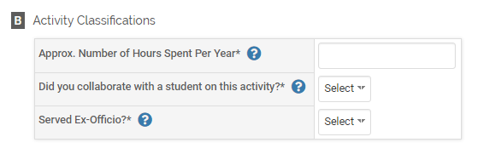

***Editing***

Required: Specify the approximate number of hours you spend on the activity each year, whether you collaborated with a student for the activity (Yes/No), and if you served Ex-Officio (Yes/No).

## Other Institutional Service Section C: Attachments (Optional)

***Appearance***



OR



***Editing***

Optional: You can upload file attachments or provide a URL to a website relevant to your Other Institutional Service activity.

## Professional Service Section A: Input Form (Required)

***Appearance***

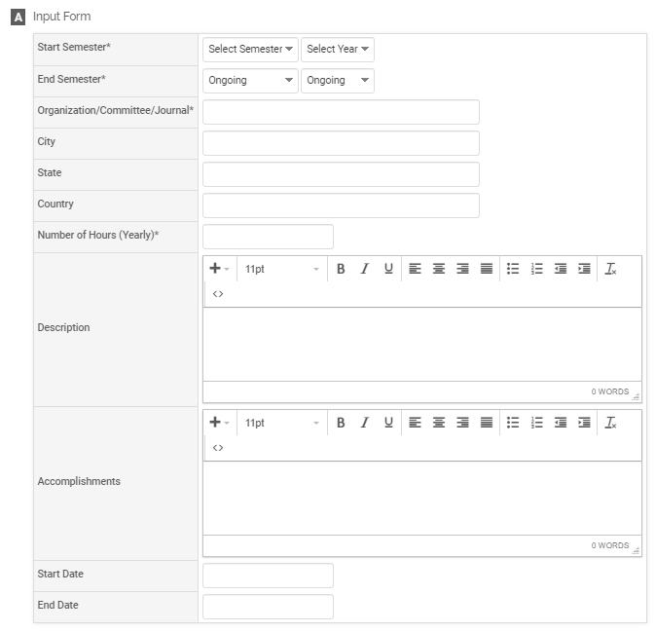

***Editing***

All asterisked (*) fields are required. If any are incomplete, then you will not be able to save your changes.

Required: Specify the start and end semester of the Professional Service activity (see p. 95), the Organization/Committee/Journal, and number of hours you spend each year on the activity.

Optional: City/state/country, description, accomplishments, the exact start and end date, which is different from tagging the start and end semester for the activity.

## Professional Service Section B: Activity Classifications (Required)

***Appearance***

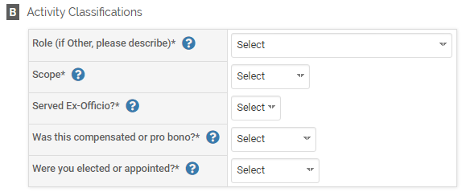

***Editing***

Required: Specify your role; the scope of your role (local/state/regional/national/international); if you served Ex-Officio (Yes/No); whether it was compensated or pro bono; and whether you were elected, appointed, or neither.

The following roles are available for Professional Service:

* Advisory Committee
  + Chair
  + Member
* Attendee, Meeting
* Board of Advisors
  + For-Profit
  + Non-Profit
* Board of Directors
  + For-Profit
  + Non-Profit
* Chairperson
* Committee
  + Chair
  + Member
* Conference Organizer
* Conference-Related
* Editor
  + Associate Editor
  + Journal Editor
  + Senior Editor
* Editorial Review Board Member
* External Reviewer
* Member
* Officer
  + Other Officer
  + President/Elect/Past
  + Secretary
  + Treasurer
  + Vice President
* Pre-Publication Reviewer
  + Ad Hoc
  + Book
  + Conference Paper
  + Journal Article
  + Textbook
* Prepare/Grade Certification Exams
* Program
  + Coordinator
  + Organizer
* Research Prize
* Reviewer
  + Grant Proposal
  + Research Prize
  + University Tenure and Promotion Cases
* Session Chair
* Task Force Chair
* Task Force Member
* Track Organizer
* Workshop Organizer
* Other

If selecting Other, a text box will appear to specify your role.



## Professional Service Section C: Attachments (Optional)

***Appearance***



OR



***Editing***

Optional: You can upload file attachments or provide a URL to a website relevant to your Professional Service activity.

## Community Service Section A: Input Form (Required)

***Appearance***

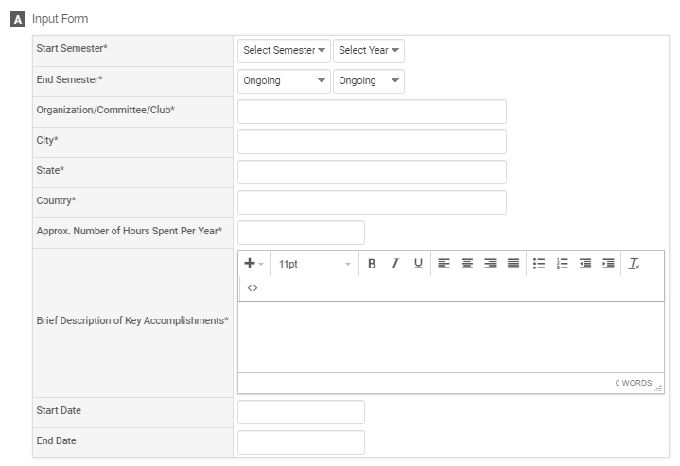

***Editing***

All asterisked (*) fields are required. If any are incomplete, then you will not be able to save your changes.

Required: Specify the start and end semester of the Professional Service activity (see p. 95), the Organization/Committee/Club, number of hours you spend each year on the activity, and City/State/Country, and a brief description of key accomplishments.

Optional: The exact start and end date, which is different from tagging the start and end semester for the activity.

## Community Service Section B: Activity Classifications (Required)

***Appearance***

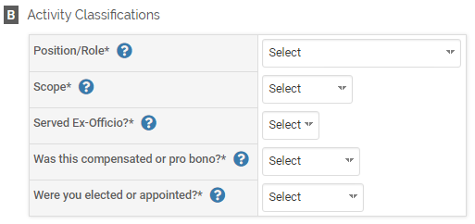

***Editing***

Required: Specify your position/role; the scope of your role (local/state/regional/national/international); if you served Ex-Officio (Yes/No); whether it was compensated or pro bono; and whether you were elected, appointed, or neither.

The following positions/roles are available for Community Service:

* Attendee, Meeting
* Board Member
* Chairperson
* Committee
  + Chair
  + Member
* Discussant
* Grant Proposal Reviewer, External
* Guest Speaker
* Member
* Officer
  + Other Officer
  + President/Elect/past
  + Secretary
  + Treasurer
  + Vice President
* Participant/Volunteer
* Program
  + Coordinator
  + Organizer
* Session Chair
* Task Force
  + Chair
  + Member
* Track Organizer
* Workshop Organizer
* Other

If selecting Other, a text box will appear to specify your role.



## Community Service Section C: Attachments (Optional)

***Appearance***



OR



***Editing***

Optional: You can upload file attachments or provide a URL to a website relevant to your Community Service activity.

## Tagging a Service Activity with a Semester and Year

For each service activity, you must tag it with a start and end semester and year. This is how it is pulled into your Faculty Annual Report (e.g., a service activity tagged Fall 2018 through Spring 2022 will show up in your 2018, 2019, 2020, 2021, and 2022 FARs).



# FACULTY DEVELOPMENT ACTIVITIES ATTENDED

## Faculty Development Activities Attended Overview

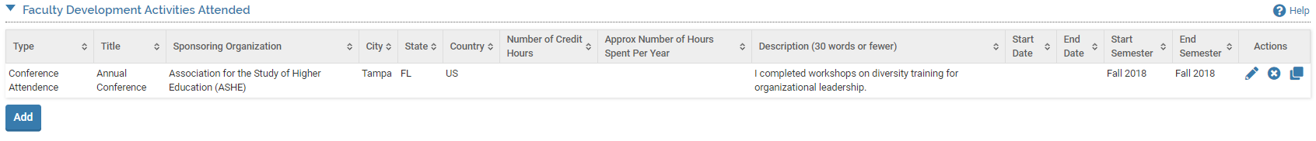

The Faculty Development Activities Form enables you to report trainings, workshops, and seminars you attended. To report faculty development activities you attended, click on the button.

Any previously reported Faculty Development Activities will also be listed and you can edit, delete, or duplicate any of these previously reported activities.

## Faculty Development Activities Attended Section A: Input Form (Required)

***Appearance***

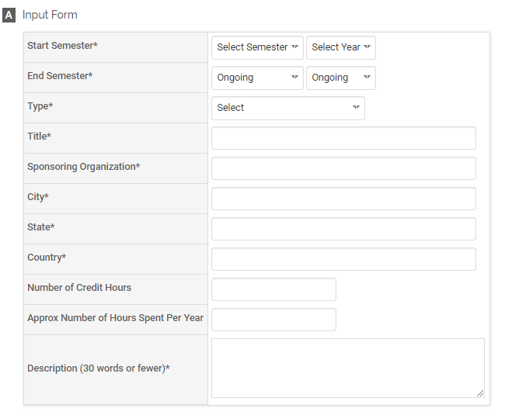

***Editing***

All asterisked (*) fields are required. If any are incomplete, then you will not be able to save your changes.

Required: Specify the start and end semester the faculty development activity you attended (see p. 102), the type, title, sponsoring organization, city/state/country, and a description. These are the types of activities you can select:

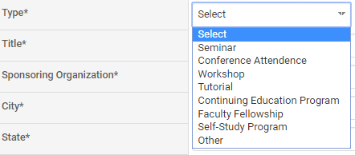

Optional: Number of credit hours and the approximate number of hours spent per year.

## Faculty Development Activities Attended Section B: Dates (Optional)

***Appearance***

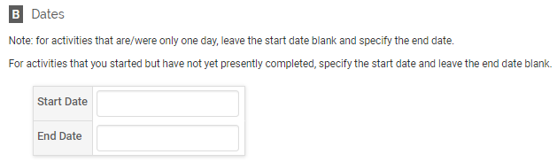

***Editing***

Optional: You can specify the exact start and end date of the activity by clicking on the pop-up calendar. Note that this is different from tagging the activity to a semester and year (discussed later).

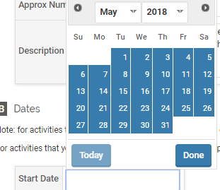

## Faculty Development Activities Attended Section C: Attachments (Optional)

***Appearance***



OR



***Editing***

Optional: You can upload file attachments or provide a URL to a website relevant to your faculty development activity.

## Tagging Faculty Development Activity Attended with a Semester and Year

For each faculty development activity attended, you must tag it with a start and end semester and year. This is how it is pulled into your Faculty Annual Report (e.g., a faculty development activity attended tagged Fall 2018 through Spring 2022 will show up in your 2018, 2019, 2020, 2021, and 2022 FARs).



# CONSULTING

## Consulting Overview



The Consulting Form enables you to report consulting activities. To report Consulting activities, click on the button.

Any previously created Consulting activities will also be listed and you can edit, delete, or duplicate any of these previously reported activities.

## Consulting Section A: Input Form (Required)

***Appearance***

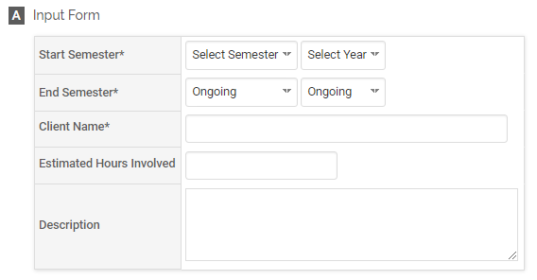

***Editing***

All asterisked (*) fields are required. If any are incomplete, then you will not be able to save your changes.

Required: Specify the start and end semester of Consulting (see p. 107), and the client name:

Optional: Estimated hours involved (specify if yearly, monthly, or weekly), and a description of the consulting activity.

## Consulting Section B: Attachments (Optional)

***Appearance***

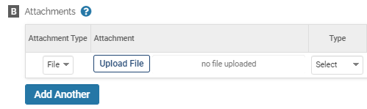

OR

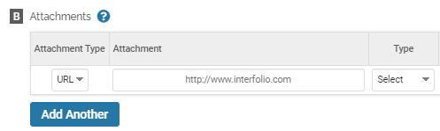

***Editing***

Optional: You can upload file attachments or provide a URL to a website relevant to your Consulting.

## Tagging a Consulting Activity with a Semester and Year

For each Consulting activity, you must tag it with a start and end semester and year. This is how it is pulled into your Faculty Annual Report (e.g., a Consulting activity tagged Fall 2018 through Spring 2022 will show up in your 2018, 2019, 2020, 2021, and 2022 FARs).



# NARRATIVE

## Narrative Overview



The Narrative Form enables you to describe your goals and accomplishments. To create a Narrative, click on the button.

Any previously created Narratives will also be listed and you can edit, delete, or duplicate any of the previously created Narratives.

## Narrative Section A: Input Form (Required)

***Appearance***

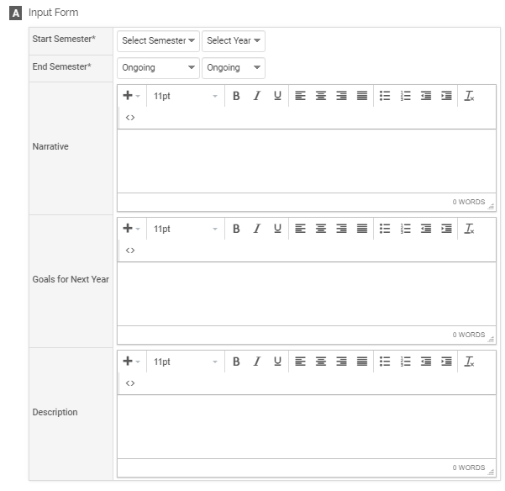

***Editing***

All asterisked (*) fields are required. If any are incomplete, then you will not be able to save your changes.

Required: Specify the start and end semester of the Narrative (see p. 113). It is assumed that you would complete at least one of the optional sections.

Optional: Narrative text, goals for next year, and a description.

## Tagging a Narrative with a Semester and Year

For each Narrative, you must tag it with a start and end semester and year. This is how it is pulled into your Faculty Annual Report (e.g., a Narrative tagged Fall 2018 through Spring 2022 will show up in your 2018, 2019, 2020, 2021, and 2022 FARs).



# HONORS

## Honors Overview



The Honors Form enables you to list any awards or honors you have received. To create an Honor activity, click on the button.

Any previously reported Honors or Awards will also be listed and you can edit, delete, or duplicate any of the previously created Honors Forms.

## Honors Section A: Input Form (Required)

***Appearance***

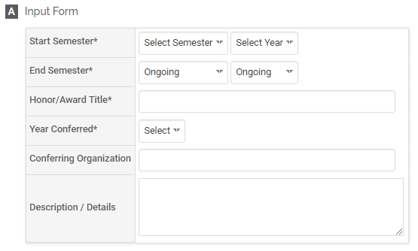

***Editing***

All asterisked (*) fields are required. If any are incomplete, then you will not be able to save your changes.

Required: Specify the start and end semester you received the honor (see p. 118), the title of the honor/award, and year conferred.

Optional: The conferring organization and a description or additional details.

## Honors Section B: Attachments (Optional)

***Appearance***



OR



***Editing***

Optional: You can upload file attachments or provide a URL to a website relevant to your Honor or Award.

## Tagging an Honor or Award with a Semester and Year

For each Honor or Award, you must tag it with a start and end semester and year. This is how it is pulled into your Faculty Annual Report (e.g., an Honor tagged Fall 2018 through Spring 2022 will show up in your 2018, 2019, 2020, 2021, and 2022 FARs).



# PREVIEWING AND SUBMITTING YOUR REPORT

## Previewing and Submitting Your Report Overview

After you have entered and updated all your activities and have completed the Conflict of Interest/Commitment Form, you are ready to preview and submit your Faculty Annual Report. If you wish to make changes after you submit your report, you may update activities anytime.

## Previewing Your Report: Option 1

1. Access your FAR by using the Action Item on your Dashboard (Home Page): **Click 20XX Faculty Annual Report** (note the year will be updated annually).



1. Click **Preview.**

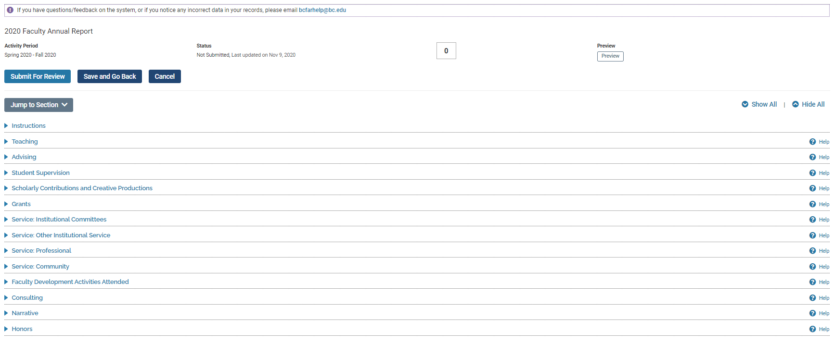

1. The following window will appear. Select a start and end semester (Spring 2018 and Fall 2018 for your 2018 report for example).

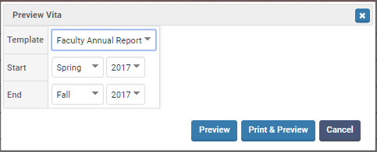

1. Click and a pop-up browser window will appear with your report. This is exactly how your Faculty Annual Report will appear to your department chair or dean when they download it. Your COI/COC Form appears at the end of the report. If you click , then the printer dialog menu will also open to enable you to print out the report immediately.

## Previewing Your Report: Option 2

1. Click on the Vitas and Biosketches on the left-side menu.

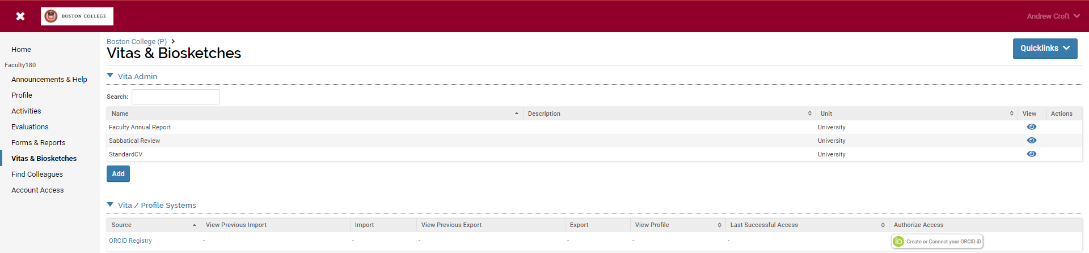

1. On the row that says “Faculty Annual Report,” click on the eye icon  on the far right.
2. A new webpage will open. The default Vita Options for report **Type** (Faculty Annual Report – University) is correct, as shown below, but you must select the begin and end semesters of the calendar year to display the correct **Date Range** for your FAR. Change the Begin semester to Spring and End semester to Fall of the calendar year, and

then click  to update the display of your FAR. Your COI/COC Form appears at the end of the report.

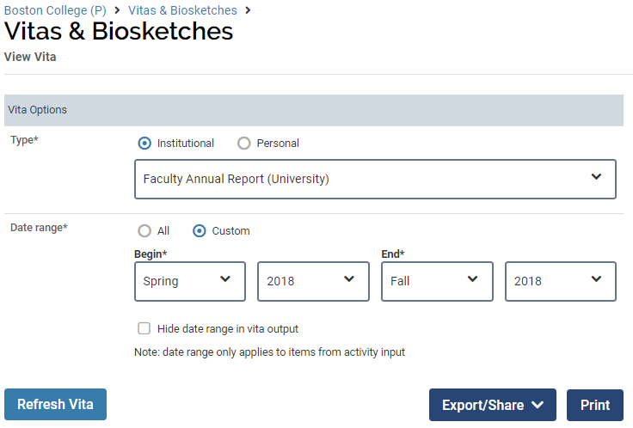

1. Click to export your report into a Word document or PDF. It is recommended that you do not share your FAR using the Web Link option.

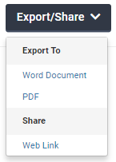

Click  to print out your FAR. A new browser window will open, displaying your report, then you must use your browser menu to print it (i.e., the print dialog menu will not automatically appear).

## Submitting Your Report

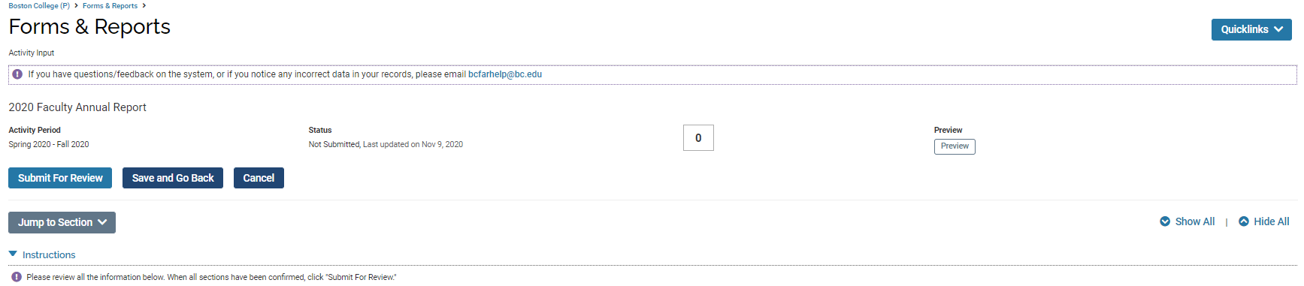

To submit your Faculty Annual Report, go to the **20XX Faculty Annual Report** page by (1) going to your Home page and clicking on the **Faculty Annual Report** under your Action Items or (2) going to **Forms & Reports** from the left-side menu and clicking on the **20XX Faculty Annual Report** under Initiated Activity Input Forms. From this menu (shown above), click on the **Submit For Review** button. If there are unresolved items, a pop-up window will appear asking you to update or complete the required information. Otherwise, it will submit your Faculty Annual Report. You can confirm that the FAR has been submitted when it disappears from your list of action items on the Home page.

Even though submitted, you can still update the activities you have reported through the **Activities** section on the left-side menu. You can also continue to preview your report through the **Vitas & Biosketches** section of the left-side menu. Follow the instructions from “Previewing Your Report: Option 2” on page 124 above.

# Appendix A: Types of Scholarly Contributions and Creative Productions

| Type | Publisher / Outlet / Venue / Event / Conference | Place of Publication / Location | Date / Month / Season | Year / Year Published | Volume | Issue / Number | Pages / Page Range | Edition | Editors | DOI | ISBN / ISSN | Journal / Book Title / Conference Proceedings Title / Encyclopedia | Sponsoring Organization / Sponsor | Type | Patent Number |
| --- | --- | --- | --- | --- | --- | --- | --- | --- | --- | --- | --- | --- | --- | --- | --- |
| Book | X | X |  | X |  |  | X | X | X | X | X |  |  |  |  |
| Book Chapter | X | X |  | X |  |  | X | X | X | X | X | X |  |  |  |
| Case Study | X |  |  | X |  |  | X |  |  |  |  |  |  |  |  |
| Conference Proceedings | X | X | X | X | X | X | X |  |  | X | X | X |  |  |  |
| Creative Activities |  | X | X | X |  |  |  |  |  |  |  |  | X | X |  |
| Edited Work | X | X | X | X | X | X | X | X | X | X | X | X |  |  |  |
| Electronic Media | X |  | X | X |  |  |  |  |  |  |  |  | X |  |  |
| Encyclopedia Entry | X | X | X | X | X | X | X | X | X | X | X | X |  |  |  |
| Exhibition | X | X | X | X |  |  |  |  |  |  |  |  | X |  |  |
| Intellectual Property (e.g., copyrights, patents) |  |  |  | X |  |  |  |  |  |  |  |  |  |  | X |
| Journal Article | X |  | X | X | X | X | X |  |  | X | X | X |  |  |  |
| Literary | X | X | X | X | X | X | X | X | X | X | X |  |  |  |  |
| Magazine/Trade Publication | X | X | X | X | X | X | X | X | X | X | X |  |  |  |  |
| Media Contribution | X | X | X | X |  |  |  |  |  |  |  |  | X |  |  |
| Newspaper Article/Op-Ed | X |  | X | X | X | X | X |  |  | X | X |  |  |  |  |
| Other | X | X | X | X | X | X | X | X | X | X | X |  |  |  |  |
| Other Teaching Materials | X |  |  | X |  |  |  |  |  |  |  |  |  |  |  |
| Presentation | X | X | X | X |  |  |  |  |  |  |  |  | X |  |  |
| Review Work | X | X | X | X | X | X | X | X | X | X | X | X |  |  |  |
| Translation or Transcription | X | X | X | X | X | X | X | X | X | X | X |  |  |  |  |

*Note*. These are fields that appear in Section A in addition to Status and Title, which appear for all types of scholarly contributions and creative productions. These fields are always optional; only Status and Title are required.

# Appendix B: Importing Scholarly Contributions and Creative Productions

**Important:** You can always revise or delete any activities that you import.

## Import via Generic (RIS / BibTeX) Bibliographic File

You may upload a bibliographic file in .ris or .bibtex format to add a scholarly contribution or creative production.

***Appearance***

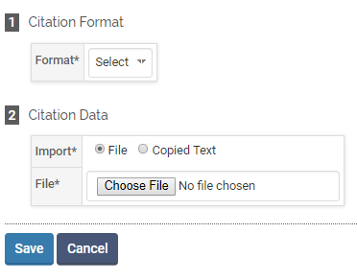

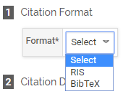***Editing***

1. Select a citation format:
2. 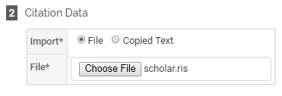Upload the RIS file:

or copy the BibTeX text (you can add multiple entries separated by a hard return):

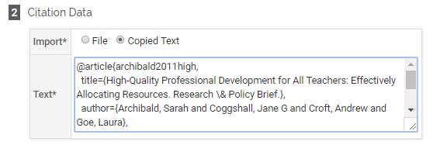

1. Click the  button.
2. Select the references you wish to add and click :

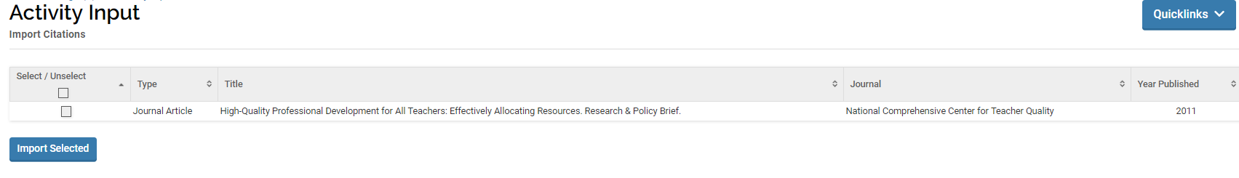

1. You will see a results screen summarizing what you did. Click Go Back to return to your activities page and review the activity uploaded.

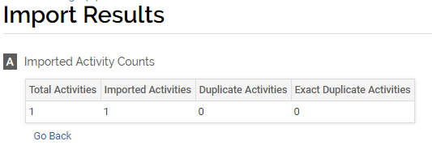

## Import via Medline/Pubmed

1. (Optional) Change the number of maximum records that will display on the page and/or check the box to hide duplicate records.

*Note*. Importing via Medline/Pubmed or Web of Science is especially useful the first time you add all your publications to your activities.

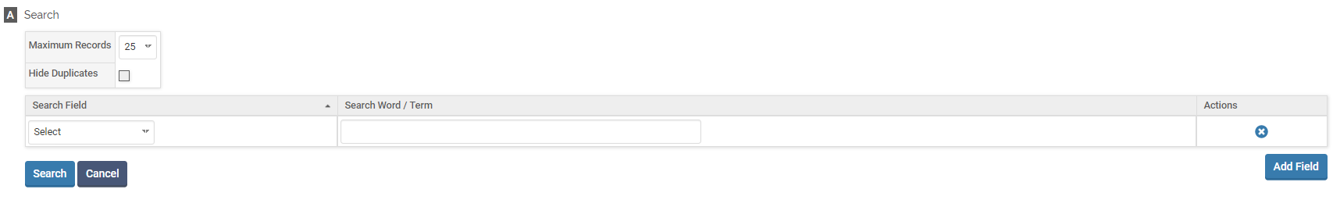

1. Select a search field (e.g., author, journal, or title) and input search word(s) / term(s):
2. (Optional) If desired, use the  button to add additional search criteria. You may use the  button to remove a row. All search terms implicitly use the Boolean term “AND”, so your search results will be more limited with the more search terms you use.
3. Click  and your results will populate below.

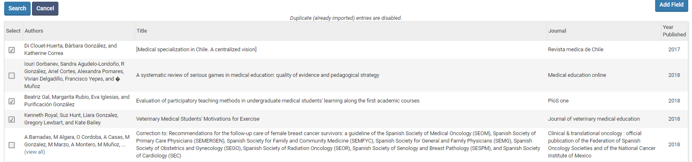

1. Select the references you wish to import by checking boxes in the first column.
2. At the end of the list, click  to add these references to your Scholarly Contributions and Creative Productions.
3. On the next page, change the semester and year for each reference if needed. Then, click  to add these activities.

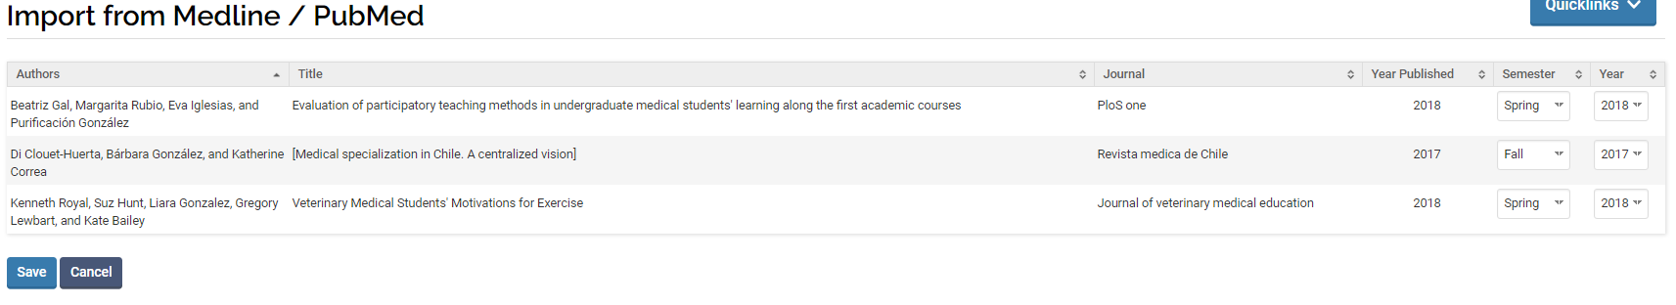

1. You will see a results screen summarizing what you did. Click Go Back to return to your activities page.

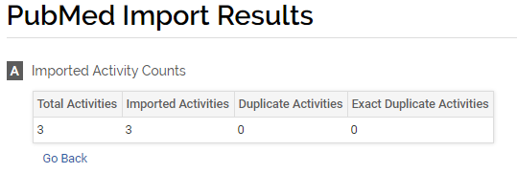

## Import via Web of Science

Follow the same directions as Import via Medline/Pubmed

## Import via ORCID

**Note:** You need to have created an ORCID account in order to use this import option. The BC library can assist you in setting up an account. For information, please use this link: <https://services.bc.edu/orcid/>

1. Click on Vitas and Biosketches in the left-side menu

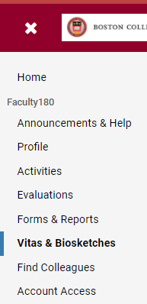

*Note*. Importing via ORCID is especially useful the first time you add all your publications to your activities.

1. Click on the connect button 



1. You will be brought to the following webpage to complete setup:

