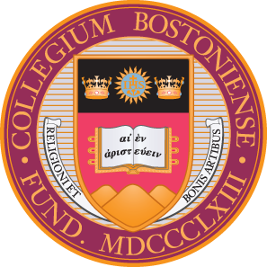ACCELERATED CLINICAL AESTHETICS

SKILLS TRAINING

The Accelerated Course Fast Track curriculum is designed to make the most of your time gaining knowledge and skills in **four Clinical Aesthetics service areas**:

* [Neurotoxins](https://www.bc.edu/content/dam/bc1/schools/cson/Academics/continuing_ed/Neurotoxins.pdf)
* [HA Dermal Fillers](https://www.bc.edu/content/dam/bc1/schools/cson/Academics/continuing_ed/HA%20Dermal%20Fillers.pdf)
* [Biostimulators](https://www.bc.edu/content/dam/bc1/schools/cson/Academics/continuing_ed/Biostimulators.pdf)
* [Collagen Induction Therapy](https://www.bc.edu/content/dam/bc1/schools/cson/Academics/continuing_ed/Collagen%20Induction.pdf)

# This course includes:

* **Online Lectures:** Preclinical instruction in the sciences of

anatomy, histology, and kinesiology as related to cosmetic injections and treatments. Lectures include essential information for FDA approved products, safety procedures and treatment protocols.

* + 2 Live
  + 1 Asynchronous
* **Hands-on training:** Small group instruction, observation and injection practice on live models under the direct supervision of experienced clinical aesthetic practitioners at Boston College’s Chestnut Hill campus.
  + Day 1: Neurotoxins and Dermal Fillers

# Eligible participants:

* APRNs
* RNs
* BSN students with

clinical experience

* PAs
* MDs
* DOs
* DDSs
* DMDs
  + Day 2: Biostimulators and Collagen Induction Therapy

Please Note: Participants are responsible for researching state/local/federal licensing laws and regulations pertaining to these services and ensuring these services are within their scope of practice prior to registering.