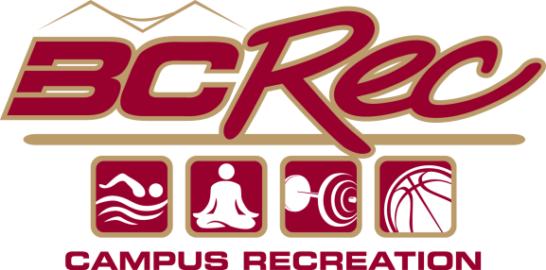

Boston College Campus Recreation:
Personal Trainer Prep Course

Applicant Name:
Graduation Year:
Major/Program of Study:
Eagle ID #:
Email:
Phone:
Applicant Interview Questions
- Why are you applying for a spot in the prep course?
- How did you hear about the prep course?
- What do you do for personal fitness?
- What areas of fitness are you interested in learning about?
- Describe any skills or experiences you have that are transferable to personal training?
- The prep course has many requirements and demands the attention of a 3-credit course. How do you feel you can handle this responsibility? Please review the syllabus as you consider this question.
- Basic yes/no questions:
  - Can you attend all classes listed on the syllabus, including the Saturday workshops? If no, then what will you miss? Please review the syllabus for the section on attendance.
  - Working mornings, sometimes as early as 6 a.m., is required in order to be hired after successful completion of the course. Are you able to work in the mornings?
  - All new personal trainers have a one-semester fitness attendant requirement, working one regular shift per week plus one to two rotating closing shifts for the semester. Are you able to meet this requirement?
  - This course does not guarantee employment, however, spots in this course are held for students who would like to work for Boston College Campus Recreation. If you pass the course successfully, do you hope to become employed with Boston College Campus Recreation?
Applicant Cueing
Please select an exercise for the following areas of the body and cue. When cueing please mention the following: exercise name, primary muscles involved in the exercise, and three to five cues (aka: directions).
Upper Body
  - Exercise Name

  - Primary Muscle(s)

  - Cues

Lower Body
  - Exercise Name

  - Primary Muscle(s)

  - Cues

Final Question
We require an application process for this course, because we occasionally get more applicants than we can accommodate. We will be accepting up to 15 students in the fall course. Why should you be one of those students?

