Boston College Budget Office: Cognos BI Reporting Guide
Contents:
- Logging into Cognos
- Forecast Reporting: Detail Forecast Report
- Navigating and Drilling Down on the Detail Forecast Report
- Drilling Options Detail Forecast Report Diagram
- Forecast Reporting: Summary and Trend Forecast Reports (Schools Only)
- Multiple Report Generator
- Single Report with Drop Down
- Printing
Note: Click on Hyperlink to bring you to each section)

- Cognos BI Reporting Logon Instructions
Log onto link to BI Reporting: https://eagledata.bc.edu/
Open Finance and Budget Folder
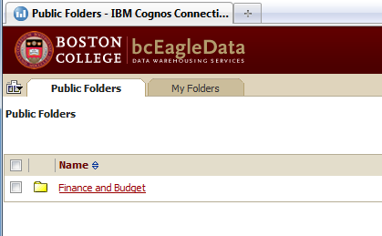
Open Budget Reports folder and navigate to the folder you with to work in.
To run the report, click on the hyperlinked name of the report. It defaults to HTML format.
If you wish to run the report in Excel or PDF format, click the arrow on the right side to run with options. Select the Format you would like to receive the report in. Click “Run”.
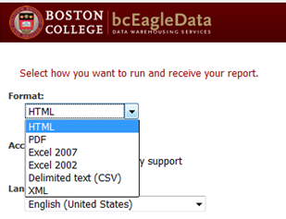
B. Forecast Reporting: Detail Forecast Report
After logging on, click Finance and Budget/ Budget Reports/Forecast Reports
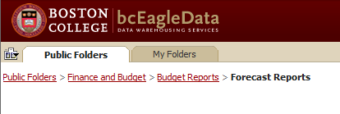
Navigate to the report for your area, and click on the hyperlinked report name to run or to run in PDF or Excel.
After running the report, you will arrive at a prompt screen. The left allows you to select which fund(s) to report on and the right side allows you to select which departments to report on.
The fund will default to fund 100, if you would like to report from a different fund, click on the plus sign and select the fund you wish to use.
Example: how to select Fund 110
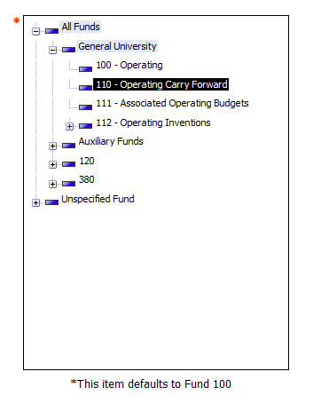
The departments have been preselected for your area, so you can simply click the finish button to produce the report. If there are departments that you do not wish to see, unselect them from the department tree on the right.
Click on plus signs to open, check or uncheck the department codes you wish to keep in the report.
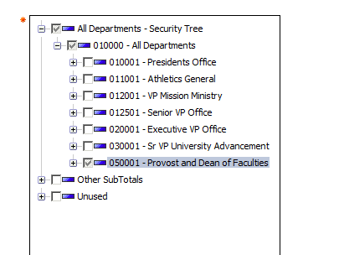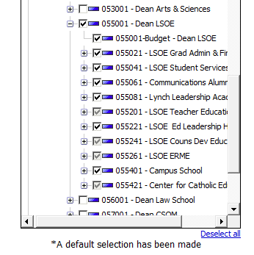
Navigating and Drilling Down on the Detail Forecast Report:
- Click Page Down: This shows each department on its own page. Use the page down link on the bottom of the screen. Each department that you selected from the tree will have its own page.
- Drill on Account (Child Account or Child Department Detail):
  - First Level drill: If the account is a parent account (parents have a carrot after the name ^, ex: 53310 - Salary Student^), drilling down will show the detail by child account. If there is no child, it will show the one line for the parent by itself, which can still be drilled further down.
  - Second Level drill: If you are on the page for a parent (or rollup) Department, this will show you the detail for each child department for that account. This only works if you started from a parent department report; if you started on a child department, this will only show a single line that is the same as the previous report.
- Drill on the Department (to get to Transaction Detail):
  - First Drill Level: Will show you chart string level data (fund source, program, property). Click page down to view additional programs/fund source/property combinations.
  - Second Drill Level: (Click on Department Code $ Amount): Shows transaction level detail similar to the TDI report from PeopleSoft. This page can filter by month or transaction type. This will show the transactional detail for Budget, Actuals, Prior Year Actuals.

Drilling Diagram: Detail Forecast Report

From Child Dept
Summary Level Report
(Parent)

From Parent Dept
Report: TDI based Transactional level Detail
Report: Child level department detail
Drill: Actuals
Drill: Account
Report: Chart String Detail
Report: Child level account detail
Drill: Account
Drill: Department
Dept

- Forecast Reporting: Summary and Trend Forecast Reports
After logging on, click Finance and Budget/ Budget Reports/Forecast Reports. These produce identical summary level trend reports, but the two versions offer different options on how they are retrieved. Additionally, the FY__ Forecast column is the same data that has been entered into the Revised Forecast on the TM1 forecast input reports.
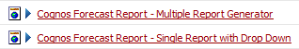

- Multiple Report Generator:
Functionality: This report creates multiple versions of the report for every combination you select in one click.
How to use: On the prompt page, select all of the fund and department combinations you would like to see and hit “finish”. It will bring you to the report for the first fund/department combination. To view the other combinations you can hit the Page down link on the bottom of the screen, or run the report as a PDF and scroll down. Additionally, if you run it to Excel, it will produce a different tab for each combination.
- Single Report with Drop Down:
Functionality: Summary report that produces one report, with the built-in flexibility of drop down boxes for fund and department for quick analysis.
How to use: Select drop down box, the report automatically recalculates the sheet.

- Printing:
On the top right hand side of the page, go to the following icon and select either “View in PDF” or “View in Excel”. The report can then be printed from those formats.
