TM1 Budget Development Applications – Step by step guide

Purpose:
Highlights: Users input volume/rate changes or Extraordinary Changes.

STEPS:
- Login to TM1 Application
  - Open Browser (preferred Mozilla)
  - Type in url: http://badger.bc.edu:9510/pmpsvc/applications.jsp
  - Enter your LDAP login user id and password
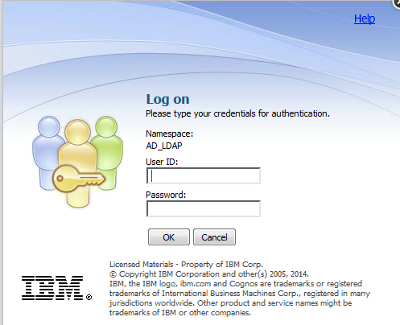

  - Click “Continue” to bypass security warning.
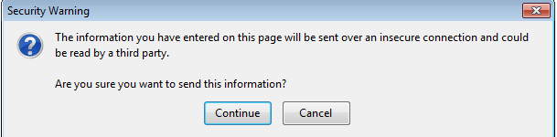

- Select your Bud Dev APP to work on 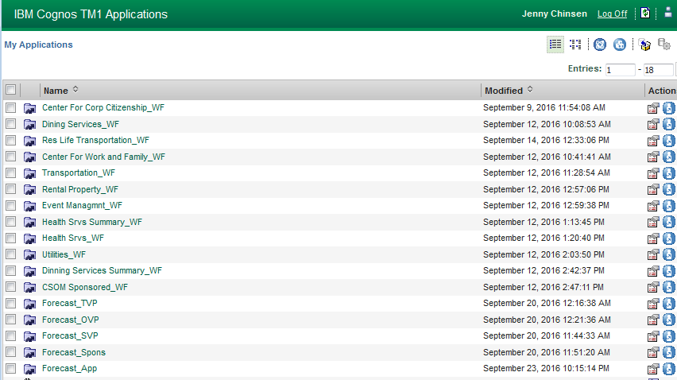

- Expand Department Tree on left to navigate to select department to input

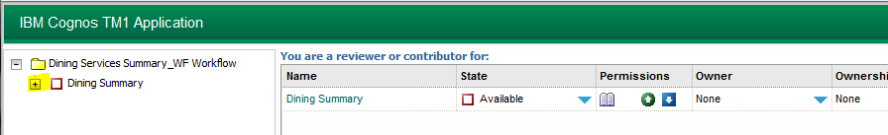

- Click on desired department on the right

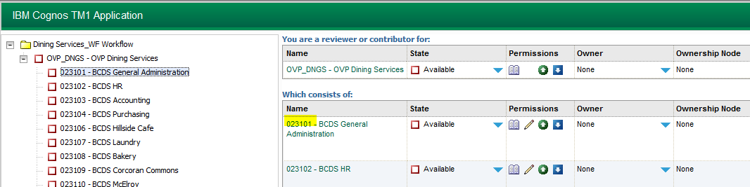

- New window will open with input schedule
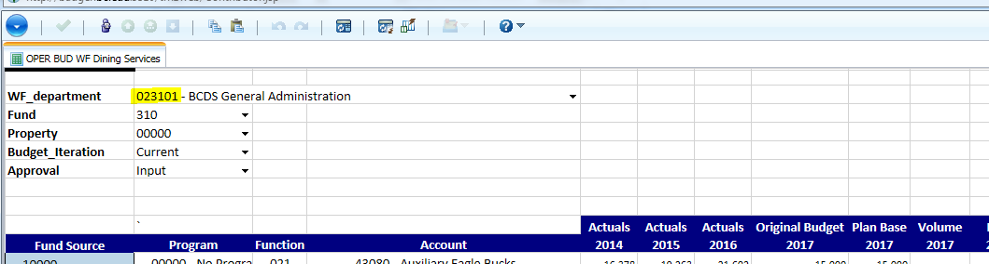
- Take control of the ownership of the App by clicking on 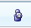 from the TM1 menu bar

- Columns available for input are the Dept Volume, Dept Rate and Dept Extra Change Amount
Inputs will be in blue until they have been committed
- Commit entered numbers by clicking on from the TM1 menu bar

- Close the App by clicking on the blue circle at the top left of the view
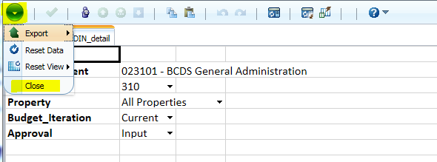

- Once input has been complete, release Ownership from the My Application page.
  - Click on icon
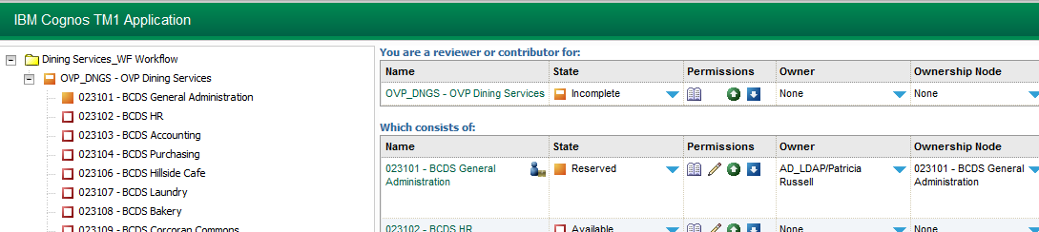

  - Confirm that you want to release ownership in the popup window.
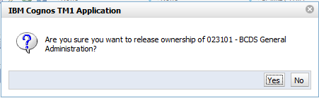

- To return to the list of Applications, click on the return arrow on the right of the menu bar
