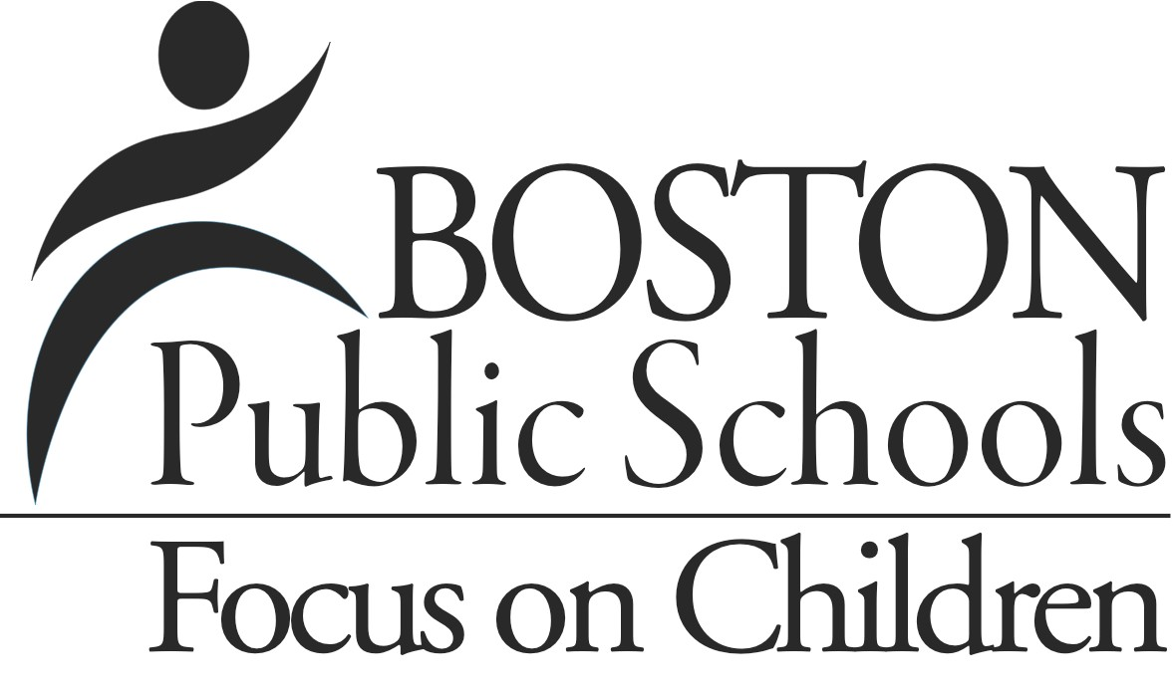
CORI/SORI Request Form
Pursuant to Massachusetts General Laws, Chapter 71, Section 38R, I hereby authorize the Boston Public Schools to obtain and review my Criminal Offender Record Information (CORI) as provided by the Criminal History System Board. Boston Schools has been certified by the Criminal History Systems Board for access to BOSPS (conviction, non-­‐conviction, and pending criminal case data). Additionally, I authorize Boston Public Schools to use local and national sexual offender registry information to determine if I pose an unreasonable risk to the children within Boston Public Schools. ALL FIELDS ARE MANADATORY
Please fill out all fields highlighted in yellow.

School/Dept/Name of Requestor:  Your Email Address or Phone Number: |  | Boston College Neighborhood Center/Erin Linnehan  bcnc.blpp@gmail.com/617.552-0445
Employee / New Hire (List the position you currently hold or have applied for)  Position Title:  BCNC Literacy Partnership Program Volunteer |  | Non-­‐Employee (Check one below)  Parent Volunteer (You currently have a child enrolled in this school)  Parent Volunteer (Your child is enrolled in another school)  X Non Parent Volunteer  Contractor/Subcontractor  Other
Last Name: |  |  |  | First Name:
Current Address:
Former Address:
Maiden/Alias Name: (if applicable)
Birth Date: |  |  | City in which you were born:
Social Security Number: |  |  | Mother’s Maiden Name:
Driver’s License Number and State in which it was issued: |  |  | Demographics: |  | Gender: Male Female Height: Feet Inches Eye Color: Brown Blue Green
Your Signature:
Date:
For Internal BPS USE ONLY
Which Form of Gov’t Issued Photo ID used: |  |  | Driver’s License Passport Other

