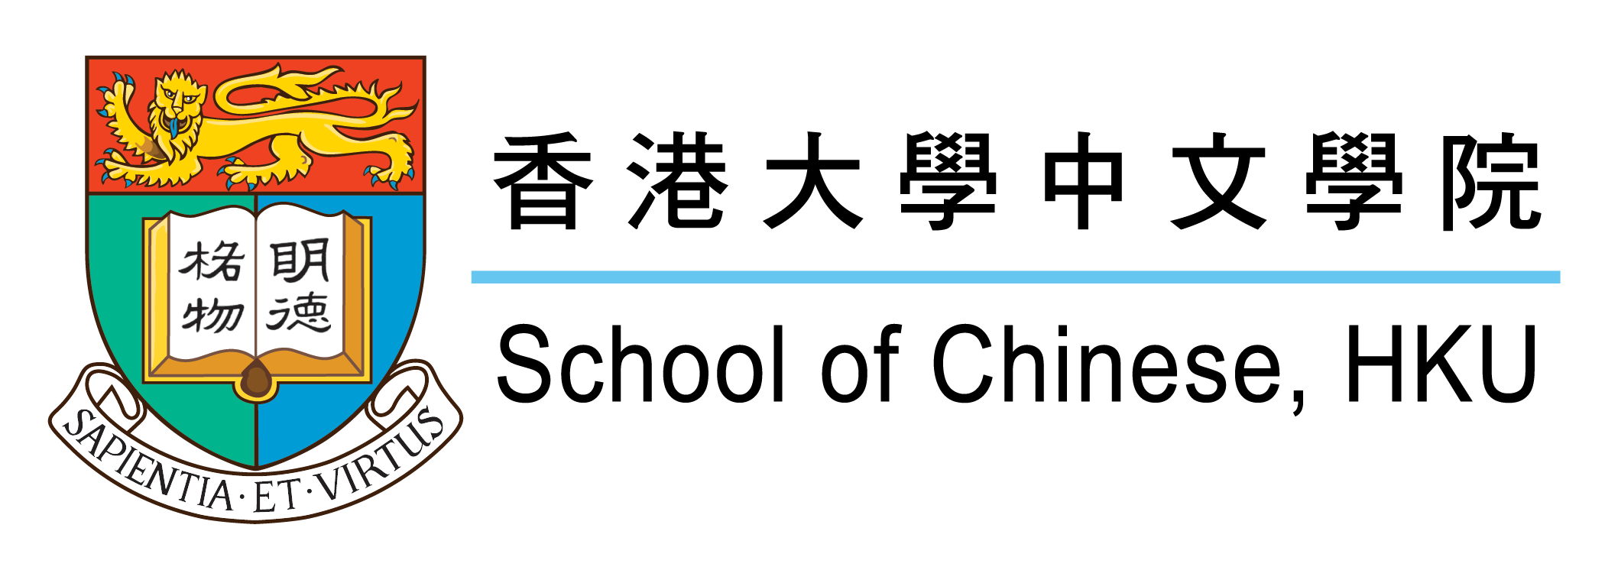
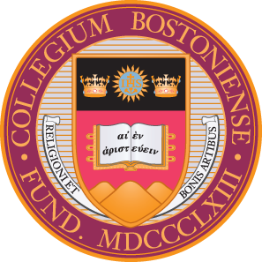
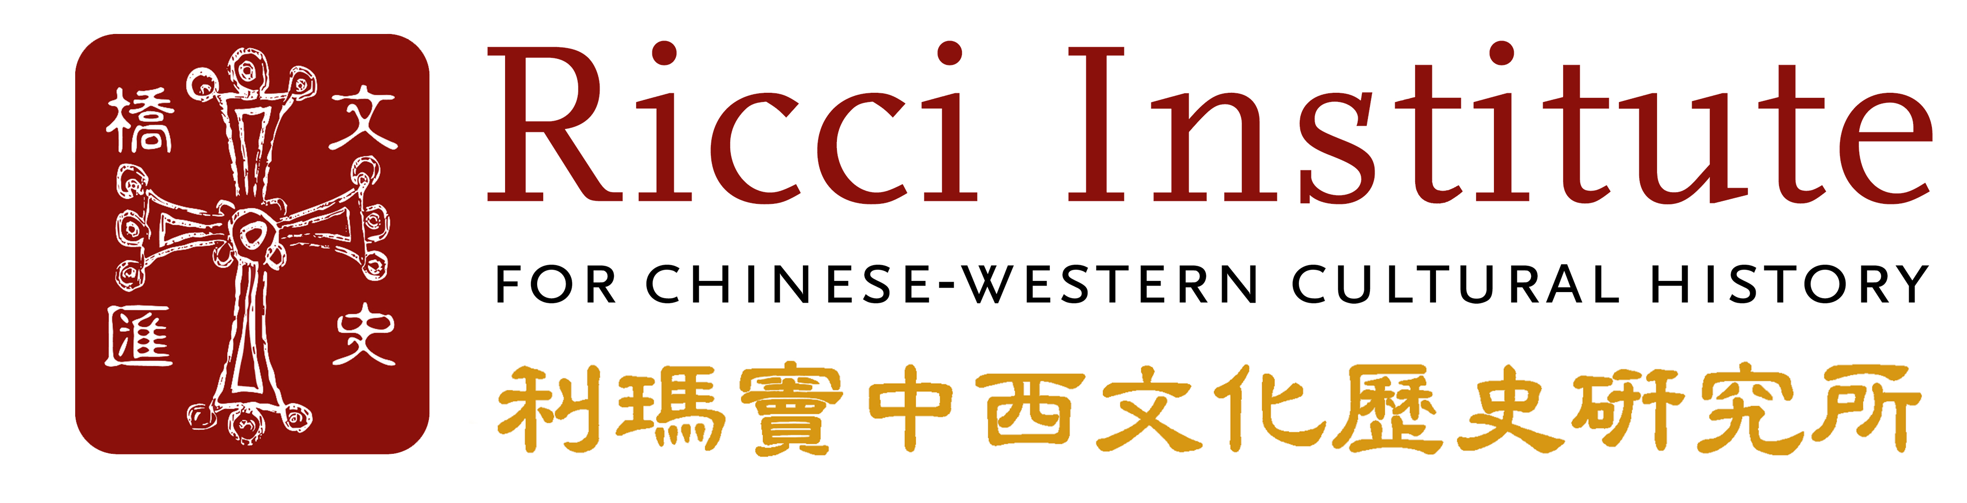

Call for Applications for an International POSTDOCTORAL Workshop
on the History of Christianity in East Asia
at the university of Hong Kong, SAR, China

The Ricci Institute for Chinese-Western Cultural History at Boston College and the School of Chinese, Faculty of Arts, University of Hong Kong will hold a four-day international workshop in Hong Kong, China from December 10 to 13, 2024. Prior to the workshop a two-night visit to historical sites in Macau related to the history of Christianity will also take place. The working language of the workshop will be English.
All participants will be expected to arrive in Macau by Sunday, December 8 and depart from Hong Kong on Saturday, December 14, 2024. They are required to attend all workshop-related activities and sessions.
The Ricci Institute at Boston College and the School of Chinese at University of Hong Kong are inviting post-doctoral level scholars and junior faculty members whose research focuses on Christianity in East Asia and who are currently preparing a book manuscript in English for publication to apply.
Entitled “Historical Legacies of Christianity in East Asia: Bridging a New Generation of Scholars and Scholarship”, this workshop is administered by the co-sponsors of both universities.
The workshop has three primary components.
[1] First, through a series of lectures and seminars by senior scholars from the co-sponsoring institutions and other universities, participants will have the opportunity to confer with specialists from across the globe regarding the interpretation of complex primary source materials. These include manuscripts, early printed books from different historical periods composed in a variety of East Asian and Western languages (e.g. Classical Chinese, Classical Japanese, Portuguese, Italian, Spanish, etc...), and other objects of material culture.
Another primary focus of the workshop will be to reflect on research methodologies and historiographies, how they developed, and the ways in which they were expressed through different scholarly traditions. The training offered will be further enhanced by visits to local archives, libraries, and museums with specialized collections pertinent to the history of Christianity in East Asia.
[2] Secondly, participants will have the opportunity to interact with a Senior Acquisitions Editor from Brill Academic Publishers (Leiden/Boston) and with other scholars to discuss the entire editorial and publication process of a scholarly monograph (with any major academic press).
[3] Thirdly, participants will be personally mentored by invited senior scholars who are well known internationally for their contributions to the study of Christianity in East Asia. These scholars will critique and discuss the participants’ draft manuscripts with a view to preparing them for publication. This will take place in an open forum together with fellow participants. Participants will be required to submit their full manuscripts in English (of their dissertations) well in advance, so that the invited senior scholars will have sufficient time to read them carefully in order to comment on them.
Qualifications. Applicants must have completed their doctoral studies and dissertation defense in order to be eligible to participate in the workshop. Post-doctoral candidates must have completed their doctoral degrees within the past five years and have been involved actively in teaching and/or research (as a post-doctoral fellow, an independent scholar, or a junior faculty member).

Requirements.
[1] a most recent Curriculum Vitae in English;
[2] an 8~10-page double-spaced statement in English that summarizes the manuscript (also to be submitted in English) the candidate has completed and is currently preparing to submit for publication. The theme of the manuscript should be related to some aspect of the history of Christianity in East Asia, i.e. China, Japan, Korea, and Vietnam. This can be either in the Catholic or Protestant tradition (16th-early 20th centuries) and may focus on one or more aspect from a wide range of historical topics (e.g., the history of philosophy, theology, history of science, missionary translation, art, architecture, music, local Christian community life, social and cultural history, etc.…).
This statement should include a synopsis of the manuscript, a detailed description of the research methodology employed, plans for additional research and writing to complete the project (if any), and a proposed timeline for the submission of the manuscript to a publisher.
[3] two up-to-date letters of recommendation (from senior scholars familiar with the candidate’s work).
Expenses. The Ricci Institute at Boston College and the School of Chinese at University of Hong Kong will cover the following expenses for all successful applicants:
[1] Transportation: return economy airfare from your city/country of residence as well as local public transportation between home and departing airport, as well as the workshop venue to Hong Kong International Airport for the workshop participants. It also includes transportation from Macau to Hong Kong on December 10, 2024.
[2] Lodging in Macau for the nights of December 8 and 9, and in Hong Kong from the afternoon of December 10 until the morning of December 14, 2024, including most meals during the workshop (Note: lodging will be pre-arranged by the School of Chinese, University of Hong Kong).
All authorized expenses will be paid as a reimbursement on presentation of official receipts, in compliance with the travel policies of Boston College. Incidental expenses of a personal nature (e.g., travel insurance, phone/SIM card, data purchase, and other incidentals, etc.) are not reimbursable.
Medical Insurance
All participants are responsible to arrange and pay for their own valid medical insurance for the duration of their stay in Macau and Hong Kong. The pre-purchase of medical insurance (before arriving in Macau and Hong Kong.) for the duration of a participant’s stay is mandatory.
Visa
If you are required to apply for a visa to enter Macau and Hong Kong, your workshop participation award letter will be considered a formal invitation letter for you to apply for your visa at your local China’s embassy or consulate.
Deadline
All required documents should be in English and submitted via email no later than May 26, 2024 to Dr. Xiaoxin Wu at: xiaoxin.wu.2@bc.edu with the subject line: “2024 Hong Kong Postdoctoral Workshop Application”. Letters from the recommenders must be sent directly to the above email address by the same deadline with the subject line: “2024 Hong Kong Postdoctoral Workshop Reference Letter for (insert name of candidate)”. The preferred formats for the letter attachments are PDF or MS-WORD. Inquiries regarding the application and the workshop should also be sent to the above email address.
Application results will be announced by the end of July 2024.
For more information about the Ricci Institute at Boston College, please visit: www.bc.edu/ricci.
For more information about the School of Chinese, University of Hong Kong, please visit: https://web.chinese.hku.hk/en/

